FOR IMMEDIATE RELEASE Corporate Contacts:
APRIL 7, 2017 Loni Dow, Marketing Project Manager
loni.dow@marconet.com Work: 320.650.1929

MARCO NAMED TO PRESTIGIOUS ‘MANAGED PRINT SERVICES BEST IN CLASS’ LIST BY HP
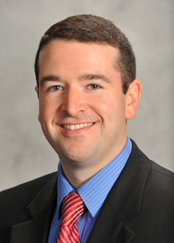
ST. CLOUD, MINN., APRIL 7, 2017 – With more than 3,700 Managed Print Services customers across the nation, Marco’s reputation for industry-leading solutions and services was recognized by HP as it named Marco to its list of MPS Best in Class Partners.

The milestone marks the first time Marco has received this award, something Marco’s Director of MPS Dan Larkin says is a testament to the entire Marco team delivering their very best. “It’s a tremendous compliment and a tremendous honor,” Larkin said. “We don’t get an award like this without everyone firing on all cylinders.”

HP began this recognition in 2015 to highlight their top-performing MPS partners based on performance statistics.

“It’s pretty special to be grouped with the class of companies that were included in this award,” said Larkin. “It’s validation that we’re doing a lot of the right things.”

Larkin says Marco’s updated MPS strategy and customers being comfortable with HP products helped lead to another successful year for Marco’s MPS.

“As we continue to focus on growing our MPS practice, the goal is that we’re going to be a mainstay on this list – year over year,” Larkin said. “With both MPS and Marco in growth mode, we’re showing no signs of slowing down. I don’t know that we’d be in this position without all the help and programs HP has put together for us.”

Marco has over 1,100 employees and serves more than 31,000 customers across the country from 46 locations throughout the Midwest.

About Marco
Marco is one of the largest technology providers in the country with over 31,000 clients throughout the Midwest and nationwide. We specialize in business IT services, copier/printer solutions and managed and cloud services. Our technology experts break down complex solutions into simple terms to position your business for success.

# # #

