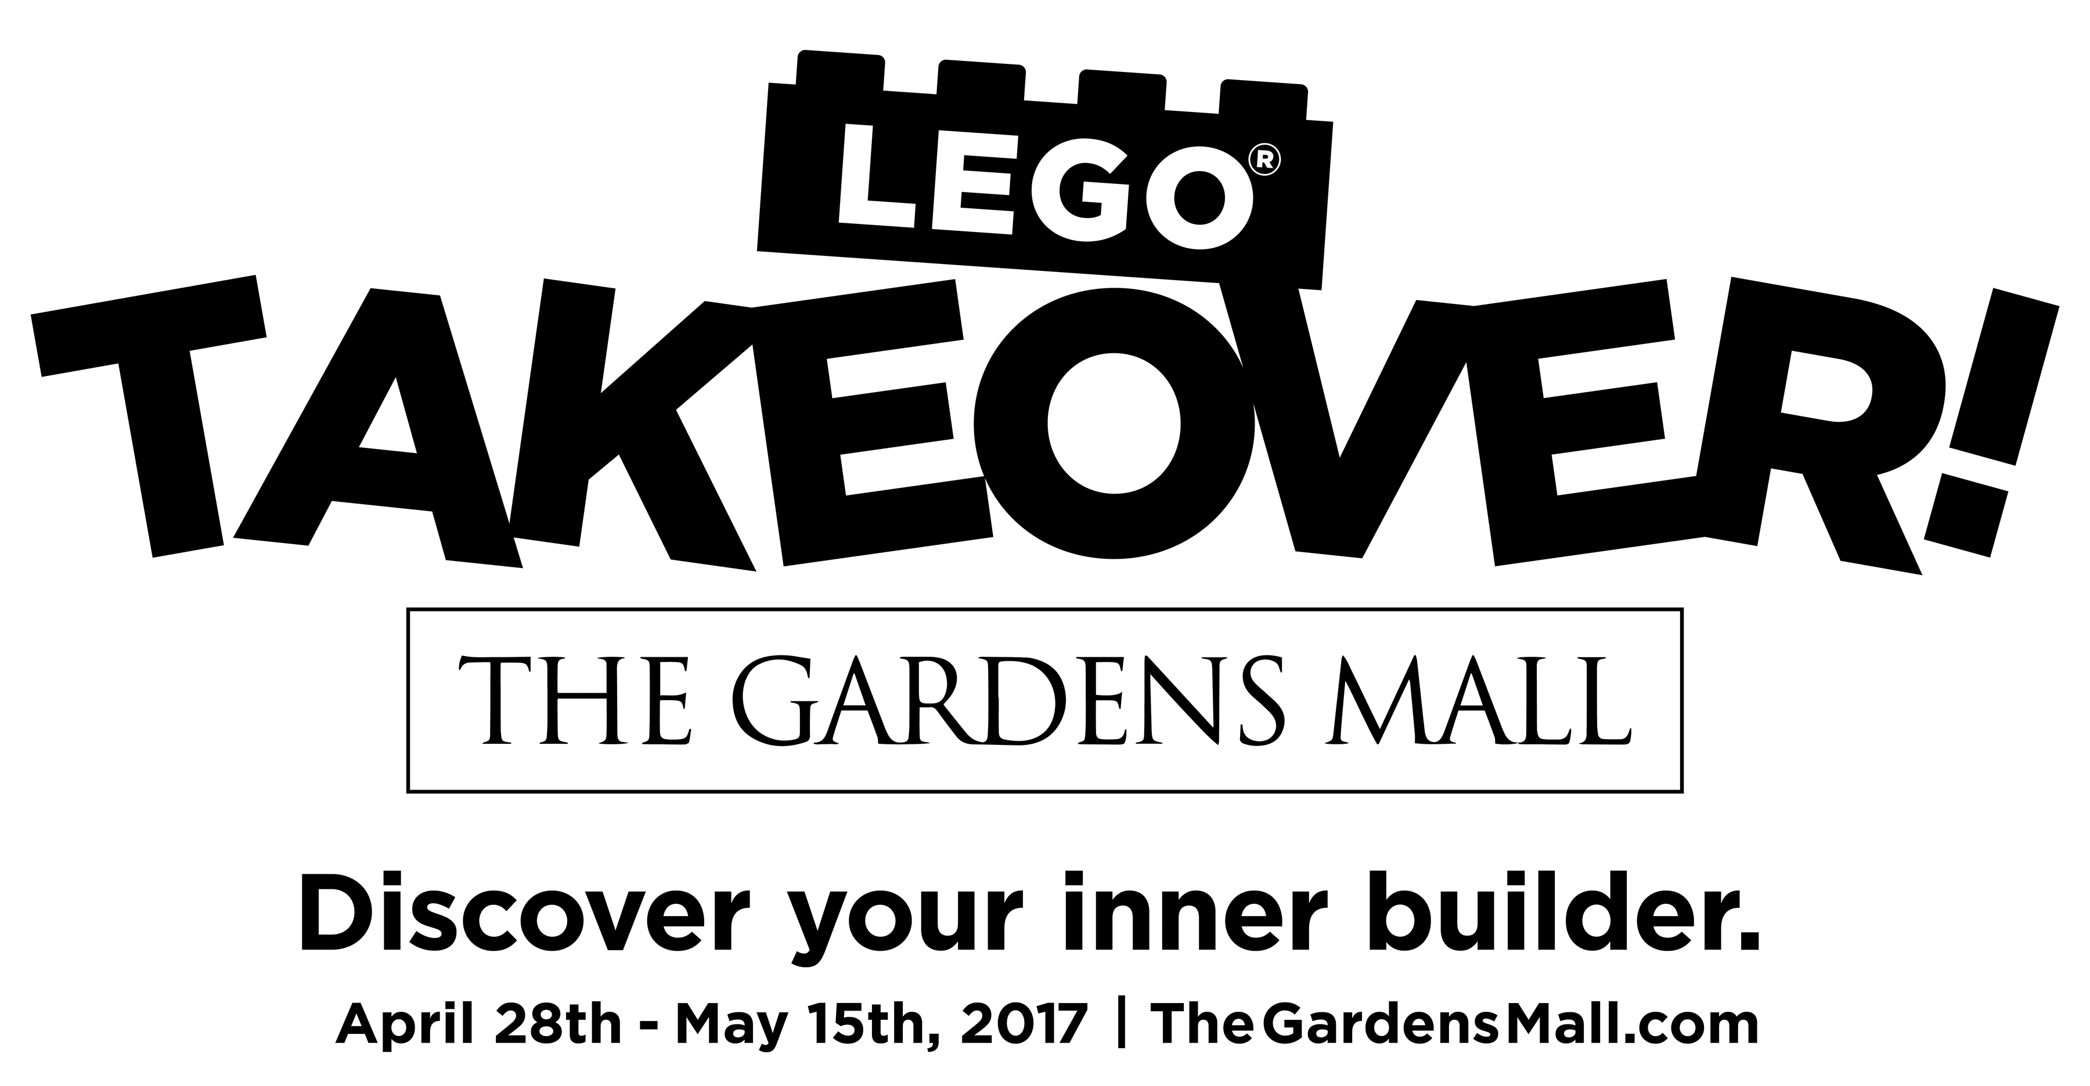

Palm Beach Gardens, Florida - The Gardens Mall invites you and your family to let your imagination run wild as you explore two floors of life-sized LEGO models, while building your own creations with the world-famous bricks. LEGO Takeover! is open to the public, with no cost of admission.

Play well, which in Danish is “leg godt,” are the two words behind the world-famous LEGO name. The LEGO Group was founded in Denmark in 1932 and has become a global enterprise.

The LEGO Group’s North America branch is partnering with The Gardens Mall in Palm Beach Gardens, Florida, for LEGO Takeover! from April 28 to May 15. For nearly three weeks, fans of the popular plastic bricks can explore The Gardens Mall and come face-to-face with nearly 50 LEGO models from many different genres. There will be Marvel Comics and DC Comics superheroes, characters from The LEGO Batman Movie, Disney princesses, galactic fighters from Star Wars, and many more.

This is the first time in Florida that LEGO fans can experience all of these models in one place. Not only can guests take selfies with life-sized LEGO models, but they can also build their own creations. Visitors can make a race car out of LEGO bricks, then watch it compete against other creations on the LEGO Race Ramps. Or, artsy guests can design their own masterpieces to go on display in the LEGO Art Gallery.

At the public grand opening on April 29, children will be able to challenge their peers in two competitions geared around the theme: “Things to do in Palm Beach County.” One competition will allow participants to build their creation before arriving at the mall. The other will be a timed event in which competitors must complete their construction in just 30 minutes.

On Saturday, May 6, guests at LEGO Takeover! The Gardens Mall will also be treated to a free showing of The LEGO Movie, courtesy of Nicklaus Children’s Health Care Foundation. Movie fans will gather in the mall’s Grand Court where they’ll snack on complimentary candy, popcorn, and other movie theater treats.

For more information, including a list of all LEGO Takeover! events, visit thegardensmall.com/ lego-takeover or call 561.775.7750.

Exhibition hours will run concurrent with mall hours, Monday through Saturday, 10 a.m.-9 p.m., and Sunday 12 p.m.-6 p.m.

About The Gardens Mall
The Gardens Mall is located one mile east of I-95 on PGA Blvd. in Palm Beach Gardens, Florida. The luxurious, 1.4-million-square-foot, super-regional shopping center features more than 150 world-class retail specialty shops and restaurants. It is anchored by Saks Fifth Avenue, Nordstrom, Bloomingdale’s, and Macy’s. The Gardens Mall is owned and managed by The Forbes Company. For more information about The Gardens Mall, call 561.775.7750 or visit the mall online at thegardensmall.com or floridaluxuryshopping.com.

About the LEGO Group
The LEGO Group is a privately held, family-owned company with headquarters in Billund, Denmark, and main offices in Enfield, Conn., USA; London, UK; Shanghai, China; and Singapore. Founded in 1932 by Ole Kirk Kristiansen, and based on the iconic LEGO® brick, it is one of the world’s leading manufacturers of play materials. Guided by the company spirit: “Only the best is good enough,” the company is committed to the development of children and aims to inspire and develop the builders of tomorrow through creative play and learning. LEGO products are sold worldwide and can be virtually explored at www.LEGO.com. LEGO, the LEGO logo, the Minifigure, and the brick and knob configuration are trademarks of the LEGO Group. © 2017 The LEGO Group.

The Gardens Mall
3101 PGA Blvd.
Palm Beach Gardens, Fla.
thegardensmall.com

Media Contact
Katie Johnson
katiej@venueadv.com
561-844-1778, ext. 33

High-resolution photos available upon request

