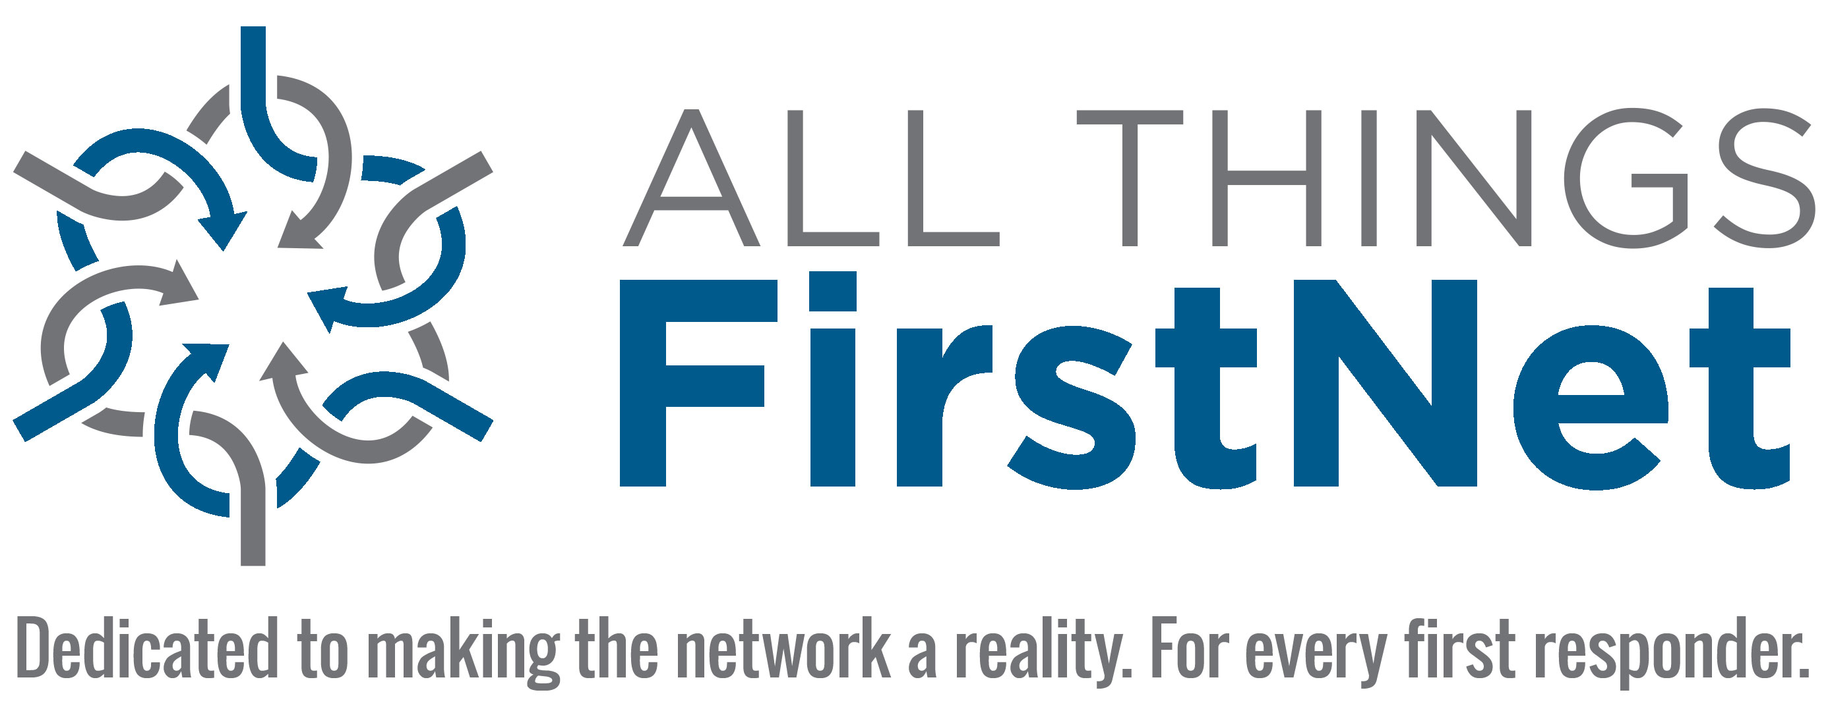
JUNE 6, 2017
CONTACT: W. B. Lee
(720) 651-8101
FOR IMMEDIATE RELEASE

All Things FirstNet Launches to Provide Critical Information on Public Safety Broadband

New website delivers information, news and analysis vital to first responder community.

The new website, AllThingsFirstNet.com, is poised to be the industry’s most authoritative source for information, news and analysis critical to public safety in the move toward a nationwide public safety broadband network.
All Things FirstNet was created to support the FirstNet mission and to support public safety’s need for the network and smart technology which is required to strengthen communications and facilitate knowledge exchange. The website and companion e-newsletter are dedicated to making the network a reality for every first responder.
The website features some of the best-known commentary and insights in the industry, including Andy Seybold’s Public Safety Advocate.
“Implementing a nationwide public safety broadband network is paramount to protecting the citizens in our communities,” said Seybold. “All Things FirstNet will be an essential hub for the public safety community as they realize this vision.”
All Things FirstNet provides the latest news and information on product announcements, partnerships, governance, networks, policy, devices, coverage and applications. The goals of All Things FirstNet include providing:
- A single site for all information related to FirstNet
- The most recent news related to FirstNet and its partners
- News archives for research and historical reference
- Product information from companies offering devices, applications and integration for the National Public Safety Broadband Network
- An understanding of the technical aspects and integration with Land Mobile Radio (LMR) related to the FirstNet deployment through Andy Seybold’s “Public Safety Advocate”
- Practical understanding for all stakeholders related to a FirstNet deployment
All Things FirstNet is offering a limited number of sponsorship opportunities to relevant organizations. For more information, contact info@allthingsfirstnet.com.

Allthingsfirstnet.com is owned and operated by RMC Media LLC

