

**LOS ANGELES**

3501 Ocean View Blvd

Glendale, CA 91208

(818) 275-1275

**FOR IMMEDIATE RELEASE**

Nathan Nazario

818.275.1275

[nathan.nazario@gopositron.com](mailto:nathan.nazario@gopositron.com)

**POSITRON AND TECHNICOLOR EXPERIENCE CENTER PARTNER TOGETHER**

**TO DRIVE CINEMATIC VR AND IMMERSIVE MEDIA PLATFORMS**

**VOYAGER™, WORLD’S FIRST FULL-MOTION CINEMATIC VR CHAIR, AND**

**POSITRON TECHNOLOGY WILL BE AVAILABLE TO VR INNOVATORS**

LOS ANGELES, CA., June 8, 2017 – VR technology studio [Positron](http://www.gopositron.com), creators of the world's first full-motion cinematic VR chair, Voyager™, today announced a partnership with the [Technicolor Experience Center](http://tec.technicolor.com) (TEC) designed to help drive the further development of cinematic VR and the immersive media ecosystem. Voyager™ chair platforms will be installed at the TEC showroom where filmmakers, creators, studio executives, artists and technologists from across the industry come together to realize the full potential of immersive media.

“Positron is focused on providing technology and products for premium cinematic VR that both audiences and creators love. We’re thrilled to make Voyager™ technology available to the Technicolor Experience Center and to contribute to this community of thought leaders focused on the creative and economic growth of VR,” said Jennifer Rundell, COO, of Positron.

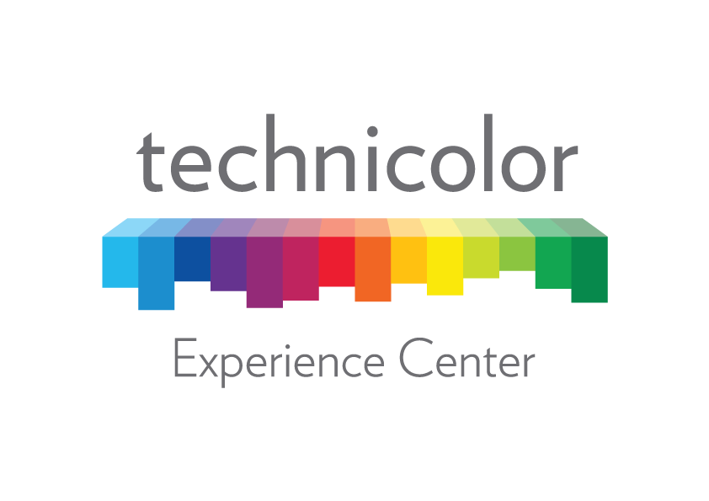

“We’re excited to partner with the Technicolor Experience Center to bring Voyager’s hardware and software platforms to Hollywood’s leading cinematic VR creators,” said Jeffrey Travis, CEO, Positron. “The Voyager platform is designed to set a new standard for cinematic VR and location-based experiences. Our mission is to empower storytellers with better ways of sharing immersive stories.”

“Motion and multisensory integration will play a critical role in the effectiveness and adoption of virtual reality and other immersive experiences in the months and years to come, “ said Marcie Jastrow, SVP Immersive Media and Head of the Technicolor Experience Center. The partnership between the Technicolor Experience Center and Positron will provide visionaries in the immersive media community with an opportunity to utilize outstanding multisensory touch points such as motion, scent and haptics into their storytelling experiences.”

**About Positron and Voyager™**

[Positron](http://www.gopositron.com/) is a VR technology studio based in Los Angeles that is focused on cinematic VR. The team includes mechatronics engineers, designers, software developers and artists who collaborate together to create premium VR experiences and products.  Voyager™ is the first full-motion chair platform designed for cinematic VR. Integrating beautiful design and high-end engineering, it reflects a passion

for VR storytelling.  Voyager™ delivers a completely new level of immersion in VR by providing a comfortable, fully integrated personal VR theater that incorporates gentle motorized yaw and pitch motion, audio-driven haptic feedback and specialized seating.  Its unique software and hardware technology integration enables nuanced motion and haptic tracks to be encoded along the featured content's visual and spatial audio tracks.  The chair precisely guides the viewers' attention to points of interest in the experience, while also allowing a viewer-controlled motion mode. Voyager™ units are available now for select theaters, hotels, concerts, and events that desire to provide a premium VR experience.  For Voyager images please visit [Positron Media](https://www.dropbox.com/sh/wbfto0siidje0ct/AABH7meOteVRHkHeURNaLKxCa?dl=0).

**About Technicolor Experience Center**

The mission of the Technicolor Experience Center is to enable partnerships and collaboration to create the future of immersive experiences. The Technicolor Experience Center is where artists and scientists from across the industry come together to realize the full potential of immersive media. By uniting talent from Technicolor and its award-winning creative brands (MPC, The Mill, Mr. X and Mikros Image) with partners from fields as diverse as gaming, animation, traditional media and technology, we enable the ideation, exploration and creation that pushes the boundaries of what immersive experiences can be.

###