**FOR IMMEDIATE RELEASE** Media Contact

Su Pak [su.pak@9to5seating.com](mailto:su.pak@9to5seating.com) | 310-220-2500 x123

9to5 seating SHOWCASES high design AND NEW WEBSITE AT NEOCON 2017

*9TO5 SEATING CONTINUES TO LOOK TOWARDS CUSTOMER SOLUTIONS FOR NEOCON INSPIRATION*

**(HAWTHORNE, CA – JUNE 2017)** – 9to5 Seating, a leading office seating manufacturer, is emphasizing ways in which it can help customers plan for the future at NeoCon 2017. Informed by customer demand, 9to5 Seating is launching new products and a brand new website and Chair Designer.

“We are excited to reveal all the new things happening with 9to5 Seating at this year’s NeoCon,” said Dara Mir, President of 9to5 Seating. “This year, we’re focusing on our high design products, such as our Sol, Luna, Acclaim, Core, Diddy and Zoom series. We’re also highlighting our Sophie lounge series.”

While Sol, Luna, Acclaim, Core, Diddy and Zoom are the showcased items, 9to5 Seating will reveal five brand new chair series that will launch in 2018. You can visit the showroom to see their new mod-style lounge chair, two ergonomic task chairs, a new conference chair, as well as a new product category they are entering: a K-12 chair.

In addition to showcasing the high design products, 9to5 Seating will be launching a brand new website with newly designed Chair Designer in time for NeoCon. Both the website and Chair Designer allow for easier usability, flexibility and the ability to spec projects and track orders.

“The new website and Chair Designer are more aligned with the direction we’re going – design focused and always centered around the customer experience,” said Mir. “We think everyone is going to be impressed with the new website and our Chair Designer with all its features, configuration options and graded upholstery choices. The best part is that you can save and download the project specs.”

Visit 9to5 Seating during NeoCon at their Chicago showroom, #10-109 Merchandise Mart, 10th floor, to learn more about the latest offerings for 2017. Check out the new website and Chair Designer at [www.9to5seating.com](http://www.9to5seating.com).

**About 9to5 Seating**

9to5 Seating, headquartered in Hawthorne, CA, has been designing and manufacturing ergonomic office seating to accommodate the rigorous demands of office environments, since 1986. 9to5 Seating presents an extensive collection of executive, task, guest, conference, stool and lounge seating. Customization is an everyday demand that 9to5 Seating welcomes. Combining its state-of-the-art in-house manufacturing systems with a commitment to continuous improvements in all phases of the operation, 9to5 Seating, with its over 500,000 sq. ft. of manufacturing resources, can confidently deliver products offered at unparalleled pricing, with quality built into every phase of manufacturing. For additional information, visit [www.9to5seating.com](http://www.9to5seating.com) or follow 9to5 Seating on [Facebook](https://www.facebook.com/9to5seating), [Twitter](https://twitter.com/9to5seating), [LinkedIn](https://www.linkedin.com/company/9-to-5-seating), [Instagram](http://instagram.com/9to5seating).

**Sol**

THE FUTURE AT A GLANCE

With flexible articulating pivoting back rest, the Sol represents an ergonomic masterpiece. Options include two aluminum finishes: Polished Aluminum and Silver powder coat finish. The Sol also has six-way adjustable arms, built-in adjustable lumbar and weight balanced mechanism with 4-position back-travel limiting lock.

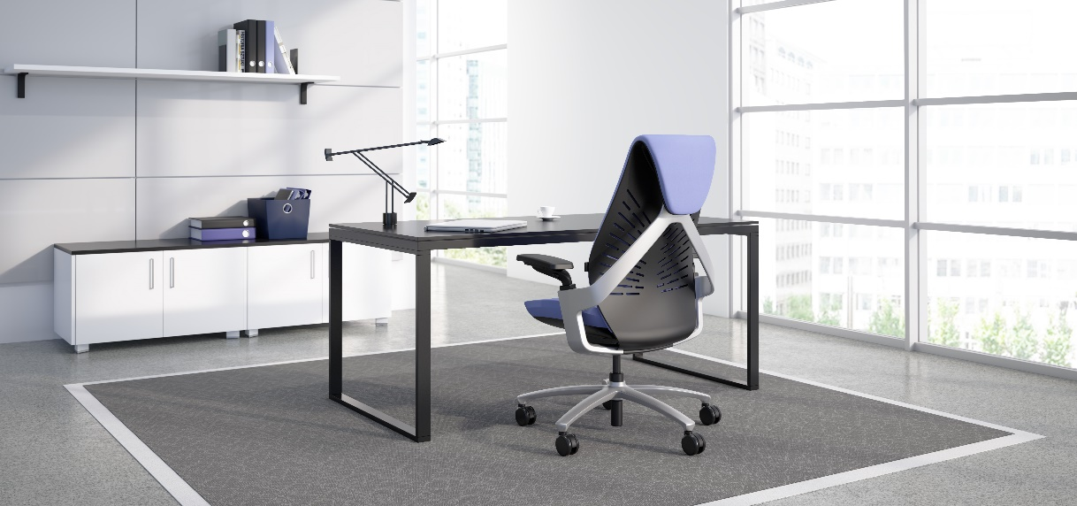

**Luna**

TASK MEETS ERGONOMIC COMFORT

Luna provides a sculptured blend of materials into a functional seating experience. Its mesh back construction, ergonomic contoured seat, built-in seat depth adjustment and multi-position recline with safety lock provides functional comfort with value pricing.

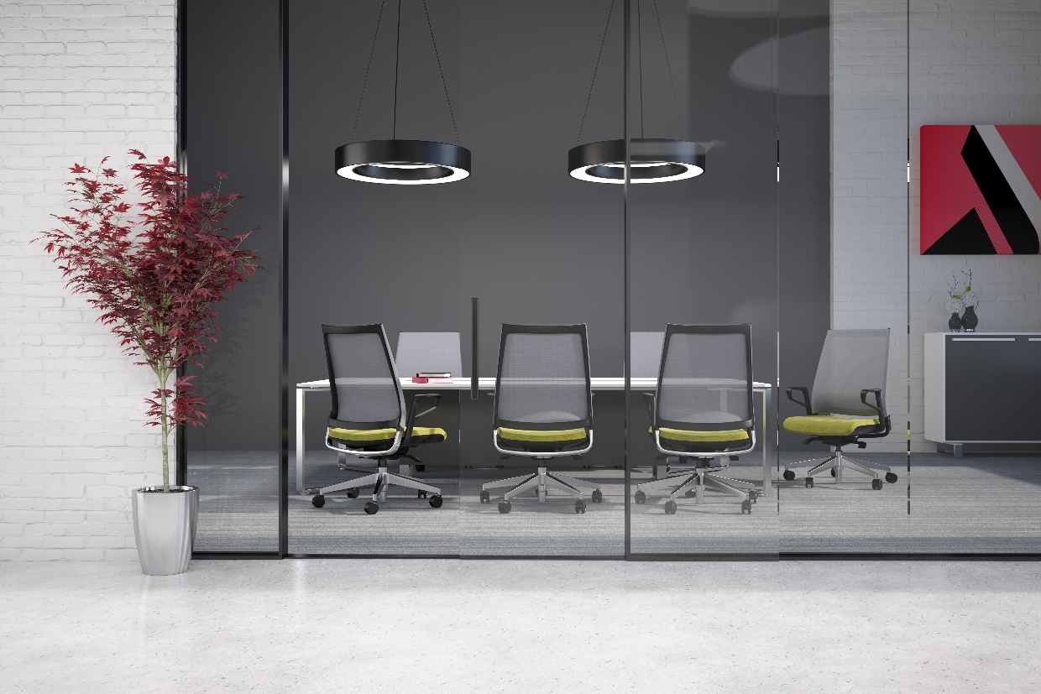

**Acclaim**

CONTEMPORARY EUROPEAN STYLING WITH SUBTLE DETAILING

With top-grain leather upholstery or extensive fabric selections and ergonomically sculptured seat and back cushions, the Acclaim brings a polished style to your conference room. The Acclaim includes polished arm style with upholstered caps, weight balanced, heavy duty synchro or full synchro with independent back angle adjustment and a 27” polished cast aluminum base option.

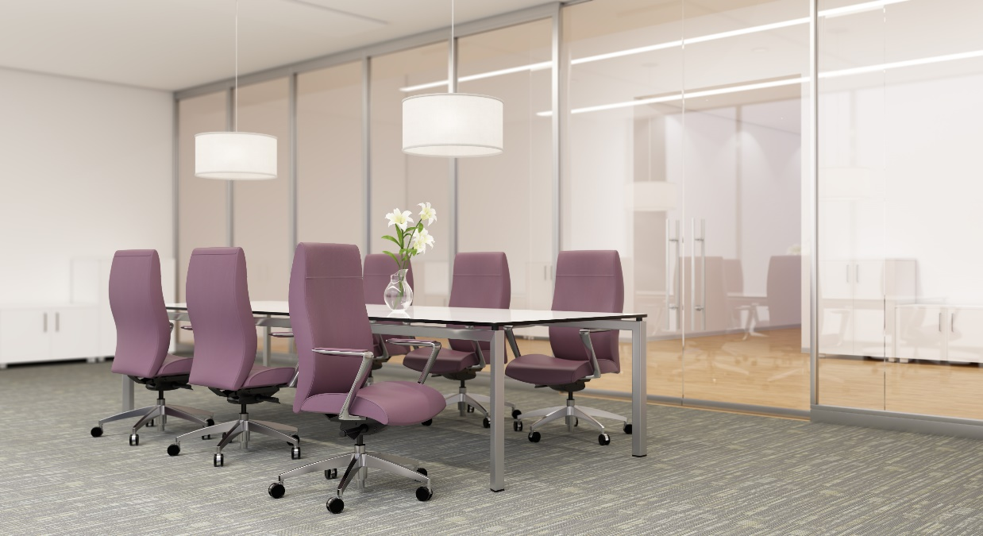

**Core**

CONTEMPORARY LINES FOR YOUR WORKSPACE

The Core’s molded foam back over mesh suspension, ratchet back height adjustment and stylish durable poly outer back introduces contemporary lines to your workspace. The “sit and forget” weight balanced control option utilizes the weight of the user to balance the back tension.

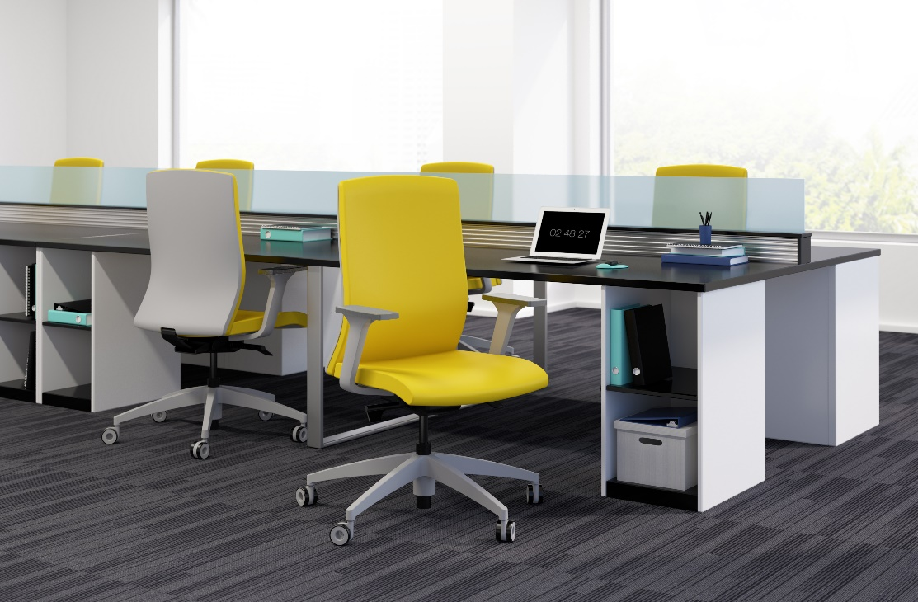

**Diddy**

DAZZLE YOUR CONFERENCE SPACE

Diddy’s classic styling with simple, clean and elegant lines are matched by its chrome finished wraparound armrest, plush padding on seat and back built from high resilient molded foam and top-grain leather upholstery options.

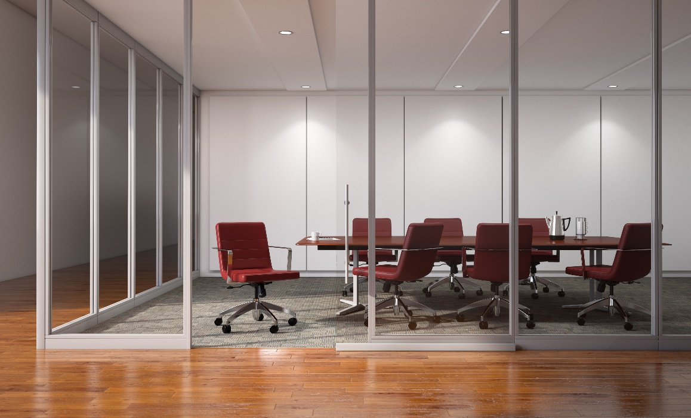

**Sophie**

COMPLETE LOUNGE SEATING COLLECTION

The complete lounge seating collection with robust design is made for high traffic reception and waiting areas (i.e. medical offices). The seat clean-out space combines comfort with easy maintenance and provides visitor and maximum flexibility with its single, double, triple, benches, hip chair and bariatric options.

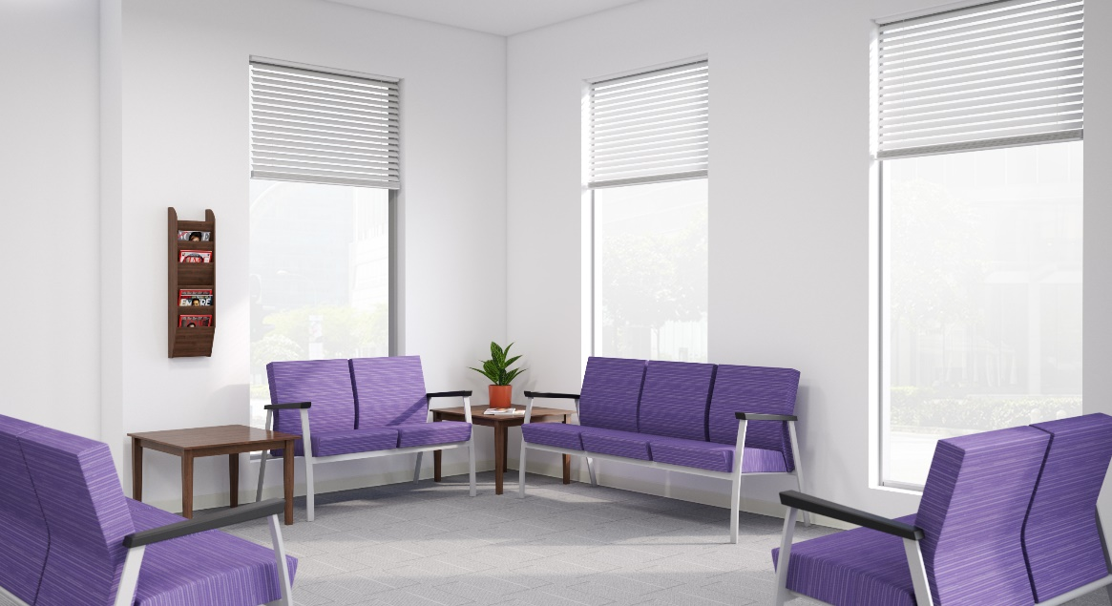

**Zoom**

RAPID SETUP FOR A CREW OR CROWD

Great option for training, task, multipurpose, stool and conference seating. The premium breathable mesh back comes in two coordinating colors (gray and white). The nesting model’s torsion spring flex back provides added comfort, in addition to the optional upholstered seat.

