**For Immediate Release**

June 13, 2017

**R&B SONGSTRESS ANNALÉ RELEASES SECOND SINGLE SHOWTIME**

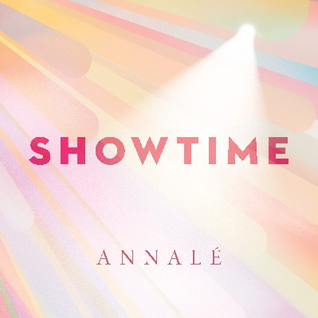

*Showtime is the follow-up to Annalé’s Urban Adult Contemporary Top 20 debut single, “Roses.”*

**Los Angeles, CA (June 12, 2017)** - Annalé is staying true to R&B with the release of "Showtime." The bouncy, feel-good track co-produced by former Mint Condition front man, Stokley Williams showcases the NYC-born beauty's R&B influences and highlight her harmonic voice.

Annalé debut single, "Roses," landed on the Top 20 Urban Adult Contemporary Chart , in fall 2016, with VOGUE hailing it as “one of the year’s [2017] finest R&B ballads.” Since then, Annalé toured the East Coast with Stokley Williams and is gearing up to release her debut self-titled album later this year. “The album will have total of 10 different songs…even though each song is pretty different from one another, they make sense as a collection so I consider the style of my album as a perfect blend of Neo-Soul, R&B and pop.”

The classically trained artist discovered her love for R&B while attending the prestigious Berkley School of Music on a full 5-year Presidential Scholarship. "I wasn’t exposed to the genre until I got to Berklee. In high school, when I found some early 2000’s R&B music, I loved it so much. I loved the groove, harmony and melody in all the R&B songs I found and I tried so hard to find more songs like it," she expresses to Marie Claire.

“I love music that I can feel and am pretty eclectic when it comes to the types of music I love. When I discovered artist like Lalah Hathaway, Erykah Badu, Floetry, India Arie, Norah Jones, Adele, Sadè, Jill Scott, Brian McKnight, Mint Condition, Musiq Soulchild and Lauryn Hill, I felt something almost visceral. Their music, melodies, move and inspire me.”

**Soundcloud Embedded Code:**

With Wordpress

[soundcloud url="https://api.soundcloud.com/tracks/321680953?secret_token=s-pnjmR" params="auto_play=false&hide_related=false&show_comments=true&show_user=true&show_reposts=false&visual=true" width="100%" height="450" iframe="true" /]

Without Wordpress

<iframe width="100%" height="450" scrolling="no" frameborder="no" src="https://w.soundcloud.com/player/?url=https%3A//api.soundcloud.com/tracks/321680953%3Fsecret_token%3Ds-pnjmR&amp;auto_play=false&amp;hide_related=false&amp;show_comments=true&amp;show_user=true&amp;show_reposts=false&amp;visual=true

***###***

For more information and the latest on Annalé, also visit:

Website: <http://www.annalemusic.com/>

Facebook: <https://www.facebook.com/Officialannalemusic/>

Twitter: @annalemusic

Instagram: @annalemusic

**Media Contact:**

Tony Ferguson

Mob: (310) 882 3309

E-mail: [tf.genius@gmail.com](mailto:tf.genius@gmail.com)