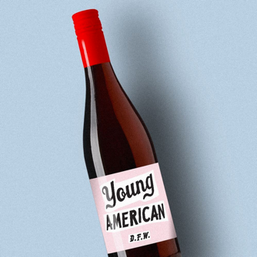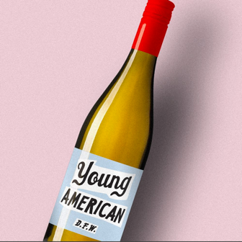

FOR IMMEDIATE RELEASE

7/4/17

CONTACT: Jonathan Boisjolie

EMAIL: [jonathan@youngamerican.wine](mailto:jonathan@youngamerican.wine)

TEL: 404-333-2183

**FINALLY A YOUNG AMERICAN WINE THAT’S DOWN FOR WHATEVER**

**Atlanta, GA** - Freedom comes in different shapes and forms. Ours is in the form of wine and so this 4th of July Young American Wine is born and #downforwhatever.

Decades are defined by current events, pop culture, fashion, personalities, and music. The memories made today become the moments that shape the mind’s eye of the past. Young American Wine is crafted to be the perfect counterpart and companion to creating these memories.

Young American Red Wine and White Wine are two unique blends designed to be different than other wines. To be enjoyed by the newest of wine drinkers as well as the most sophisticated wine expert. Everyone is welcomed to experience wine any way you want. If you enjoy your wine with a cube of ice, we would never tell you no.

Our wines are community, are social and antisocial, shared with friends or kept to yourself, but are always Down For Whatever.

#DrinkFreshServeCold.

For more information about Young American Wine and the August 2017 release in the Atlanta market, visit [www.YoungAmerican.wine](http://www.YoungAmerican.wine) and follow on Instagram [www.instagram.com/youngamericanwine](http://www.instagram.com/youngamericanwine).

**Young American Wine Crafted, Vinted, and Bottled By**:

Young American Wine is bottled by Yonah Mountain Vineyards in Cleveland, Georgia. Making wine since 2006, Yonah Mountain Vineyards is a family run 200-acre farm winery. For more information about Yonah Mountain Vineyards, visit [www.YonahMountainVineyards.com](http://www.YonahMountainVineyards.com).

**Sales and Media Contact:**

Jonathan Boisjolie – Marketing and PR

EMAIL: [jonathan@youngamerican.wine](mailto:jonathan@youngamerican.wine)

TEL: 404-333-2183