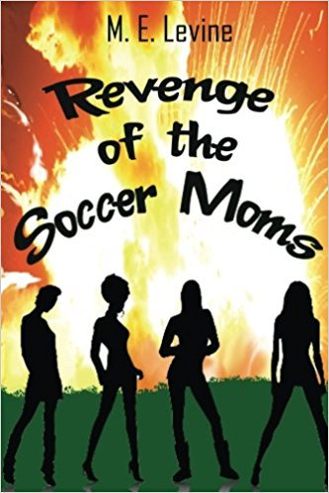

FOR IMMEDIATE RELEASE
July 11, 2017

Contact: Kate Shepherd, 317-442-1674
Kate@KateShepherdCommunications.com

Revenge of the Soccer Moms is Perfect Summer Read
WESTFIELD, INDIANA – Life in the Midwest suburbs inspired Myra Levine’s fun summer book, “Revenge of the Soccer Moms.” The book answers the question, “What if middle-class women set aside good sense and actually did the things they think about doing?”
The dark comedy is set in a Westfield, Indiana subdivision and focuses on a group of smart, funny, stay-at-home moms who meet every week for playgroup. Main character Karma Kranski is far from the picture-perfect housewife. She’s battling her weight, holds the record for late pick-up fees at her daughter’s preschool, and is hiding the existence of her brain-damaged twin sister.
When her daughter is hit by a car speeding past her own house, Karma turns to her playgroup friends to find and punish the driver. After a drunken Tupperware party, the deed is done, which empowers the moms to take on other challenges, including sexual predator teens and a violent husband.
Questions raised by the book include:
- When does Neighborhood Watch become vigilantism?
- Why do some women underestimate men, especially their husbands?
- Can a mother go too far in protecting her child?
- Why is it so difficult to reveal our true selves, even to our best friends?
Levine’s novel takes an amusing, and occasionally dark, look at suburbia, child-rearing, and stay-at-home motherhood.
“I left the business world to become a stay-at-home mom in the suburbs,” author Myra Levine said. “Then I was talked into running for the HOA board, and became the enforcer who would chew out your neighbor so that you didn’t have to fight with them. When there was trouble, I heard about it. But I also met a great bunch of women who’d set aside their careers for a time to raise their kids. Revenge was inspired by those amazing women and lots of crazy, real events.”
The book is available in print and e-book editions on Amazon.com. Levine is currently finishing her second novel, about a woman who dies in her sleep, and joins a club for women who can’t give up mothering even though they’re dead.
###

M.E. (Myra) Levine has pledged to never reveal the identities of those who have inspired the stories in her novel “Revenge of the Soccer Moms.” The novel is available on Amazon in both print and e-book editions. You can learn more about Levine at www.myralevine.com and follow her on Facebook (Revenge of the Soccer Moms) and Twitter @msmyra5.

