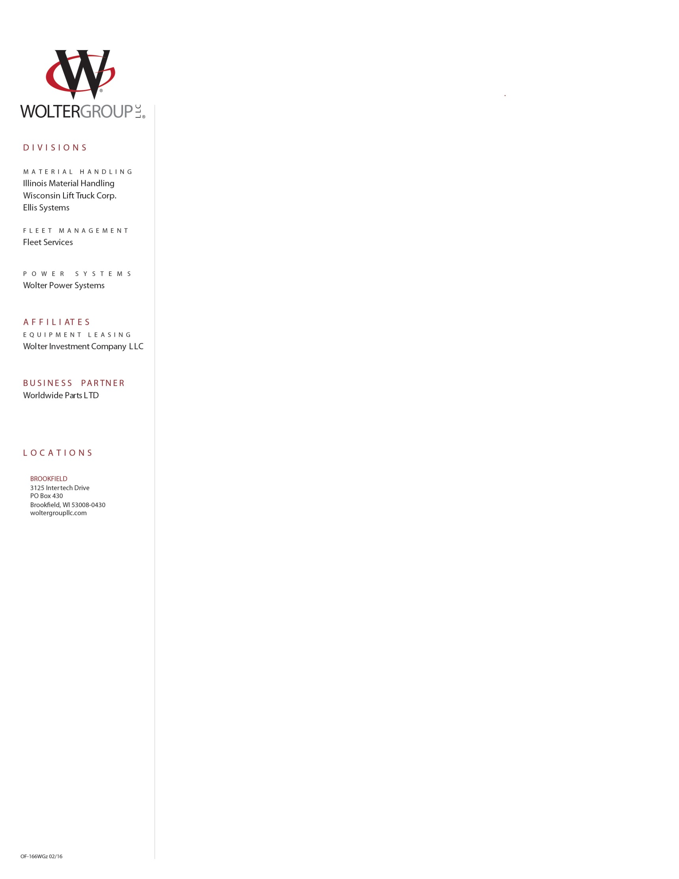

News Release July 10th, 2017

For Immediate Release WLT-0417

**WOLTER GROUP LLC EXPANDS ITS RAIL CAR MOVER BUSINESS**

The Wolter Group’s Wisconsin Lift Truck operations have been in the rail car mover business for over 30 years, offering new, used, rental & reconditioned mobile railcar movers as well as service and parts support throughout Wisconsin & Upper Michigan. Wisconsin Lift Truck services all of the top brands such as Shuttlewagon, Trackmobile, Rail King, Switchmaster & more. Mobile railcar movers are a smart solution for towing multiple railcars loaded or unloaded with ease and are more convenient and cost effective than locomotives.

The trend in mobile rail car movers is to larger equipment with the tractive effort to tow more rail cars. Nordco’s Shuttlewagon business unit introduced the Navigator series in 2013 with a capacity range of 38,000 to 60,000 lbs. of tractive effort. The Shuttlewagon’s Navigator series expands the railcar mover market, providing fresh alternatives to higher-cost-of-operation locomotive power by providing the only mobile railcar mover/shunting applications that exceed 35,000lbs tractive effort, offering unparalleled pulling capability.

Shuttlewagon has appointed the Wolter Group, through its Wisconsin Lift Truck and Illinois Material Handling operations as the exclusive servicing dealer for Shuttlewagon in Wisconsin, Upper Michigan and Northern Illinois. The Wolter Group has over 180 technicians with 13 technicians trained in rail car mover service.

The combination of the Wolter Group’s service capability with the quality and breadth of Shuttlewagon’s mobile rail car mover provides users with the widest selection of equipment, supported by an unmatched service support system.

“This is a great opportunity for the Wolter Group to enhance its mobile rail car product offerings to its customers and to expand our territory into the northwest portion of Wisconsin and Illinois, where we did not have operations previously”, said Jerry Weidmann, President of Wolter Group LLC.

Joel Frank, President of Shuttlewagon expressed excitement with the appointment of the Wolter Group as the servicing dealer in Wisconsin, Upper Michigan and Northern Illinois. “Their extensive service capabilities will greatly enhance service support for our current and future Shuttlewagon users in the market.”

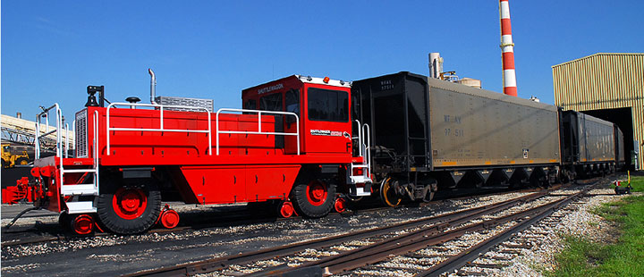



***ABOUT WOLTER GROUP LLC***

*Wolter Group LLC is a family owned and operated group of companies consisting of Wisconsin Lift Truck Corp., Illinois Material Handling, Wolter Power Systems, Fleet Services and Ellis Systems. Through these businesses, the Wolter Group provides parts, rentals, service, and training as well as new and used sales of forklifts, aerial lifts, industrial engines & generators, filing & material storage systems, automated material handling solutions as well as fleet management services. The Wolter Group has a highly trained staff of over 390 employees with an average tenure of 17 years of service who take pride in delivering superior service to over 15,000 customers throughout Illinois, Wisconsin & Upper Michigan. Visit: woltergroupllc.com.*

***ABOUT NORDCO***

*The Nordco family of companies provides an extensive selection of products and services that make it possible for rail-related industries to build, improve, maintain and inspect their track infrastructure and move rolling stock. Nordco, headquartered in Oak Creek, Wisconsin, has a long history as a manufacturer of new and rebuilt railroad Maintenance-of-Way Machinery. Today the company’s product line includes in-house and on-site machinery inspection and repair; reconditioned machinery rental; mobile railcar movers; ultrasonic rail flaw testing equipment and services for railroads and other industries; and replacement parts.*

*Nordco operates manufacturing facilities in Oak Creek, Wisconsin; Ridgefield, Connecticut; Grandview, Missouri; and Arcola, Illinois.*