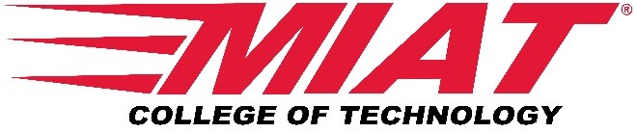

MIAT College of Technology Receives The ACCSC School of Distinction Award
The ACCSC School of Distinction Award recognizes member schools that have demonstrated a commitment to the expectations and rigors of ACCSC accreditation

MIAT College of Technology Houston, TX campus has been awarded the ACCSC School of Distinction Award. As stated on the official ACCSC webpage, “The ACCSC School of Distinction Award recognizes member schools that have demonstrated a commitment to the expectations and rigors of ACCSC accreditation as well as a commitment to delivering quality educational programs to the students, graduates and employers that deserve our best work. Through this award, it is the Commission’s intent to recognize the significant achievement of schools that completed the accreditation process without any findings of non-compliance and having satisfied all requirements necessary to be in good standing with the Commission.”

Houston Campus President John Willis stated, “We are honored by the ACCSC award of a School of Distinction. This type of award recognizes our daily efforts to always strive ‘to do what is best for our student.’ The rigor of the ACCSC standards ensure that we make decisions every day that are focused on compliance and the outcomes of our graduates. We look forward to participating in the awards ceremony and continuing the daily focus of compliance.”

About MIAT College of Technology

MIAT College of Technology was founded in 1969 and operates a 125,000 square foot facility in Canton, Michigan and a 40,000 square foot facility in Houston, Texas. In addition to Aviation Maintenance Technology, MIAT offers programs in HVACR, Energy, and Global Logistics and Dispatch. The school's Aviation Maintenance Technology-AAS degree, Airframe and Powerplant Technician certificate, and Aviation Dispatch course, are FAA certificated and NCATT accredited.

MIAT College of Technology has helped thousands of individuals acquire the industry-relevant skills, experience, and connections it takes to pursue rewarding technical careers. After almost 50 years in technical career education, MIAT has built an excellent reputation and strong working relationships with top employers. MIAT programs are developed in direct response to feedback from industry leaders looking for qualified employees, and the school collaborates with these employers to tailor its programs to fit industry needs. MIAT graduates feel confident and fully prepared to make a smooth transition into the workplace after getting so much industry-influenced, practical training.

