THE RHINOS NEED US

Corporate Software Services recently teamed up with Kevin Pieterson, a Surrey Cricket Superstar, in advocating and bringing awareness to saving the Rhinoceros, a critically endangered species that are being poached for their horns. The data team has scouted the web∗ and compiled the current statistics on the rhinos. Here are what we found:
Poaching has declined but still high and unacceptable
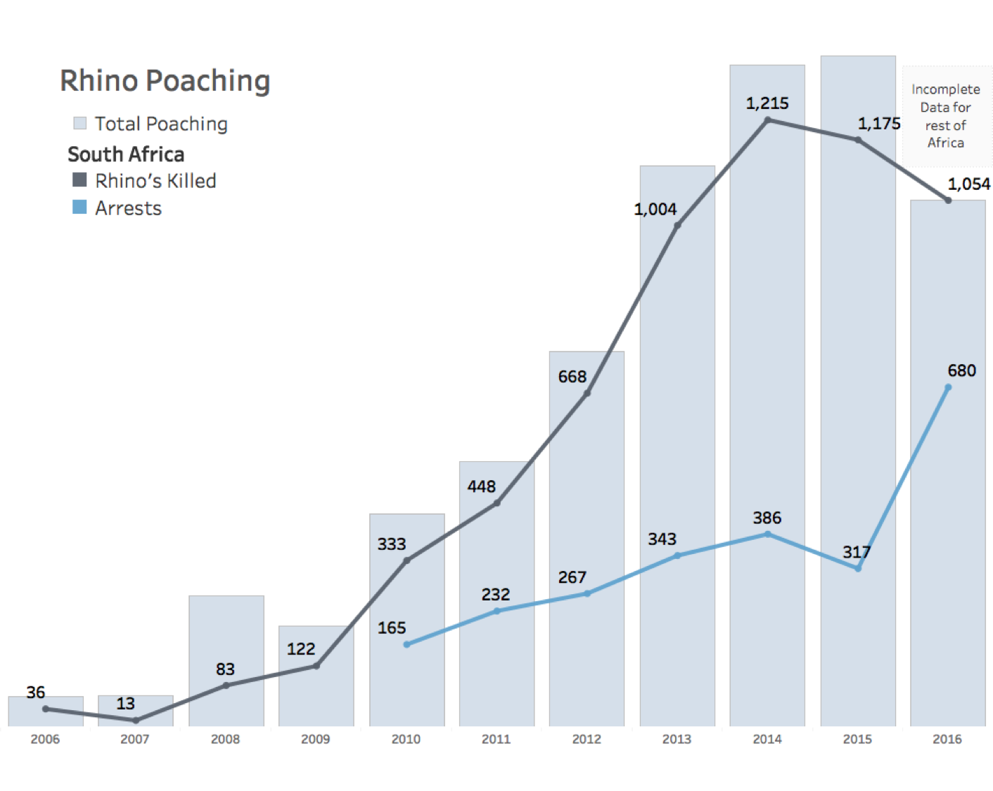In South Africa, where Rhino poaching is most prevalent, the number of Rhinos poached has declined from the peak in 2014. However, the most recent count of 1054 (2.88 rhinos/day) is still 29 times more than the reported number in 2006, leaving an unknown count of orphaned baby rhinos. We need to do more to achieve ZERO rhino poached per day to ensure the survival of this endangered species.
Increased patrolling is not enough
The data team tested the hypothesis that if increased arrest correlates with fewer rhinos poached. Unfortunately, although the increased number of arrests in 2016 led to fewer rhinos poached, we did not find any statistically significant relationship between the arrest and the number of rhinos poached. This implies that either more patrolling is needed or more education or both. We are cautiously optimistic about 2017 data for a revisit of this issue.

Where raised awareness can help
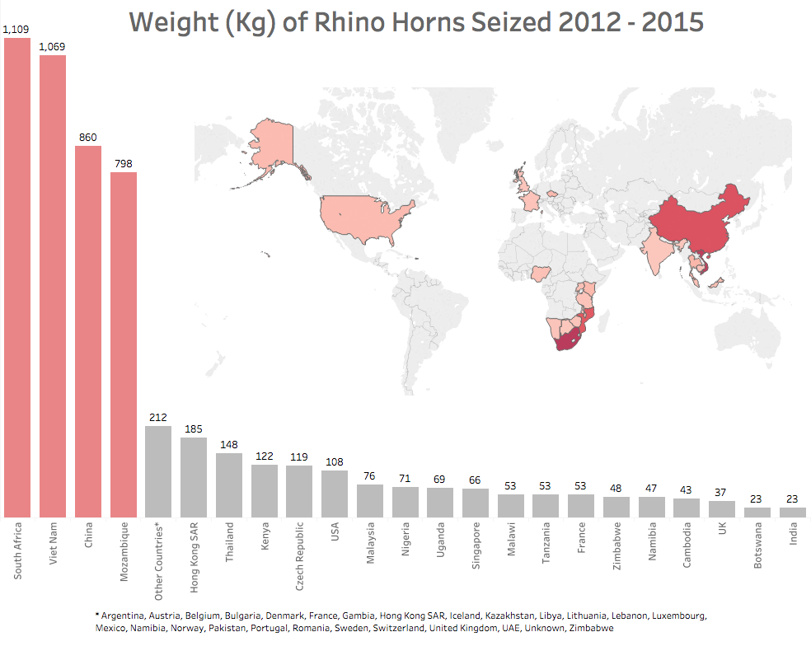
The increased incidence of Rhino being poached has been reported to follow the demand for their horns, which are being bought as trophies or most particularly as deluded cure for hangover and cancer. By looking at the market for rhino horns, we can identify areas where conservation awareness and education effort can help.
From the heat map, number one is South Africa and number two is Viet Nam. The education efforts focus on raising awareness (in South Africa) of how Rhinos are important to the ecosystem and convincing people (in Viet Nam and Asia) that rhino horns, which are made of the same material (keratin) found in hair and nails, offer no medicinal values.
How can you get involved?
Ongoing conservation efforts could really use both your time and support. We list the several reputable organizations to help you learn more.

Name | Country
Save The Rhinos | England
International Rhino Foundation | USA
Project Rhino KZN | South Africa
San Park Ranger Corps | South Africa

∗ https://cites.org/sites/default/files/eng/cop/17/WorkingDocs/E-CoP17-68-A5.pdf https://www.environment.gov.za/mediarelease/molewa_progressonintegrated_strategicmanagement_ofrhinoceros

