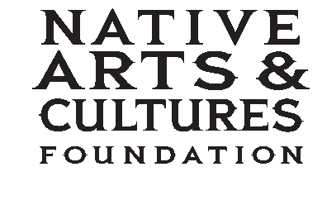

For Immediate Release

Media Contact: Rupert Ayton
(503) 445-4848 / Rupert@nativeartsartsandcultures.org

For press image contact: Elizabeth Madrigal
(360) 334-7260 / elizabeth@nativeartsandcultures.org

NATIVE ARTS AND CULTURES FOUNDATION OPENS NATIONAL ARTIST FELLOWSHIP CALL FOR SUBMISSIONS

Vancouver, Washington: August 9, 2017

The Native Arts and Cultures Foundation has issued an open call for submissions for its 7th year of National Artist Fellowships. The fellowship awards up to $20,000 to American Indian, Alaska Native, and Native Hawaiian artists who demonstrate exemplary skill and exceptional quality of work in any one of the following five categories: Traditional Arts, Music, Visual Arts, Artistic Innovation and Literature.

Eligible applicants will be Native artists who both reside in the U.S. and are enrolled citizens of a U.S. federally or state recognized American Indian Nation, Alaska Native Corporation or with other documentation of Native Hawaiian ancestry. A panel of art peers and professionals review the applications for recommendation to the foundation’s board.

“The National Artist Fellowship continues to support many compelling, inspiring and astounding American Indian, Alaska Native and Native Hawaiian artists nationwide. We have awarded a notable list of National Artist Fellows since 2010. And as we see the rise in spoken word, blended art forms, creative mix of contemporary/traditional materials and exploration of technology, we anticipate another remarkable pool of Native artist applicants in the Contemporary and Traditional art fields,” says Francene Blythe (Sisseton-Wahpeton Dakota, Diné, Eastern Band Cherokee), director of programs at the foundation. “We are always humbled and honored by the artists and the work we see submitted each year.”

Through the National Artist Fellowship, the foundation recognizes Native artists who are making a significant impact in their discipline, who are respected by their colleagues and the greater arts field, or who may be emerging as powerful voices in the arts. Awarded National Artist Fellows also work with their communities and share their culture in numerous ways. The award is designed to support Native artists as they explore, develop and experiment with original or existing projects.

Native artists may find the online application at www.nativeartsandcultures.org/programs/funding-opportunities
The open call closes at 5 p.m. PT, Monday, September 25, 2017.

About Native Arts and Cultures Foundation
The Native Arts and Cultures Foundation’s mission is to promote the revitalization, appreciation and perpetuation of American Indian, Alaska Native and Native Hawaiian arts and cultures through grant making, convening and advocacy. To date, the foundation has supported 255 Native artists and arts organizations in more than 30 states and the District of Columbia. To learn more about the National Artist Fellowship and the Native Arts and Cultures Foundation—nurturing the passion and power of creative expression, visit: www.nativeartsandcultures.org.

# # # #

