DRAFT

Media Contact:

Sharon Gallagher

215-766-1211

EarthRes Hosts Congressman Brian Fitzpatrick at its Bucks County, PA Facility

Pipersville, PA – August 21, 2017 - EarthRes, a 75-person full-service engineering and consulting firm headquartered in Bucks County, Pennsylvania and member of the International Bottled Water Association (IBWA), hosted Bucks County Republican Congressman Brian Fitzpatrick (PA-08) on a tour of its LEED-certified Bucks County facility today and met to discuss issues facing small businesses, groundwater supply and the bottled water industry. Also in attendance was IBWA Director of Science and Research, Albert Lear.

EarthRes management and their team of engineers and scientists showcased their technical expertise in mining, solid waste, energy and water resource management and discussed groundwater safety and bottled water initiatives, as well as took Congressman Fitzpatrick on a tour of their LEED Silver-certified facility. The EarthRes office is an environmentally friendly, state-of-the-art facility that includes a ground source geothermal heating/cooling system, rainwater harvesting system and on-site sewage treatment plant.

After a meeting with EarthRes management, EarthRes employees and Congressman Fitzpatrick headed outdoors to witness the solar eclipse. EarthRes employees were then invited to a Q&A in which Congressman Fitzpatrick outlined his office’s position and answered questions regarding his initiatives on issues facing both Bucks and Montgomery Counties, as well as Pennsylvania, and the nation.

“We are very excited to have had the opportunity to introduce our small business, discuss local and national water issues and showcase our firm’s capabilities and environmentally-friendly LEED Silver-certified facility with Congressman Fitzpatrick,” states Jan Hutwelker, President of EarthRes. “We feel Congressman Fitzpatrick is dedicated to supporting small business, invoking change with groundwater regulation and safety and are honored that he took time out of his schedule to visit our office here in Bucks County.”

“When our local small businesses succeed, they create jobs, invigorate our communities, and preserve the distinct character of our local economy. As a Certified Public Accountant (CPA) and member of the House Committee on Small Business, I’m committed to visiting 100 small businesses across Bucks and Montgomery Counties this year, and every year, to better appreciate the needs of local small businesses and to help them create good paying jobs right here in our community,” said Fitzpatrick. “I’m grateful for the opportunity to visit with EarthRes and learn about their important work here in our region, and to have a chance to speak with the staff about the issues most important to them.”
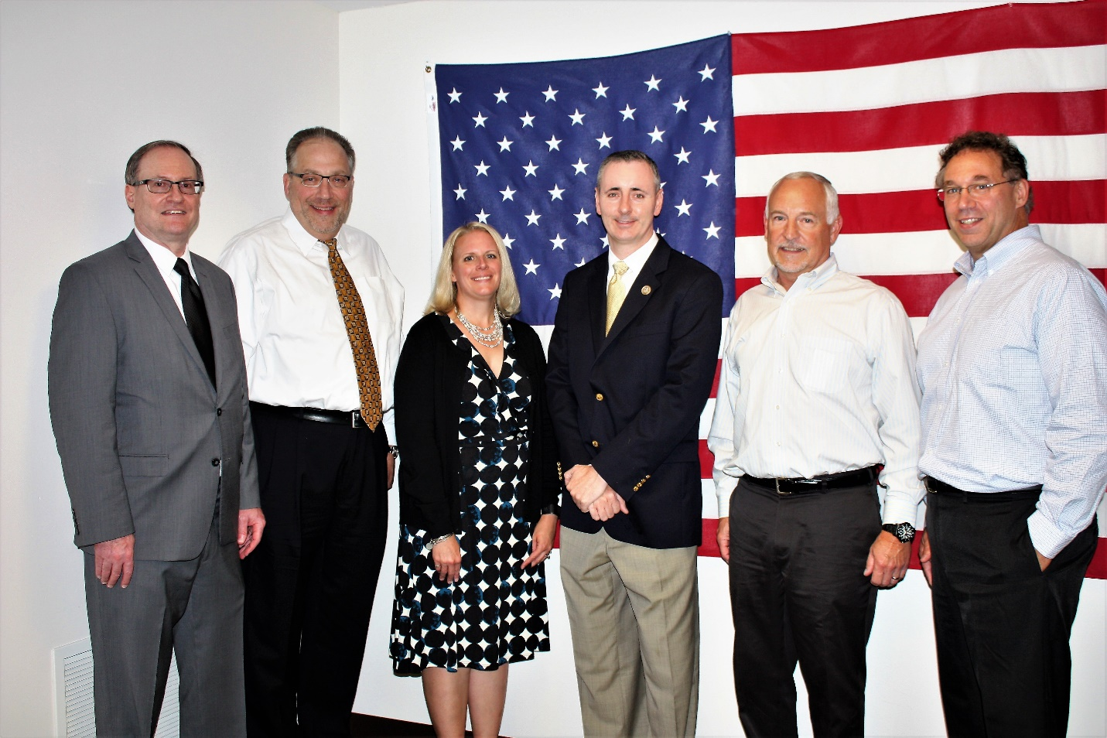Photo 1: Caption: Touring the EarthRes Facility in Bucks County PA. Featured (Left to Right) IBWA Director of Science & Research, Albert Lear; EarthRes Senior Project Manager, Thomas Pullar; EarthRes Senior Project Manager, Jillian Olsen; PA Republican Congressman Brian Fitzpatrick; EarthRes President, Jan Hutwelker; and EarthRes Vice President Louis Vittorio.

For more information on EarthRes, visit www.EarthRes.com or 800-264-4553.

Serving clients in the Solid Waste, Mining, Oil & Gas, Government, Industrial and Commercial sectors, EarthRes delivers innovative and integrative engineering solutions that keep our clients successful. With offices in Pipersville,

PA and Morgantown WV, EarthRes takes pride in our unique ability of being able to establish long term client relationships through a culture of trust, sound ethics, open communications and solid project management principles.

