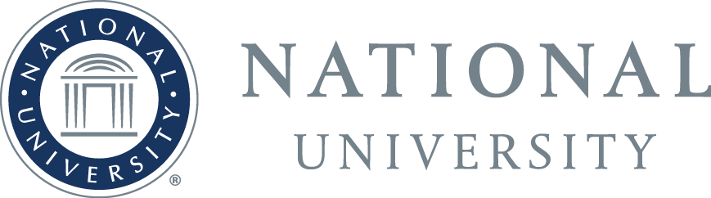

A Private Nonprofit University Serving the Public Good™

City of San Diego/National University Professional Development Scholarship Makes Positive Impact in Community

San Diego, Calif. – August 28, 2017 – As the first recipient of the City of San Diego/National University Professional Development Scholarship, city employee Nicole McNeil demonstrated her determination to achieve her education goals, graduating this June while giving back to the local community. Her success represents the spirit of an education-focused collaboration launched in 2015 that expands educational opportunities to city employees through National University’s designation as the City of San Diego’s Preferred Employee Education Program Partner.
Through the initiative, City of San Diego employees are offered a 15 percent tuition scholarship, a portion of which are matched by tuition assistance – and the chance to qualify for the more competitive Professional Development scholarship, which recognizes employees who demonstrate an exceptional commitment to public service and giving back to the San Diego community. McNeil is one of a number of city of San Diego employees who are benefitting from the partnership, with the chance to pursue their dreams in specialties such as business and cybersecurity. City of San Diego employees can learn more: https://www.nu.edu/citysd/pdf/City_of_San_Diego_eb.pdf
“I feel fortunate to have been given this opportunity to further my education, which enables me to better serve the San Diego community while advancing my career,” said McNeil. “It is challenging to work full-time while going to school but National University was very supportive and set me up for success.”
While pursuing her degree at National University, which is among the largest private universities in California, McNeil worked as a pool manager for the City of San Diego. Applying newly-learned skills from her degree program, McNeil created and promoted drowning-prevention initiatives that enhanced aquatic safety for San Diegans of all ages, even receiving a national award for her efforts. McNeil recently graduated with a Bachelor of Arts in Integrated Marketing Communications from the National University School of Business and Management. Her story demonstrates the value of lifelong learning, and National University’s commitment to developing education partnerships with the communities it serves, including the public sector and other entities that serve the public good.
“National University is proud to be the Preferred Employee Education Partner of the City of San Diego,” said National University President Dr. David Andrews. “I was thrilled to see Nicole receive her degree and am pleased that we can offer City employees access to a quality education that ensures San Diego’s continued development as a place of opportunity and innovation.”
Scott Chadwick, City of San Diego Chief Operating Officer, concurred: “Through this scholarship opportunity, National University helps the City fulfill its mission to effectively serve and support our communities. We are grateful for National University’s commitment to the professional development of our workforce, and are so proud of Nicole for reaching this significant milestone in her career.”
McNeil’s dedication to serving the San Diego community combined with her educational accomplishments resulted in a recent promotion in which she oversees approximately 100 staff across 6 of the City’s 13 pools. As the lead organizer of all large-scale aquatic and recreational events at the City Heights pool, McNeil collaborates with the San Diego Fire Department, San Diego Police Department, Rady Children’s Hospital, and an array of community groups and nonprofit organizations on a regular basis. Through her many San Diego connections, McNeil helped secure an author for the Pool Safety Act, which could save many children’s lives in the state of California. McNeil has earned numerous commendations and awards of excellence from the City, and has been called on by the American Red Cross to share her drowning-prevention knowledge at a national level. In addition, McNeil’s exceptional work in the field of drowning prevention earned her the 2017 Community Lifesaver Award at the 16th Annual Drowning Prevention Educational Conference in April 2017.
McNeil, who is the 2015 recipient of the Development Scholarship, plans to return to National University to pursue a master’s degree in public administration with a specialty in organizational leadership so she can further advance her career and continue to foster positive programs in the local community. The 2016 recipient of the Development Scholarship is San Diego Fire-Rescue Dept. Lt., Andy Lerum, who has been at the forefront of bringing the latest technology to the city’s lifeguard division.
National University has long been an educational leader in California, and about 25 percent of San Diego Unified School District principals are National University alumni as are former San Diego Mayor Jerry Sanders, now President and CEO of the San Diego Chamber of Commerce; and former San Diego City Councilwoman Marti Emerald. San Diego City Council President Myrtle Cole, who served as the keynote speaker for National University’s 2017 commencement ceremony at Petco Park, is also an alumna of National University.
About National University
Founded in 1971, National University is one of the largest private, nonprofit universities in California. With more than 150,000 alumni, National University is the flagship institution of the National University System. National University is dedicated to making lifelong learning opportunities accessible, challenging and relevant to a diverse population of students. Four schools and two colleges – the College of Letters and Sciences; the Sanford College of Education; the School of Business and Management; the School of Engineering and Computing; the School of Health and Human Services; and the School of Professional Studies – offer more than 100 graduate and undergraduate degrees and 13 teacher credentials and licensures. Programs are offered at locations throughout California and across the nation, and are also available online. National University is headquartered in La Jolla, California. www.nu.edu/

