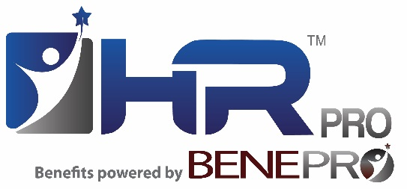
FOR IMMEDIATE RELEASE
Contact: Jennifer Wajeeh
Phone: 248-556-7972
Email: jwajeeh@hrpro.biz

HRPro/BenePro has been named to the 2017 list of “Metropolitan Detroit’s Best and Brightest Companies to Work For®.”

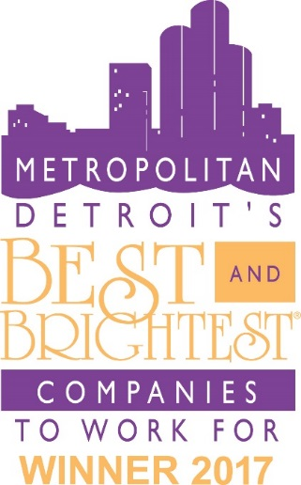
Royal Oak, MI – August 30, 2017 – The Best and Brightest Companies to Work For® competition identifies and honors organizations that display a commitment to excellence in their human resource practices and employee enrichment. Organizations are assessed on categories such as communication, work-life balance, employee education, diversity, recognition, retention and more. The Best and Brightest programs identify, recognize, and celebrate the organizations that epitomize Better Business. Richer Lives. Stronger Communities.

Kristopher Powell, CEO/President of HRPro/BenePro says this award proves what he already knew, that his employees are some of the best in the area and together form an amazing team.

“We’re proud to be selected as one of the best and brightest companies in Metro Detroit to work for. This recognition continues to reinforce our commitment to our employees and our goal to have a relaxed, productive work environment. Our mission is to help other companies take care of their people and to achieve this, we must first take care of our own. We feel our company is not only one of the best and brightest to work for, we also have a staff of some of the best and brightest in Michigan and are excited and proud to share this award with them.”

To see the complete 2017 List of the Best and Brightest Companies to Work For®, visit 101bestandbrightest.com.

About HRPro/BenePro
HRPro/BenePro is one of Michigan's top HR and benefit advisory and administration firms, offering a Total People Solution for small to mid-sized companies. HRPro/BenePro strives to create a fun, collaborative culture that puts an emphasis on customer relationships and personalized service. Recently celebrating their 27-year anniversary, they are constantly working to stay ahead of latest trends and needs in the industry. Their mission is to work closely with organizations to understand and help them achieve their human capital goals, increase productivity, increase employee morale, ensure compliance and build a strong, lasting HR foundation. For more information visit the company’s website at www.hrbenepro.com.

