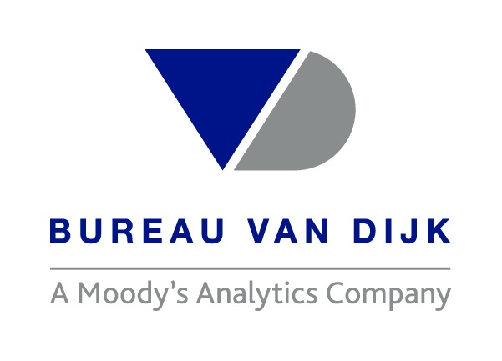

**North American M&A value jumps by a quarter month-on-month**

**PE and VC value was second-highest for the last 12 months**

***Zephyr reports on North American M&A and private equity activity in August 2017 –*** [***access report***](https://www.bvdinfo.com/BvD/media/reports/North-America-August-2017.pdf)

**August 1st 2017, New York, NY** – There were a total of 1,928 mergers and acquisitions (M&A) worth a combined USD 133,002 million targeting North American companies announced in August 2017, according to information collected by the leading M&A database Zephyr. Value for the same period advanced by almost a quarter from USD 107,728 million in July against a marginal 2 per cent decline in volume from 1,974 deals. Year-on-year, volume was down 11 per cent from 2,172, while value was up 2 per cent from USD 130,761 million in August 2016.

Zephyr shows that all of August’s top 20 deals by value comprised US targets, with Sempra Energy’s acquisition of 60 per cent of Energy Future Holdings for USD 18,800 million accounting for the month’s largest M&A deal by value. Acquirors from outside the region featured in the top 20 North American deals by value included Softbank and Fresenius Medical Care.

Deals within the gas, water and electricity sector quadrupled month-on-month from USD

8,028 million to USD 36,540 million, which accounted for 27 per cent of North America’s total value of USD 133,002 million.

Lisa Wright, Zephyr director, commented, “It is refreshing to see a series of high-value deals being announced in a month typically viewed as a holiday season, especially as a couple of these were private equity investments. We will have to wait and see if this increased interest continues through to the end of the year.”

The Zephyr database shows that the value of PE and VC investment targeting companies based in North America almost doubled month-on-month to USD 39,704 million – representing the second-highest recorded for the 12 months under review and a 23 per cent increase year-on-year (August 2016: USD 32,228 million).

The overall improvement can be attributed to an increase in the value of PE and VC investment in US companies, which rose to USD 39,595 million in August from USD 21,041 million in July.



*Lisa Wright, Zephyr director*  [Click here to access report](https://www.bvdinfo.com/BvD/media/reports/North-America-August-2017.pdf)

**Ends**

**For more information please contact:**

Zephyr Editorial

* Tel: +44 (0)161 838 9552
* [Email us](mailto:zephyreditorial@bvdinfo.com)
* [Get the full report](https://www.bvdinfo.com/BvD/media/reports/North-America-August-2017.pdf)
* [Access the raw data used in the report](http://www.bvdinfo.com/BvD/media/reports/NorthAmericaAugust2017.xls)
* [Download a high-res photograph of Lisa Wright, director of Zephyr](http://www.bvdinfo.com/getmedia/37ecb560-002b-47da-8817-c5fd3026598c/LisaWright-Zephyr.aspx)

**Notes to Editors:**

**About the data**

1.    Activity is based on the activity of the target country

2.    The date range for August 2017 is deals announced between 01/08/2017 – 31/08/2017 inclusive

3.    The sector breakdown uses targets’ activities as defined to be ‘Major Sectors’ by Zephyr

**About Bureau van Dijk**

The leading provider of the richest, most reliable private company, corporate ownership and deal information in the market, Bureau van Dijk is in the business of certainty.

Bureau van Dijk’s product range combines data from regulatory and other sources, including 150 information partners, with flexible software to allow users to manipulate data for a range of research needs and applications. Its Orbis database provides information on more than 240 million companies across the globe.

In addition, Bureau van Dijk addresses specific business challenges through its range of Catalysts including M&A research and valuations, KYC, client on-boarding, credit, procurement, and transfer pricing, while its Custom division delivers bespoke solutions. <http://www.bvdinfo.com/corporatefinance>

**About Zephyr**

Zephyr is an information solution containing M&A, IPO and venture capital deals and rumours with links to detailed financial company information. Winner of numerous recent M&A industry awards, including Best Global M&A Database 2016 at the Acquisition International M&A Awards, Zephyr is published by Bureau van Dijk. The deals on Zephyr are linked to the company financials and peer reports on Bureau van Dijk's product range. Zephyr contains information on over 1.4 million deals.

[More information on Zephyr](http://www.bvdinfo.com/en-gb/our-products/economic-and-m-a/m-a-data/zephyr)

**About M&A Research Catalyst**

Drawing data from Orbis and Zephyr, M&A Research Catalyst delivers clear and easy-to-interpret reports specifically created for M&A research. They combine information on companies, comparable deals and valuations alongside an interface to help you identify targets, or acquirers, and value companies. M&A Research Catalyst provides you with M&A-tailored information in an easy-to-interpret report, including: financials; earnings estimates; news and deals; comparable companies and deals; DCF valuation; and valuation multiples. [www.bvdinfo.com/ma-catalyst](http://www.bvdinfo.com/ma-catalyst)