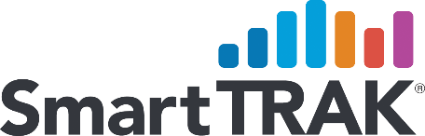

BioMedGPS Announces Expanded European Market Coverage with SmartTRAK EU Trauma and EU Extremities

BioMedGPS, the leading provider of real-time analytics and strategic intelligence of the orthopedic/spine, wound care, regenerative medicine and neuro therapies markets, announces expanded coverage of SmartTRAK Business Intelligence for the European market with the addition of modules in SmartTRAK EU Extremities and EU Trauma.

SmartTRAK EU Extremities and EU Trauma provide up-to-date market data — each including reports for Europe and five of the largest EU markets: UK, Germany, France, Italy and Spain — with market and procedural projections, markets forecasts, competitive overviews, and more. SmartTRAK EU Extremities covers the $1.03B extremity fixation and joint arthroplasty markets including shoulder, elbow, wrist, finger, ankle, and toe replacement. The $687 million SmartTRAK EU Trauma market delves into IM nailing, plates & screws, cannulated screws and external fixation devices.

“The EU Trauma & Extremities markets represent 23% of the global market,” reports Lisa Mahan, Vice President, Content Development – Orthopedics. “The four largest companies represent approximately 70% of the WW Extremities Market and 80% of the WW Trauma market, with the remainder split between low cost local suppliers and specialist niche companies.” SmartTRAK covers all players in the orthopedic markets including both the large dominant firms such as Stryker, DuPuy Synthes, Zimmer Biomet, Smith & Nephew, and Medtronic as well as the emerging firms such as 4WEB. Medical, Paragon, and Tissue Regenix Group and much more.

SmartTRAK has become an integral resource for some of the largest medical device companies currently used by the top ten orthopedic/spine implant manufacturers and nine of the top ten wound care companies. A key differentiator for SmartTRAK is its team of industry experts who are all former marketing, business development, and competitive intelligence professionals at leading medical device firms. The lead analysts for the EU SmartTRAK Extremities and Trauma modules previously held positions with DePuy Synthes and Stryker.

Please read, with our compliments, an in-depth article by Natasha Weeks, Managing Editor/Sr. Analyst Trauma & Extremities, regarding “New Products and Acquisitions in the Foot and Ankle Market.”

About BioMedGPS, LLC

BioMedGPS, LLC is the developer of SmartTRAK Business Intelligence, the leading portal for real-time data and analysis on the life sciences industry. Known for expert analysis and innovative tools, SmartTRAK provides daily updates, strategic insights, and in-depth analyses of the orthopedics, wound care, regenerative medicine and neuro therapies markets. For more information about SmartTRAK please visit SmartTRAK.com.

CONTACT

Media

Rebecca Gonzalez

(714) 328-9999

rebecca.gonzalez@smarttrak.com

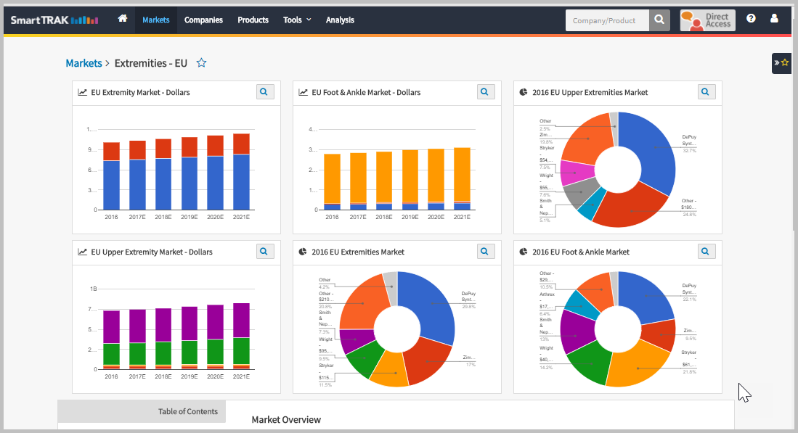

SmartTRAK EU Extremities Charts and Graphs

