C² Technologies Names Manik Rath as Chief Operating Officer

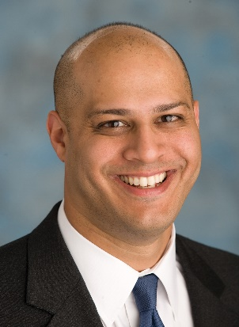
Tysons, VA, September 12, 2017 — C²Technologies, Inc., a global leader in training, human capital management and information technology, services, dedicated to improving human performance, announced today that Manik K. Rath will become its Chief Operating Officer.

“We were amazed by the extraordinarily talented people vying for this position. We are excited to have Manik join C^{2,} and confident that Manik’s proven leadership and experience will enable us to expand our impact on our customers,” said Dolly Oberoi, C² Technologies’ CEO.

Mr. Rath has a law degree from the University of Virginia and brings over 20 years of experience in IT, human capital and management consulting for public sector clients including Defense and intelligence agencies. Mr, Rath joins C² after serving as Senior Vice President for LMI, and Co-Founder of Alion Science and Technology.

Manik Rath is a corporate growth leader who has helped public and private companies develop and execute accelerated growth strategies, having led more than 20 acquisitions. Mr. Rath served LMI as Senior Vice President, a federal logistics, management and IT, consulting firm headquartered in the Washington, D.C. area with over 1,300 professional consultants, engineers, and employees worldwide.

Before joining LMI, he was a co-founder and Vice President of Alion Science and Technology Corporation. Before joining the founding team of Alion, Mr. Rath advised public and private companies ranging from the Fortune 100 to start-ups.

Mr. Rath serves on multiple boards including the Board of Directors of the Northern Virginia Chamber of Commerce, the Foundation for Fairfax County Public Schools and former Chairman of the Association of Corporate Growth (ACG). He also serves on the Board of Advisors of Credence LLC, ThreatSwitch and Hill Top Security Inc., a cyber security startup.

Manik Rath said “C² Technologies has a tremendous reputation amongst its customers for developing and delivering highly differentiated and mission-critical services and tools. I feel privileged to being a part of their mission.”

About C² Technologies, Inc.
C² (www.c2ti.com) is an internationally recognized company dedicated to human performance improvement. For more than 28 years, C² has developed award-winning training, human capital and IT solutions, using industry best practices to enhance the performance of Government and private-sectors clients.

