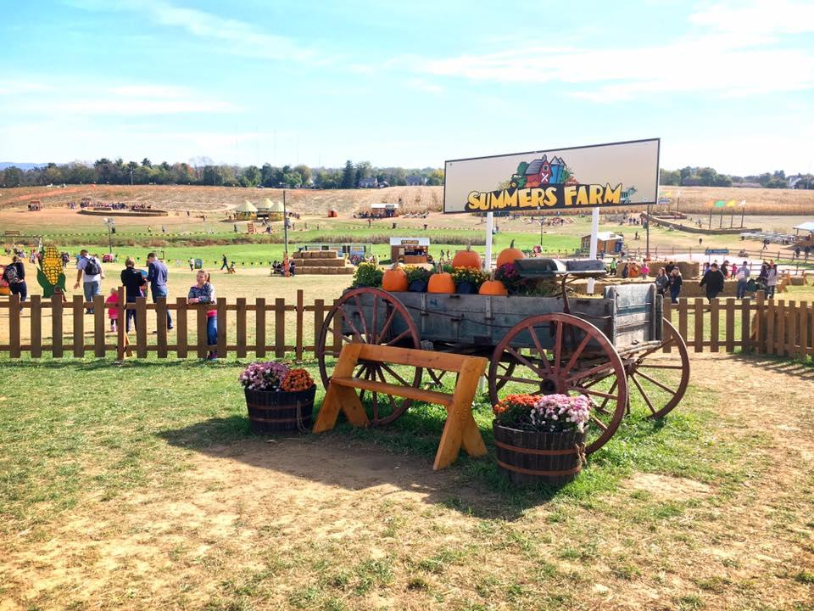
Summers Farm’s 2017
Calendar of Events

Heroes Weekend
September 23-24 | Summers Farm – 5620 Butterfly Lane, Frederick, Maryland 21703 301-620-9316 www.SummersFarm.com
This weekend, active duty members and veterans of the United States Armed Forces and First Responders (firefighters, EMT’s, police) are admitted FREE with valid identification. Immediate family members are admitted at half price. Throughout the remainder of the season, we are proud to offer these heroes and their families a 20% discount on tickets. Homegrown fun and farm fresh adventures await at Summers Farm in Frederick, Maryland. Attractions include Military themed cornfield maze, live entertainment, wagon rides, pig races, jumping pillows, farm animals, pick your own pumpkins, slides...and more! Enjoy nights at the farm with our flashlight corn maze or reserve a campfire site. Visit www.SummersFarm.com or call 301-620-9316 for more information about hours and ticket prices.

Maryland Pumpkin Festival
October 7-8 | Summers Farm – 5620 Butterfly Lane, Frederick, Maryland 21703 301-620-9316 www.MarylandPumpkinFestival.com Teresa@SummersFarm.com
The Maryland Pumpkin Festival will be held October 7th and 8th at Summers Farm in Frederick, Maryland. The weekend will feature a host of special events and entertainment celebrating all things pumpkin! In addition to our corn maze, pumpkin patch, wagon rides, slides, farm animals, jumping pillow and homemade pumpkin donuts, the Festival will feature live entertainment, free face painting, a pumpkin hunt, pumpkin sculpturing demonstration, Saturday night fireworks and much more! The Maryland Pumpkin Festival is part of the annual fall harvest festival at Summers Farm located at 5620 Butterfly Lane in Frederick Maryland. Visit www.MarylandPumpkinFestival.com or call 301-620-9316 for more information.

21st Annual Fall Harvest Festival at Summers Farm
September 23– October 31 | Summers Farm – 5620 Butterfly Lane, Frederick, Maryland 21703 301-620-9316 www.SummersFarm.com
Homegrown fun and farm fresh adventures await at Summers Farm in Frederick, Maryland. Fall farm attractions include Military themed cornfield maze, live entertainment, wagon rides, pig races, jumping pillows, farm animals, pick your own pumpkins, slides...and more! Enjoy nights at the farm with our flashlight corn maze or reserve a campfire site. Starting Sept. 30th, every Friday and Saturday night will feature fireworks. Fun for kids from 2 to 92. Open September 23th – October 31st. Visit www.SummersFarm.com or call 301-620-9316 for more information about hours and ticket prices.

