Media Contact:
Justina Nielsen | 310.845.6892
PR@TowneParkBrew.com

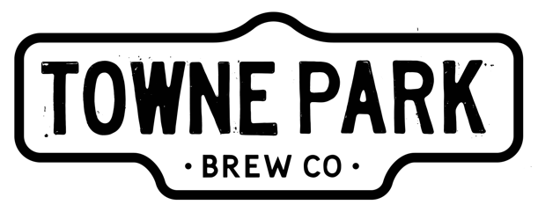

There’s a New Beer in Towne!

ANAHEIM, CA (Sept. 25, 2017) – Towne Park Brew is proud to announce the opening of their flagship brewery in Anaheim, California. On Friday, Sept. 22, 2017, Brett Lawrence was joined by Anaheim’s Mayor Tom Tait to ceremonially cut the ribbon to one of the largest and most notable craft breweries in the area. Towne Park is proud to unveil their impressive 20,000-square-foot, 30-barrel brewhouse to the public with a weekend full of festivities. Following the ribbon-cutting on Friday, Towne Park hosted a series of events for the opening weekend. The Anaheim community joined Towne Park for their Official Opening Day on Saturday featuring a performance from Smith Band, food trucks and beer. And again, on Sunday for Classic Cars of Towne; a day full of classic cars, BBQ, beer and old-school hip-hop.

Ribbon cutting ceremony with Mayor Tait and Towne Park Team

Towne Park will continue to host weekly events and specials.

MONDAYS- Industry Night – Football and Friends. Featured beer: Pale Ale.
TUESDAYS- Taco Tuesday- Tacos & Tunes. Featured beer: American Lager.
WEDNESDAY- Trivia Night- Brew & Brain Teasers. Featured beer: White Ale.
THURSDAY- Cask Night- Tap that cask! Featured Beer: Limited Edition.

FRIDAY- TGIF- Good times & Unwind. Featured Beer: IPA.
SATURDAY- Why Not?! Beer, Beer & More Beer. Featured beer: Blonde Ale.
SUNDAY- Classic Cars- Cars, Brews & Grooves. Featured Beer: Amber Ale.

Situated next to the train tracks in the heart of “upTOWNE” Anaheim, the brewery is a welcoming indoor and outdoor setting housing Towne Park’s barrels and tasting room, a private event space, as well as kegging, canning and bottling-line operation. When the industrial doors are rolled up, hops and good times fill the old train-station-inspired tap room, serving as the perfect location for brewery tours, community events and private parties.

Towne Park Brew was founded by Brett Lawrence, an Orange County native and entrepreneur, who started Towne Park from nothing but a home-brew kit and a passion for a good, cold beer. During the last four years, Towne Park Brew focused on perfecting their recipes based on feedback from family and friends, who had experienced the early brews at Rancho Las Lomas, a Lawrence-family event property. Inspired by the pioneering spirit of his family and his love for a quality, drinkable beer, Lawrence wanted Towne Park to be something more than just another startup craft brewery. With the help of an incredible team, he set out to build a business from the ground up. Lawrence recruited Jeremy Mayo, a seasoned brewer and craft-beer expert, to ensure that Towne Park’s beer is not only flavorful and unique, but exceptional in taste and enjoyed by both beer savants and those in search of something new.

With Lawrence’s vision and Mayo’s expertise, Towne Park is proud to publicly unveil their take on six of the most iconic beers. Towne Park aims to be recognized for the bold flavors that craft beer is proud to represent without the heaviness that consumers have grown to accept. The brewery will debut something for every beer-drinker’s palate: an American lager, an India pale ale, a white ale, a pale ale, an amber ale and a smooth blonde ale derived from the original blonde ale that Lawrence home-brewed back in 2013. The new Towne Park brewing facility is equipped to produce about 20,000 barrels annually.

The entire portfolio of Towne Park cans, bottles and kegs will be available this fall throughout Southern California. The Towne Park brewery will also keep 10 additional and exclusive styles on draft rotation in the taproom for the thirsty enthusiast. Towne Park is open seven days per week.

Towne Park Brew
1566 West Lincoln Ave.
Anaheim, CA 92801

For more information about Towne Park Brew, please visit www.towneparkbrew.com and @TowneParkBrew.

About Towne Park Brew
Towne Park Brew was founded on the belief that good beer reflects the community it creates. We believe beer brings us together; it doesn’t play favorites. Beer is a catalyst for conversation and celebration and it inspires creativity. Our mission is to brew the best pint for a diverse flavor palate, perfect for sharing with friends from all walks of life — blue collar, white collar, no collar. We believe in beer, we believe in people, we believe in a good time. “It’s your Towne. Paint it.”

###

