PRESS RELEASE
World’s leading bamboo company announces MOSO North America, Inc.
Certified sustainable and durable bamboo products now available in the US and Canada
Pennsauken, September 2017. We are happy to inform you that as of now there is a new bamboo supplier in the USA/Canadian market: MOSO North America, Inc. MOSO has been at the forefront of bamboo product manufacture. The privately owned company is acknowledged as the world leader in bamboo, due to its focus on technical excellence, sustainability and the development of innovative and trendsetting solutions in bamboo. The MOSO® brand has become synonymous with high quality, reliable bamboo products. Founded 20 years ago in the Netherlands, MOSO International now serves customers worldwide from 6 subsidiaries with more than 60 employees.
Newly incorporated MOSO North America focus on outdoor products with Bamboo X-treme
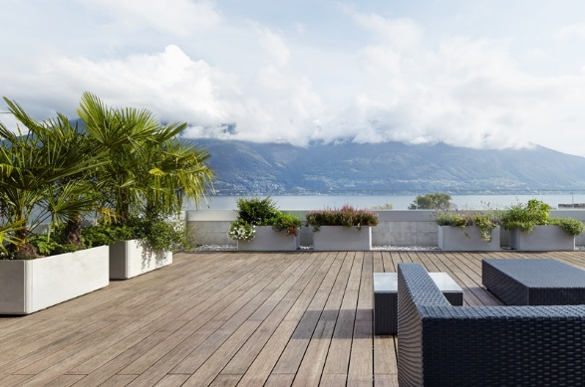
One of the most important products in the MOSO® range is Bamboo X-treme®: decking, siding, 1x4 T&G, lumber – all made of densified, heat-treated bamboo according the unique Thermo-Density® production method. Key benefits are the sustainability (proven to be CO₂ neutral), durability, stability and the beautiful natural appearance. With a complete package of marketing tools, MOSO® will empower distributors, installers, architects and landscapers to offer the true alternative to tropical hardwood to property owners and project developers.
High quality bamboo products from MOSO International
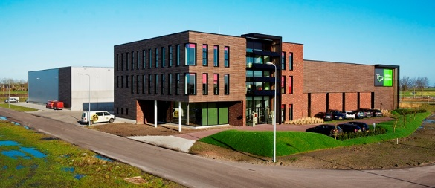
MOSO’s headquarters are in the Netherlands, but the group has around 20 permanent employees in China involved mainly in production and product quality control. MOSO has pioneered many bamboo production techniques and new bamboo products. No other bamboo company supplies as wide a range of bamboo products, and offers the same levels of quality and certification, as MOSO® does. MOSO® bamboo products are all tested and certified to European quality and environmental standards. Bamboo is one of the fastest growing and most sustainable building and decoration materials on earth, and MOSO® solid bamboo products are carbon neutral or better.

***

About bamboo:
Bamboo is a grass, and is considered to be the fastest growing plant on earth. A new shoot can grow over three feet per day. In addition, bamboo reaches an incredible hardness: it is many times stronger than oak or the still popular but endangered tropical hardwoods. Every year a fifth of all the stems of the giant bamboo can be harvested without jeopardizing the stock. A system of sustainable forest management ensures responsible yield and increases the CO₂ absorption. With its extraordinary properties, bamboo has evolved in recent years into a much sought-after industrial product. Nowadays parquet floors, stairs, wall and ceiling coverings, door panels, beams, furniture and much more is created with this millennial commodity. Who would have thought that a grass might be an alternative to hardwood or tropical timber?

MOSO® – the bamboo specialist
MOSO International B.V., established in 1997 in the Netherlands, specializes in the development of innovative and sustainable bamboo products for interior and exterior applications. MOSO® is a global player that operates from its headquarters in the Netherlands (Zwaag) and offices in China (Hangzhou), Spain (Barcelona), United Arab Emirates (Dubai), USA (Delaware), South Africa (Cape Town) and Italy (Milan). With its extensive experience and focus on innovation, MOSO® can meet the highest customer requirements and has become the European leader and the number one brand in high-end industrial bamboo products. For more information: www.moso-bamboo.com.

***

Not for publication

Copyright
MOSO® has only limited usage rights for the images provided with this press release, all further rights belong to the respective photographers. The images may only be published free of charge if they are clearly and explicitly combined with the picture credits, combined with a logo or mentioning of MOSO®. Any other form of publication is not permitted. No part of this text may be reproduced without mentioning MOSO®.

More information
For more information, please contact:
MOSO North America, Inc MOSO International B.V.
CEO / Brett Kelly Marketing department / José De Ruijter-Luken
Tel: +1 855 343 8444 / bkelly@moso-bamboo.com Tel: +31(0)229-265732 / marketing@moso.eu

