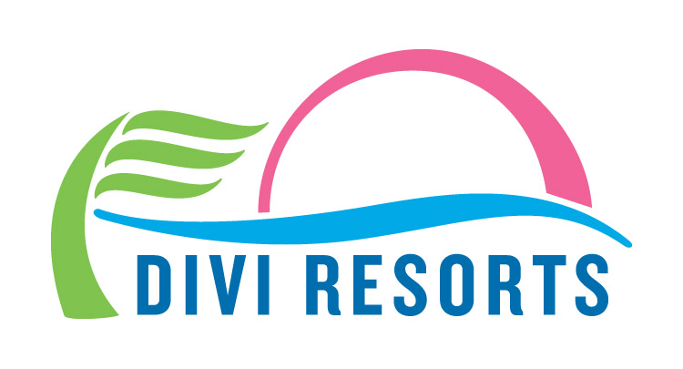

Contact: Alyssa Smith
Phone: (919) 419-2039
Alyssa.smith@diviresorts.com

Divi Resorts Lends a Helping Hand to Hurricane Victims, Aid Workers in St. Maarten
Company establishes GoFundMe campaign to assist displaced staff members

CHAPEL HILL, N.C., September 28, 2017 – While cleanup and restoration continues on St. Maarten following the recent, destructive hurricanes, Divi Resorts is dedicated to assisting displaced staff members and relief workers.

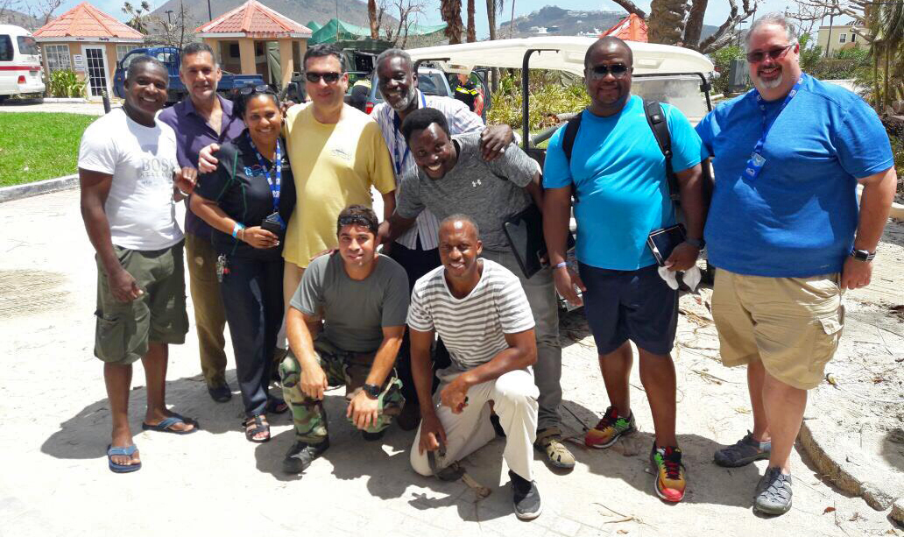

Divi Resorts President & COO, Marco Galaverna and a group of key staff visit St. Maarten to assess the damage and thank local employees.

“St. Maarten was hit hard by Hurricane Irma, followed quickly by Tropical Storm Jose and Hurricane Maria, causing widespread damage on the island,” said Divi Resorts President & COO, Marco Galaverna. “But what was most devastating was the fact that many of our employees lost their homes and livelihoods due to these storms.”

Since Hurricane Irma struck, Little Bay has been providing shelter for many staff members and their families while they begin to fix their homes or find new housing solutions.

In response to frequent guest and owner outreach regarding how to help, Divi Resorts created a GoFundMe campaign with the goal of raising funds for staff’s personal needs and recovery efforts.

“Our employees are family to us and to many of our guests and owners,” Galaverna said. “We’ve had an outpouring of concern and support for our staff, and we are committed to helping them recover from this tragic natural disaster.”

Divi Resorts’ GoFundMe campaign continues to accept donations at: gofundme.com/send-love-to-divi-little-bay-staff. All money raised will go directly to employees, as determined by management at the Resort in consultation with staff and their labor union.

The Resort has also been accommodating a troop of Dutch Marines, on the island to assist citizens of St. Maarten, since the end of Hurricane Irma.

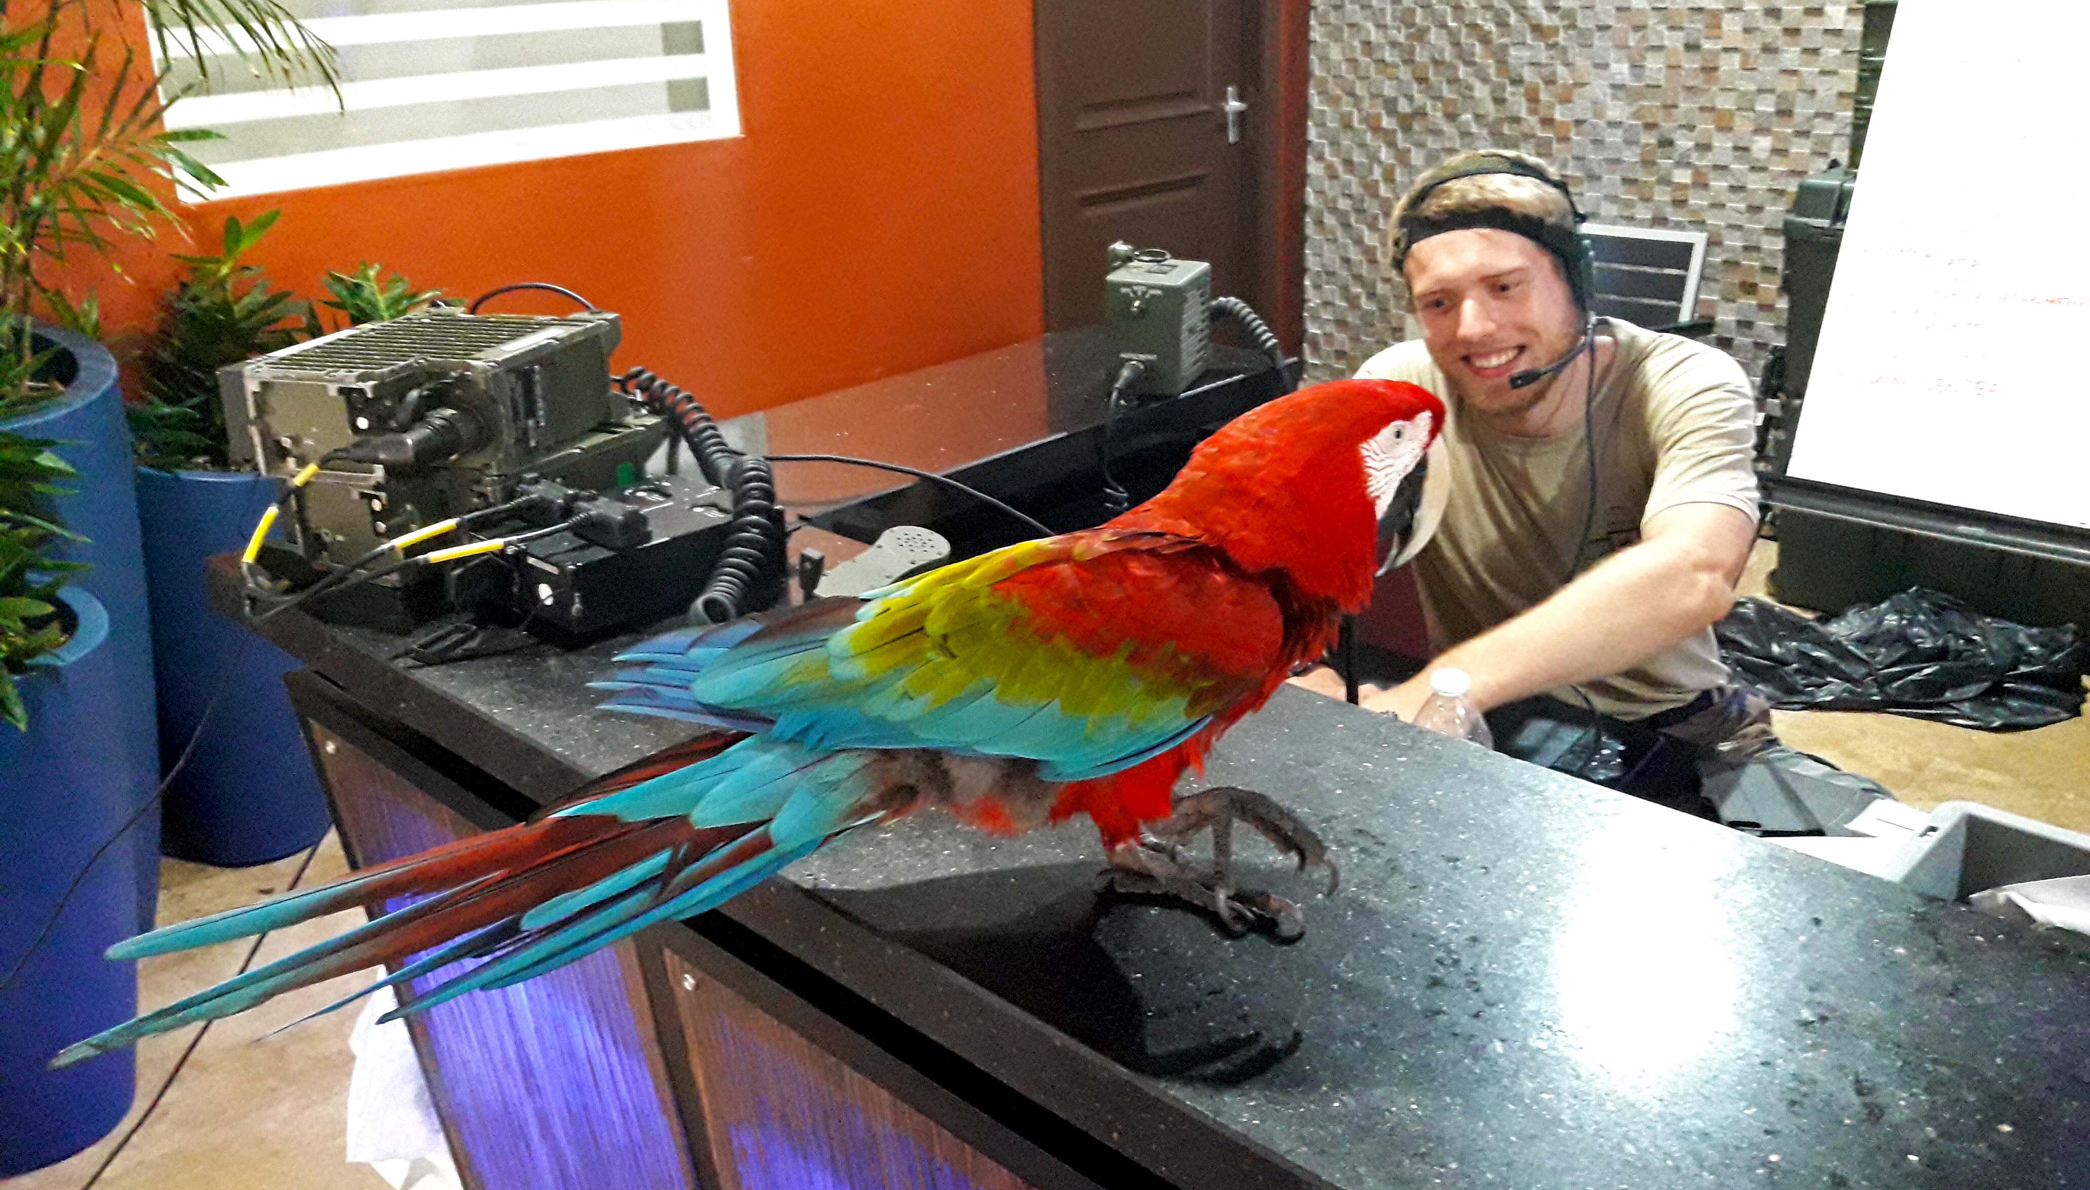

Divi’s diva, Gizmo spends quality time with her new friend, a Dutch Marine on site to assist St. Maarten citizens.

“We’re happy to provide accommodations for these heroic men and women as they spend their days cleaning up and rebuilding infrastructure on the island,” said Galaverna. “A few of the Marines have even made friends with our little Divi diva, Gizmo.”

About Divi Resorts

Divi Resorts is the vacation expert of the Caribbean, with a collection of eight premium resorts spanning the five stunning Caribbean islands of Aruba, Barbados, Bonaire, St. Croix, and St. Maarten. For more information on Divi Resorts, call 1-800-367-3484 or visit www.diviresorts.com.
###

