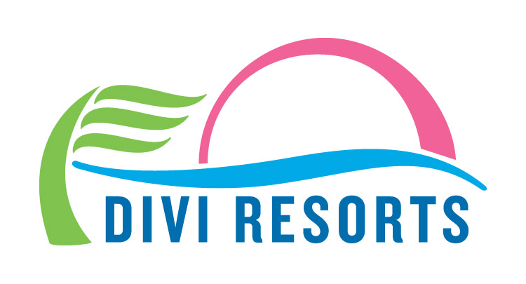

Contact: Alyssa Smith
Phone: (919) 419-2039
Alyssa.smith@diviresorts.com

Fall Into Savings at Divi Resorts in Aruba, Barbados, Bonaire
Despite recent hurricanes, several Divi Resorts destinations are enjoying a fantastic season

CHAPEL HILL, N.C., October 2, 2017 – There’s never been a better time to travel to some of the Caribbean destinations not affected by recent hurricanes. Divi Resorts destinations on Aruba, Barbados and Bonaire remain unharmed and fully open for business. And with Divi’s biggest sale of the season happening now, with rates as low as $125 per night, room only, and $175 per person, per night for all-inclusive, it’s a win-win for all!

“We are very saddened by the massive devastation recent storms have caused throughout the Caribbean and beyond, and our hearts go out to each and every person affected,” said Marco Galaverna, Divi Resorts President & COO. “In the midst of this tragedy, we are extremely fortunate to still have the opportunity to provide a magical Caribbean experience in Aruba, Barbados or Bonaire for travelers whose plans may have been impacted by the storms or for tourists looking to escape the chilly fall and early winter temperatures.”

Amazingly, Aruba and Bonaire remain firmly outside of the Hurricane belt, so booking for fall is a safe bet! Divi Resorts destinations provide a wide variety of on-site amenities, including elegant restaurants with mouthwatering menus, lively bars with unlimited libations, fabulous freshwater pools, sports courts, spas and more, allowing you the freedom to do everything, or nothing at all.

Plus, with Divi’s ‘Kids Stay and Eat Free’ program and complimentary Treasures of the Caribbean kids club, we keep our youngest guests happy while giving you the time to relax and enjoy your vacation on a budget.

For those in search of sunny skies and warm, sandy beaches, fall specials on room only or all-inclusive stays are as follows:

- Divi Village Golf & Beach Resort on Aruba – rates start at $155 per night, room only or $210 per person, per night all-inclusive
- Divi Dutch Village Beach Resort on Aruba – rates start at $149 per night, room only or $195 per person, per night all-inclusive
- Divi Aruba Phoenix Beach Resort on Aruba – rates start at $199 per night room only
- Divi Flamingo Beach Resort & Casino on Bonaire – rates start at $149 per night room only or $175 per person, per night all-inclusive
- Divi Southwinds Beach Resort on Barbados – rates start at $125 per night room only

In addition to exhilarating on-site amenities and events, Galaverna says there are many thrilling happenings on each island this fall. Highlights include:

Aruba –
- Eat Local Restaurant Month: More than 60 restaurants are participating in this opportunity to explore Aruba’s rich culinary heritage, including Windows on Aruba at Divi Village Golf & Beach Resort. To learn more, go online to restaurantweek.aruba.com.
- Challenge Aruba Triathlon: This triathlon, as well as a sprint distance race, takes place entirely along the beautiful Aruban coastline. For details, visit www.challenge-aruba.com.
- 15th Annual National Coastal Cleanup: Sponsored by the Aruba Hotel & Tourism Association, this national cleanup focuses on keeping Aruba’s beaches clean.
- 11th Edition Aruba International Beach Tennis Tournament: Beach tennis pros and amateurs travel to Eagle Beach from around the world to compete in the premier beach tennis tournament in the Caribbean. For more information, visit www.arubabeachtennis.com.

Barbados –
- 8th Annual Barbados Food & Rum Festival: Tantalize your taste buds at this year’s event featuring Divi Resorts Executive Chef Henderson Butcher and his creative culinary skills. Slated to be even bigger and better than last year, this mouthwatering event, happening November 16-19, highlights the island’s internationally acclaimed master chefs, unique Caribbean flavors and world-class rum.
- Surfer of the Year Championships: This event, hosted by the Barbados Surfing Association, decides who will be the 2017 Barbados Surfer of the Year.
- 4th Annual Barbados Jazz Excursion: Join in this weekend-long celebration of jazz artists with several concerts at multiple venues. For details, visit www.barbadosjazzexcursion.com.
- Barbados Open Water Swim Festival: Open-water swim events at this five-day-long festival include guided 2k, 5k, and “Just for Fun” swim races. For more information, visit www.swimbarbadosvacations.com.

Bonaire –
- 50th Annual Bonaire Regatta: Sailors from all kinds of sailing divisions from around the world, compete for the championship in their class. For details, visit www.bonaireregatta.org.
- Dive Friends Cleanup Drive: Dive Friends Bonaire hosts their quarterly Underwater Cleanup Dive. The public is encouraged to join in and participate in cleaning up the coral reefs and beaches.
- Cultural Market: This free market, open the last Saturday of every month, features local arts and crafts, plants and vegetables, and educational presentations. Sample delicious Bonairean food while listening to talented local musicians.

Fall specials are on sale now for a limited time only but you can travel right up until December 31, 2018. For individual reservations, please call 1-800-367-3484 (Toll-free US) or 1-919-419-3484 (International). For group reservations, please call 1-800-801-5550 or email groupsales@diviresorts.com. To find out more information about Divi Resorts, visit www.diviresorts.com.

About Divi Resorts

Divi Resorts is the vacation expert of the Caribbean, with a collection of eight premium resorts spanning the five stunning Caribbean islands of Aruba, Barbados, Bonaire, St. Croix, and St. Maarten. For more information on Divi Resorts, call 1-800-367-3484 or visit www.diviresorts.com.

