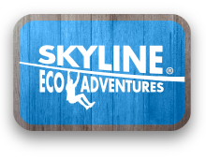

Media Contact:
Tom Kratsch
Director Marketing
Skyline Eco-Adventures
808-568-0179
tkratsch@zipline.com
Skyline Eco-Adventures Supports Local Hawaii Food Banks with over 19,000 pounds of donated food in September

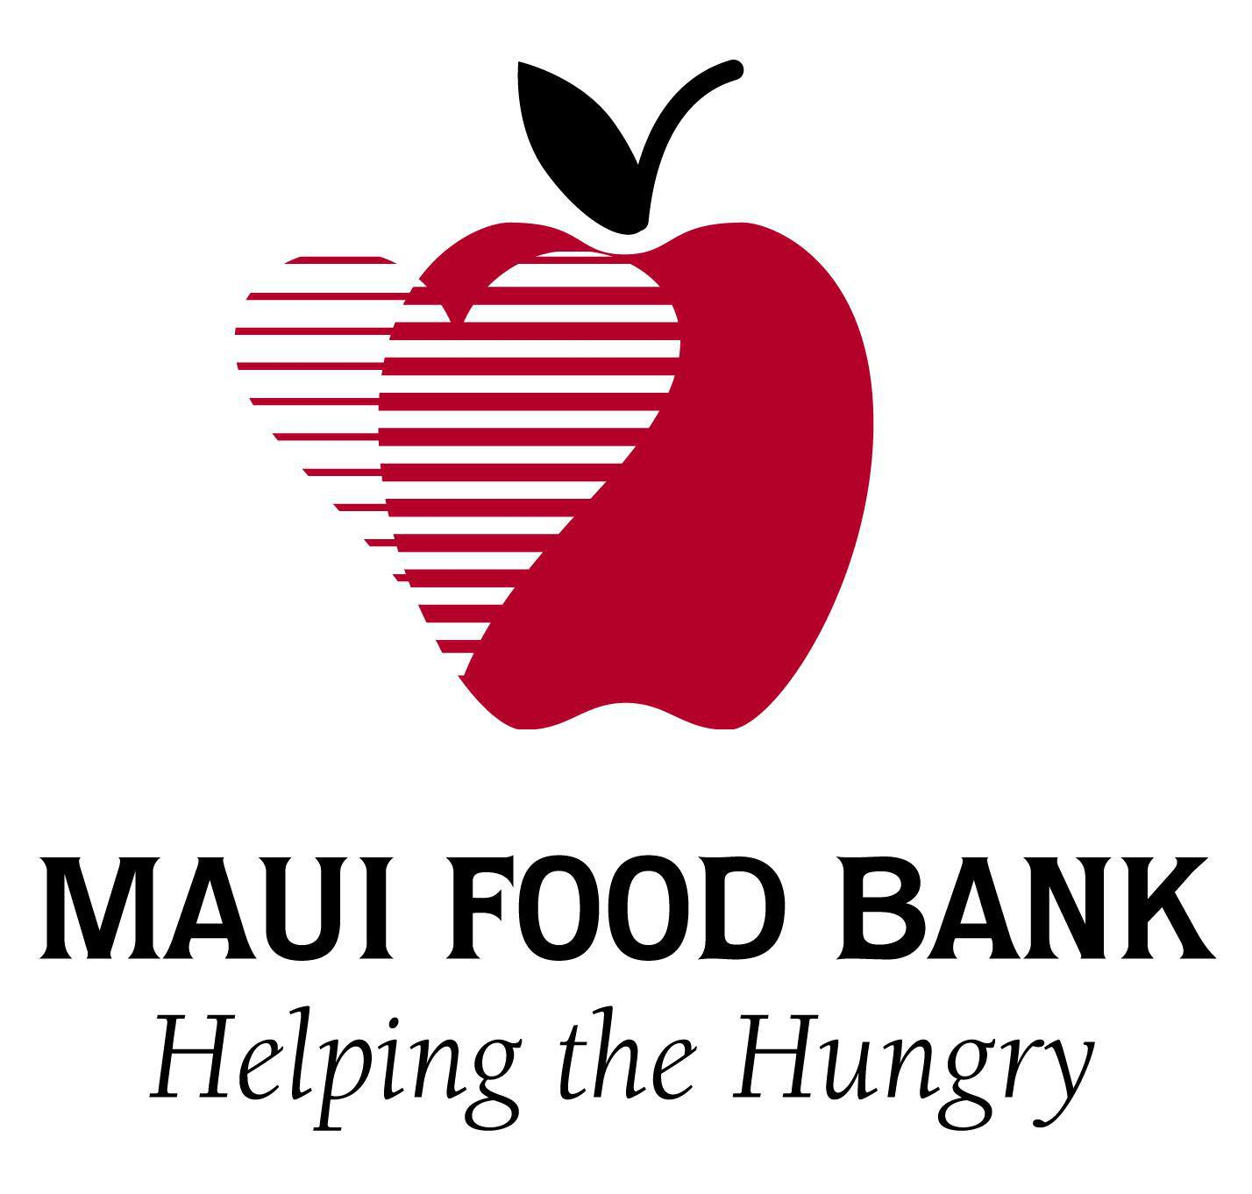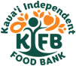
MAUI, HAWAII (Oct. 9th, 2017) – Skyline Eco-Adventures, Hawai'i’s award-winning zipline tour company and operator of the first zipline course in the United States, launched their 4th annual Skyline Loves Kama’aina resident promotion in September supporting local Food Banks on Maui and Kauai.

In September, Skyline Eco-Adventures offered free Zipline tours to Hawai'i residents with the donation of 10 non-perishable food items per person. Residents were able to experience ziplining on a choice of Skyline’s two Maui courses, including Skyline Haleakala and Skyline Ka’anapali, along with Skyline Poipu on Kaua'i. The promotion zipped over 2900 Kama’aina residents supporting the donation of more than 29,000 individual food items to the Maui Food Bank and Kauai Independent Food Bank On Maui, the Maui Food Bank received 11,787 pounds of food which provides for 9067 meals according to Stephanie Kaplan, Community Relations manager for the Maui Food Bank. The Kauai Independent Food Bank received 7651 pounds of food from the promotion which provides for 5885 meals to those in need on Kauai.
In addition to Skyline’s local community involvement Skyline Eco-Adventures is committed to giving back and as a member of 1% For The Planet, Skyline donates 1% of annual revenues to local community and conservation causes. For more information on Skyline’s charitable giving, visit www.zipline.com/dogoodhavefun

Skyline Eco-Adventures is Hawaii’s most awarded zipline company and operates tours on Maui at Ka‘anapali and Haleakala, in addition to the Akaka Falls Skyline Adventure on Hawaii Island, and the Poipu Skyline Adventure on Kauai. Call (808) 878-8400 or visit www.zipline.com.
.

