Rhinelander Brewing Company LLC
43 S. Brown Street, Rhinelander, Wisconsin 54501
www.RhinelanderBrewery.com Tel: (715) 550-BEER

Announcing the purchase of a 8,000 sq ft property on Brown Street, expansion of our gift and bottle shop and start of a tap room/brewery in Rhinelander, WI

Rhinelander: Wednesday, November 8, 2017: Ms. Jyoti Auluck, Founder, President and CEO of Rhinelander Brewing Company is “tickled pink” and “over the moon” to announce a major expansion of her operations in downtown Rhinelander, WI. She has purchased an 8,000 sq ft property at 43 S. Brown St in downtown Rhinelander where she will open a tap room and a brewery that will produce its craft beers including a new line of small batch craft beers - Hodag Ales (design shown below).

The new building will be the headquarters of the company. It will feature a taproom with 10 of its tastiest craft beers as well as offer tours and tastings to the public. It will also have a gift shop and retail shop for beer to take home in growlers, cans and bottles and a historic brewery memorabilia museum. Ms. Auluck is urging local residents to donate to the brewery any historic Rhinelander or other area breweries’ memorabilia they might have. Donated items will be displayed for enjoyment by locals and visitors alike. The donators names will be acknowledged in the museum with the display of the artifacts.

A local brewer and craft beer enthusiast Al Ewan is the new brewmaster and Brenda O’Rourke is the manager of the taproom, retail Store and bottle Shop. This is a culmination of Ms. Auluck’s dream to revive Rhinelander beer production in the city of Rhinelander, WI.

As people in the Midwest still recall fondly, the historic Rhinelander Brewery produced the finest beers at its brewery from 1882 to 1967, owned by Otto Hilgermann and Henry Danner located at Ocala Street in Rhinelander, next to the Pelican River. - The former brewery location is now the Eye Clinic of Wisconsin at 2 E Ocala St. It was closed just like hundreds of other breweries closed with the advent (and aggressive tactics) of multi-national mega breweries. Interestingly, Mr. Hilgermann and his family lived in the house across the street from the brewery at 919 Arbutus St. complete with a 5 foot tunnel under the street and a 2 inch beer pipeline to his house. For many decades, Rhinelander Shorty was one of the most successful regional brands sold in the Midwest including Minnesota, Illinois, Indiana and of course, Wisconsin.

During the period from 1882 to 1967, Rhinelander Brewery put Rhinelander on the map. It's returnable Rhinelander Export Lager and of course, the Rhinelander 7 oz Shorty is still etched in the memory of millions of Midwesterners. The historic Joseph Huber Brewery in Monroe, WI kept on producing Rhinelander beers in the 12 oz returnables from 1970s for another 35 years. The famous Rhinelander returnables lost their lustre in the early 2000s when the customers gradually stopped bringing back their Rhinelander returnable bottles. It should be noted that the returnable bottles are heavier and more expensive than one way bottles. In fact, the returnable bottles must have at least 10 turns for them to be a viable alternative. Joseph Huber Brewery switched Rhinelander beer to cans but that was not what the customers wanted and soon the Northwoods lost one of its most famous beers.

In June 2011, the Canadian born Ms. Auluck re-launched Rhinelander Shorty with great success. It took her 2 years, requiring a sizeable capital investment including creating brand new molds for the Shorty style bottle, creating a retro label design, equipping the brewery to package the unusually shaped Shorty bottle and most importantly, working diligently to perfecting the recipe and creating the taste of the original Rhinelander Shorty beer.

The response throughout Wisconsin and the Midwest was nothing short of amazing. Almost every retail store and bar in and around Rhinelander started selling the Rhinelander Shorty Export Lager, as well as Madison, Milwaukee and other parts of the state of Wisconsin. Orders were also received from other Midwestern states and from parts of Canada.
Keeping the “best quality” mantra that the original Rhinelander Brewery stuck to for 85 years of its existence, Ms. Auluck expanded the Rhinelander family of beers to Rhinelander Lager and Rhinelander Light 12oz, Craft Beers Thumper American IPA, Imperial Jack Double IPA, Chocolate Bunny Stout and Mystical Jack Traditional Ale as well as seasonal Rhinelander Oktoberfest. Also in early 2016, she launched her Rhinelander Hard Root Beer soon followed with Over the Barrel branded hard sodas in 5 flavors, Rootbeer, Blueberry, Cream Soda, Black Cherry and Grape hard soda – all with great success. Rhinelander Brewing Company now produces and sells over 1 million pints of beers per year throughout the Midwest, making it one of the largest breweries in Wisconsin.
She is also expanding her gift shop in downtown Rhinelander on Brown Street with exciting new Rhinelander branded apparel, glassware and a lot of her beer products – where people can come and taste their fine products and buy them to enjoy at home. The retail gift shop and beer tasting area is now being expanded ten fold.
It should be noted that Rhinelander Brewing Company’s new location on Brown Street will sell a lot of its beers and other alcoholic products but it will NOT sell its own products that are carried and marketed by other Rhinelander based retailers. This is Ms.Auluck's way of supporting local businesses and a way of thanking Trig’s Cellar 70, Stein’s, WalMart, House of Spirits and other local retailers who have supported her immensely over the last 7 years, thereby contributing greatly to her success.
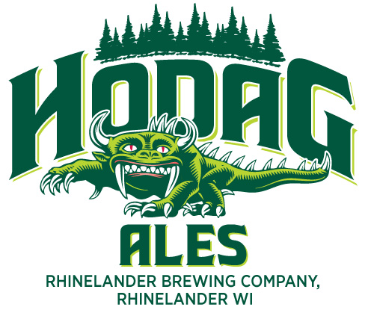
Ms. Jyoti Auluck, President & CEO of Rhinelander Brewing Co is available for interviews. E-mail her at President@RhinelanderBrewery.com or by telephone at (715) 550-BEER.

