GuestCentric wins international award for the website design of Hotel Rest Plymouth

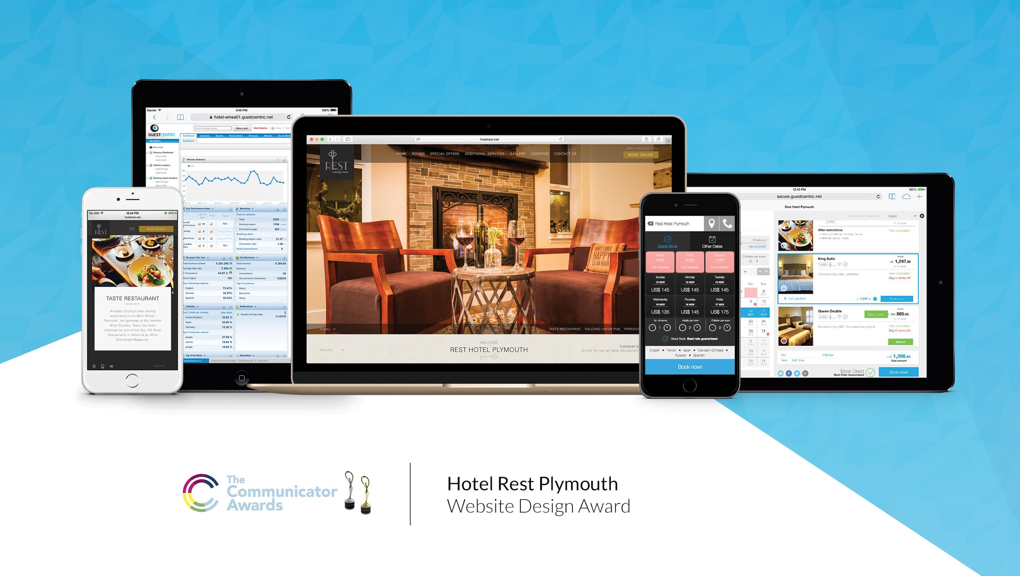

GuestCentric, the leading provider of marketing software for hotels, announced that it has been honoured by Communicator Awards with an international website design award for its work on the 2017 edition of Hotel Rest Plymouth corporate website.

With sixteen charmed and comfy rooms located on the main street Plymouth, in California, the Rest Hotel Plymouth is a different independent hotel boutique concept with a new fun option for lodging in the Sierra Foothills Wine Country.

Independent hotels like Rest Hotel Plymouth are constantly making greater efforts to stand out in the online hotel industry, a very competitive sector with increasingly demanding users. In addition, competition from OTAs can seem like an insurmountable obstacle:

"We are very excited to receive this award. The web design team at GuestCentric took the time to understand our property and worked with as one team for the best result. They helped to convey our identity and showcase the concept clearly to our potential guests. The success of this website is certified by this award”, said Tracey Berkner, Owner Rest, a Boutique Hotel, Hotel Rest Plymouth.

GuestCentric work focuses on the development of online technologies and strategies which provide hoteliers with a number of tools to compete with major chains and online travel agencies.

GuestCentric innovative web design has been recognized with more than 150 international awards, also offering a simple and efficient reservations engine optimized for mobile devices with all operating systems as well as a channel manager compatible with more than 400 channels.

Through the Guestcentric platform, Hotel Rest Plymouth has access to the contents and images of its web pages, marketing tools on social networks, SEO optimization and analytical data:

"We are very excited to have been selected by Hotel Rest Plymouth, a unique brand hotel, to offer its guests the best online experience possible," said Filipe Machaz, VP of Sales of GuestCentric. “I am very proud to get this international website design award for Hotel Rest Plymouth corporate website. This means that without a doubt we have managed to tell their story through their new website design" concluded Machaz.

