Press Release
For immediate release
Date: 17th November 2017

One travel company is shocking the industry by increasing sales by as much as 800% thanks to it's unique training programme.

The Travel Franchise has created a unique training programme, taking it's homeworkers on luxury all-inclusive 'Elite Experiences' and the results are phenomenal. Just back from it's latest trip to Mauritius, sales are already up 50% in the first 30 days.

In the last year, The Travel Franchise (the recruitment arm of travel agency Not Just Travel) has created a bit of a wave within the Travel Industry.

Fresh from winning 10 awards at the Hays conference in Spain, Not Just Travel and The Travel Franchise, has taken 27 of its existing homeworkers on the ‘ultimate’ educational, something they call the ‘Elite Experience’.

Proof that this ‘Elite Experience’ has a massive impact on business can be seen in the 50% increase in sales which have already occurred since returning from Muaritus.

100% unique to The Travel Franchise, this ‘experience’ is designed to help the Travel Franchise homeworkers develop their business bigger and better than any other homeworker. A bold claim, but given it’s unique training content, Homeworkers with The Travel Franchise are potentially given a head start in business.

Paul Harrison, Co-Founder of The Travel Franchise says “we recognise that most people who become Homeworkers with us have never been self-employed before. This coaching programme is massively important to their success”

The Elite Experience was hosted in conjunction with Beachcombers Tours who created a very special itinerary for the group. “The Travel Franchise wanted to create a very special tour which showed off Mauritius to its Homeworkers, allowed their corporate team time to provide bespoke training and treated their Homeworkers like VIP’s” said Rupert Diggins, Sales Manager for Beachcomber Tours who was approached by The Travel Franchise and asked to help create something unique.

Unlike most educational trips or overseas conferences, The Travel Franchise actually pays for the Elite Experience, therefore ensuring this is not simply about destinations or suppliers. This event really does focus on training. That said, Beachcomber Tours contributed massively to this event. “Beachcomber have been phenomenal. Without them this trip would have not been possible. They allowed us to experience a different side of Mauritius, see behind the scenes and enjoy full access to the stunning Beachcomber hotels and resorts” said Steve Witt, Co-Founder of The Travel Franchise.

Steve Witt goes on to say “we believe that training such as our Elite Experience is the reason why we are paying out such large sums of money as commission to our homeworkers”.

This annual event (which becomes bi-annual next year), is held in a different location each time. Mauritius has seen a surge in popularity as it represents fantastic value compared to Europe at present.

Harrison says “we have taken all the best elements of a traditional ‘educational’, focused on a small number of brilliant hotels and combined with training to ensure our homeworkers really benefit from this time away and increase their income”.

The Elite Experience was not just about training and coaching. There was a perfect balance of work and play. Beachcomber Victoria is quoted as saying they had their best audience ever for their music.

The 50% increase in sales that has already been seen with both the suppliers involved in the Elite Experience and the destination can be attributed to the training programme included within this trip. Other travel companies in the UK are currently reporting sales increases of just 8-10% annually.

In May 2017 The Travel Franchise partnered with Club Med to take 20 of it’s travel homeworkers to Gregolimano, the Club Med resort in Greece. Since then sales have increased by as much as 800%.

The Elite Experience 2017 Facts:

Mauritius, 1 amazing island.
27 Travel Consultants / Homeworkers
Stayed in 4 amazing Beachcomber hotels
Hosted dinners and events at 7 Beachcomber hotels
14 exquisite lunches and dinners
Enjoyed fine dining on 1 breath taking beach
Played golf on 1 top golf course
Enjoyed 3 unique experiences
1 amazing Catamaran cruise

The Elite Experience is quoted as being a ‘money can’t buy experience’. Something the team at The Travel Franchise are very proud to have created, and clearly something which is making a real difference in the travel industry with suppliers and tour operators reporting huge increases in sales through the Not Just Travel group.

In the last year, The Travel Franchise (the recruitment arm of travel agency Not Just Travel) has created a bit of a wave within the Travel Industry.

Fresh from winning 10 awards at the Hays conference in Spain, Not Just Travel and The Travel Franchise, has taken 27 of its existing homeworkers on the ‘ultimate’ educational, something they call the ‘Elite Experience’.

Proof that this ‘Elite Experience’ has a massive impact on business can be seen in the 50% increase in sales which have already occurred since returning from Muaritus.

100% unique to The Travel Franchise, this ‘experience’ is designed to help the Travel Franchise homeworkers develop their business bigger and better than any other homeworker. A bold claim, but given it’s unique training content, Homeworkers with The Travel Franchise are potentially given a head start in business.

Paul Harrison, Co-Founder of The Travel Franchise says “we recognise that most people who become Homeworkers with us have never been self-employed before. This coaching programme is massively important to their success”

The Elite Experience was hosted in conjunction with Beachcombers Tours who created a very special itinerary for the group. “The Travel Franchise wanted to create a very special tour which showed off Mauritius to its Homeworkers, allowed their corporate team time to provide bespoke training and treated their Homeworkers like VIP’s” said Rupert Diggins, Sales Manager for Beachcomber Tours who was approached by The Travel Franchise and asked to help create something unique.

Unlike most educational trips or overseas conferences, The Travel Franchise actually pays for the Elite Experience, therefore ensuring this is not simply about destinations or suppliers. This event really does focus on training. That said, Beachcomber Tours contributed massively to this event. “Beachcomber have been phenomenal. Without them this trip would have not been possible. They allowed us to experience a different side of Mauritius, see behind the scenes and enjoy full access to the stunning Beachcomber hotels and resorts” said Steve Witt, Co-Founder of The Travel Franchise.

Steve Witt goes on to say “we believe that training such as our Elite Experience is the reason why we are paying out such large sums of money as commission to our homeworkers”.

This annual event (which becomes bi-annual next year), is held in a different location each time. Mauritius has seen a surge in popularity as it represents fantastic value compared to Europe at present.

Harrison says “we have taken all the best elements of a traditional ‘educational’, focused on a small number of brilliant hotels and combined with training to ensure our homeworkers really benefit from this time away and increase their income”.

The Elite Experience was not just about training and coaching. There was a perfect balance of work and play. Beachcomber Victoria is quoted as saying they had their best audience ever for their music.

The 50% increase in sales that has already been seen with both the suppliers involved in the Elite Experience and the destination can be attributed to the training programme included within this trip. Other travel companies in the UK are currently reporting sales increases of just 8-10% annually.

In May 2017 The Travel Franchise partnered with Club Med to take 20 of it’s travel homeworkers to Gregolimano, the Club Med resort in Greece. Since then sales have increased by as much as 800%.

The Elite Experience 2017 Facts:

Mauritius, 1 amazing island.
27 Travel Consultants / Homeworkers
Stayed in 4 amazing Beachcomber hotels
Hosted dinners and events at 7 Beachcomber hotels
14 exquisite lunches and dinners
Enjoyed fine dining on 1 breath taking beach
Played golf on 1 top golf course
Enjoyed 3 unique experiences
1 amazing Catamaran cruise

The Elite Experience is quoted as being a ‘money can’t buy experience’. Something the team at The Travel Franchise are very proud to have created, and clearly something which is making a real difference in the travel industry with suppliers and tour operators reporting huge increases in sales through the Not Just Travel group.

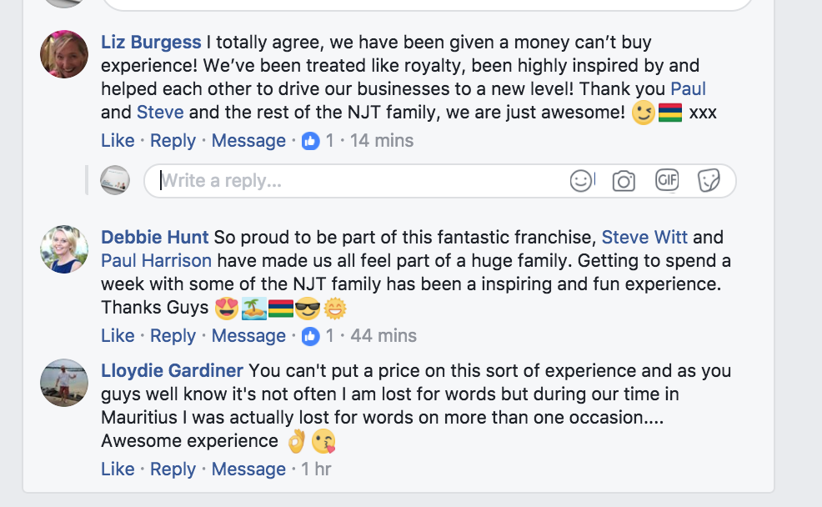

Photo’s
To download photos of the event please go to:
http://www.the-travel-franchise.com/elite-experience-mauritius-photos/

For further information please contact:

Paul Harrison
Co-Founder & Event Host
Mobile: 07901795725
Email: paul@notjusttravel.co.uk

Steve Witt
Co-Founder & Event Host
Mobile: 07766100569
Email: steve@notjusttravel.co.uk

Amanda Mitchell
Director of Marketing
Tel: 01202 978219
Email: amanda.mitchell@notjusttravel.co.uk

