Classic Black is Texas’ Number 1 Plate in 2017!

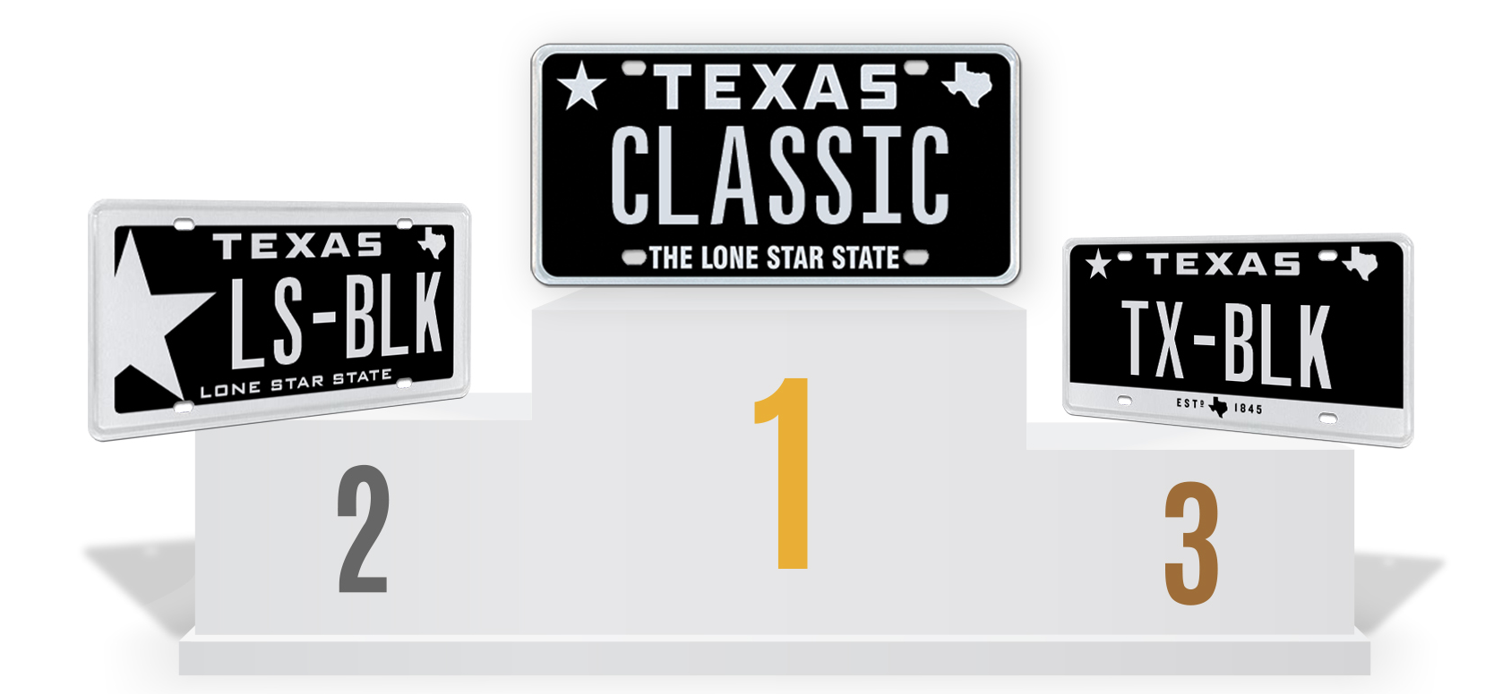

4 January 2018 (Austin, TX) – It’s official; the number one specialty license plate design in Texas for 2017 is the full black background design, Classic Black, from My Plates.com. This is the second consecutive year this old-style design has held this honor, outselling the second-place getter, Lone Star Black.

In 2017, more than 9,500 Texans purchased the Classic Black design, almost 2000 more than the Lone Star Black design. The popularity of this design harkens back to 1968, which was the last time a full black Texas license plate, but then was available only as a general issue pattern.

In second spot with 7,631 plates sold in 2017 is the ever-popular Lone Star Black design from My Plates that can still boast having more plates sold overall in Texas, totaling more than 80,000 since it became available. Rounding out the Top 3 plates is the Texas Black 1845, holding off the fourth-place finishing Small Star Black. In fact, the top 4 plates, each black and white, account for 51% of total sales. With over 44,700 plates sold each year, that’s a lot of black and white plates!

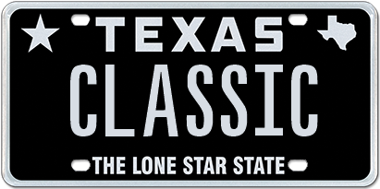 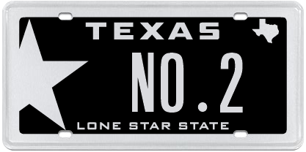 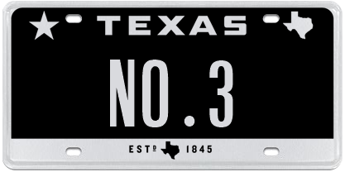

**My Plates - Top 5 Selling Plates 2017**

1. Classic Black 9,574
2. Lone Star Black 7,631
3. Texas Black 1845 3,498
4. Small Star Black 2,212
5. Small Star Silver 1,036

“Black and white plates are very popular in Texas, they look sleek, cool, and compliment every vehicle color,” said Steve Farrar, President of My Plates.com.

If you were wondering what other plates proved popular in 2017, like which plate was the top College or Sports plate, My Plates also released the rankings for these and other plate categories such as Flags & Texas Themes, Colors and Charities.

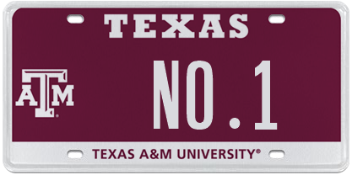 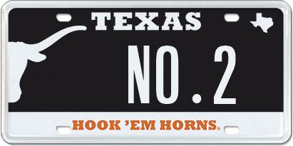 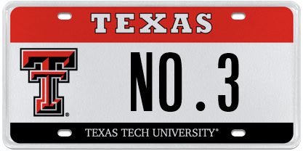’

**My Plates - Top 5 College Plates (In-State)**

1. Texas A&M University
2. University of Texas
3. Texas Tech University
4. Texas Christian University
5. University of Houston

**My Plates - Top 5 College Plates (Out-of-State)**

1. University of Iowa (launched in 2017)
2. Colorado School of Mines (launched in 2017)
3. Louisiana State University
4. University of Oklahoma
5. University of Alabama

**My Plates - Top 10 College Plates (All – In & Out of State)**

1. Texas A&M University
2. University of Texas
3. University of Iowa
4. Colorado School of Mines
5. Texas Tech University
6. Louisiana State University
7. University of Oklahoma
8. University of Alabama
9. Oklahoma State University
10. Texas Christian University

Interestingly, six of the top ten My Plates College plates sold in Texas during 2017 are schools that are out of state. “We’re not that surprised, Alumni chapters are very active in supporting and promoting their alma mater” said Farrar.

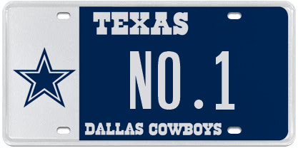 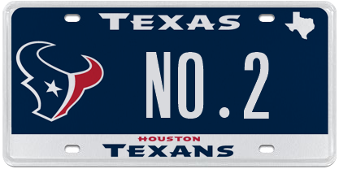 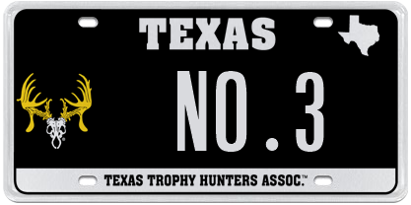

**My Plates - Top 5 Sports Themed Plates**

1. Dallas Cowboys
2. Houston Texans
3. Texas Trophy Hunters Association
4. San Antonio Spurs
5. Houston Rockets

**My Plates - Top 5 Flag or Texas Themed Plates**

1. Texas Oil & Gas
2. Come and Take It
3. Texas Tough Black
4. Carbon Fiber
5. Don’t Tread on Me

**My Plates - Top 5 Colors** (excluding black)

1. Pink
2. Silver
3. Red
4. Blue
5. White

**My Plates - Top Charity Plates**

1. Calvary Hill
2. Protect Wild Animals
3. National Breast Cancer Foundation
4. Peace Officers Memorial Foundation

____________________________________________________________

**My Plates** designs and markets new specialty license plates as a vendor for the Texas Department of Motor Vehicles. Texans have bought more than 345,000 My Plates since November 2009, putting more than $58M in the state general revenue fund. My Plates’ goal is to create a long-term, mutually beneficial relationship designed to maximize revenues for the state through the sale of My Plates specialty plates. [www.myplates.com](http://www.myplates.com).

**The Texas Department of Motor Vehicles (TxDMV)** serves protects and advances the citizens and industries in the state with quality motor vehicle related services. For every $1 it spends, the TxDMV returns $11 to the state. The agency currently registers 24 million vehicles; issues more than 7 million vehicle titles; licenses more than 38,000 motor vehicle dealers and distributors; credentials nearly 60,000 motor carriers; issues more than 800,000 oversize/overweight permits; investigates more than 15,000 complaints against dealers and motor carriers; and awards grants to law enforcement agencies to reduce vehicle burglaries and thefts. Learn more at [www.TxDMV.gov](http://www.TxDMV.gov).

____________________________________________________________

For more information, contact Steve Farrar at (512) 633-7978 or [steve@myplates.com](mailto:kristy@myplates.com)

Safe Hero Image Download:

<https://ce9a9387e1bc258c3cfa-af7906f4e771b24864bbfa3048e4a635.ssl.cf2.rackcdn.com/My%20Plates%20Top%203%20Plates%202017.png>