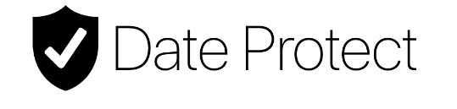

New Mobile App “Date Protect” Helps Users of Online Dating Platforms Stay Safer During a First Date

App sends text alerts to friends and family with a user’s location and their date’s photo

FOR IMMEDIATE RELEASE

Seattle, WA. – January 17, 2017 – We’re obsessed with our dating apps, such as Tinder and Bumble, but could we do more to protect ourselves before meeting up with someone new online?

New app Date Protect is a simple and discreet way for a user to share their location and a photo of the person they are meeting for the first time with friends and family in the form of a text alert. Users may send an alert to an individual in their mobile phone contact list or a group text.

Date Protect encourages users to enter a few details about their date, including the time and location they are scheduled to meet someone. That information is stored in case of an emergency and can also be sent by the user prior to their date to their loved ones. The app is the ideal way to casually inform a friend or family member via text of upcoming plans. It’s the new way to “check in.”

“We all want to believe that most people are sincere in their reasons for joining online dating sites but it’s also important to take a few precautions, especially if you’re going somewhere alone,” said app creator Mike Draghici. “There’s no excuse for slacking on personal safety.”

“Date Protect is a reminder to take that extra step to alert a best friend, brother or parent — anyone from your inner circle — that you’re on your way to meet a new person for the first time and where you plan to be in case you suddenly become unreachable,” Draghici said.

Date Protect is now available in the Apple Store for $1.99. To learn more, please visit http://dateprotect.com or click here for a demo.

***

About Date Protect

The Date Protect app helps users provide details with their loved ones about an upcoming date and / or outing they have with someone new they’ve met online. The app allows users share text alerts about their plans in case they become unreachable during a date. Date Protect was developed by startup company SiFi Communications LLC, creators of the wireless internet sharing app called SiFi.

CONTACTS:
Mike Draghici
+1 (206) 883-4453
draghicimike@gmail.com

