A smooth workflow ensures that claims are managed:

Thoroughly - Nothing slips through the cracks. Projects progress as required pieces of information are entered.

Punctually - Time stamps and SMS reminders ensure that projects move quickly through the system.

Superiorly - Quality is upheld as everyone uses the same system, the same way, every time.

Satisfactorily - Homeowners are delighted to have their roofs replaced or repaired in a timely, predictable and high-quality way.

No wasted time:
Chasing down missing information.


Forgetting to call the insurance company or homeowner. Not having proper photos.
Having to remember, estimate, and calculate each and every line item and pricing for supplement claims.

Download Our App!
The first CRM customized for Roofers to: Accept credit card payments from homeowners Allow messaging among team members
Enable SMS communication

Provide reporting based on specific size and needs of each contractor

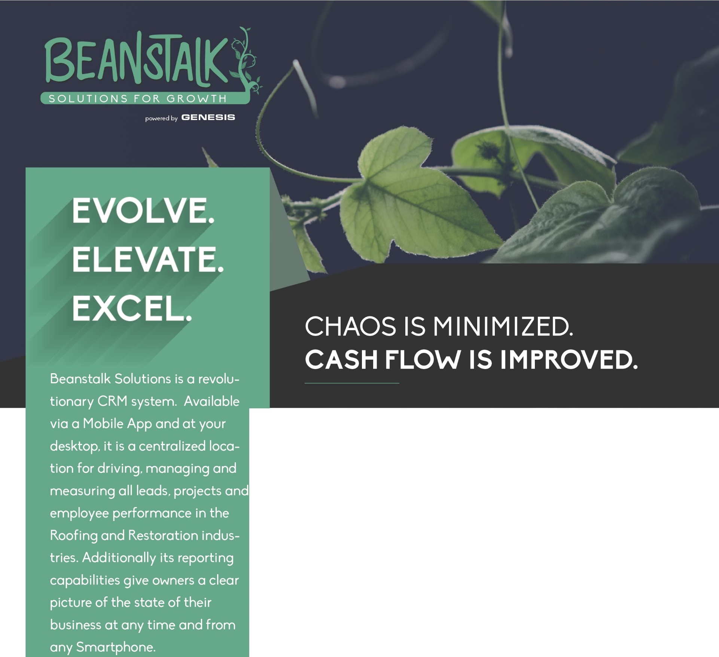


FOR SALES REPRESENTATIVES



Increase Sales Close Deals Faster
Manage Projects Efficiently
Drive Customer Loyalty and Satisfaction

Organize and track your leads in a way that forces efficiency, never allowing for overlooked or lost leads.
You are able to focus on the right leads, which allows you to qualify and close faster.
Job boards, information tracking, reminders, and more. It’s impossible not to stay organized and keep your projects progressing.
Homeowners recognize and appreciate when you are prepared, professional, and consistent. Their likelihood to use you for future projects and to refer you their friends and family is high.


FOR OWNERS

Real-time Project Dashboard
An easy to read, accurate snapshot of your business available at all times. No more time spent wondering how many projects or their status.

Reporting

All questions answered and information tracked. Prove your growth and identify areas where you could improve.

Tracking By

Salesperson, Project, Numbers – Care to know your best performers, their stats, their whereabouts and more? Use tracking to inform hiring, firing and expectations.

Manage, Monitor and Measure Growth
You can only manage what you measure and this is the tool to help you do just that. Knowing your numbers is the first step in targeting areas for growth.

ADDITIONAL FEATURES



Mobile App Integration
FEATURES DESCRIPTION LIST
SOLUTIONS FOR GROWTH
Available via a desktop website and a mobile app, the versatility is what you and your sales team needs to operate in a way that makes the most sense and is user friendly.

Materials Ordering and Tracking
No more supplier invoices or missed communication when you order Materials through Beanstalk.

Document Uploads

Never lose another piece of paper again. Contracts, paperwork, loss sheets…they can all be uploaded, easily filed, and quickly retrieved.

Team Collaboration

Message team members and communicate from a central location regarding all project needs.

Photo Uploads

Both offline and online, pictures of your project can be snapped and instantly added, eliminating the need for storage on your Smartphone or remembering to upload later.

Project Notes

Store pertinent information in a place that’s easy to input and subsequently find.

Funding Requests and Tracking
One of a kind in our industry! Request capital with the push of a button. Get paid faster and keep projects moving swiftly.

Claims Management

Time to file for a supplement? Doing so within Beanstalk puts the process in motion as your supplement is built, approved by insurance and funded to you.

