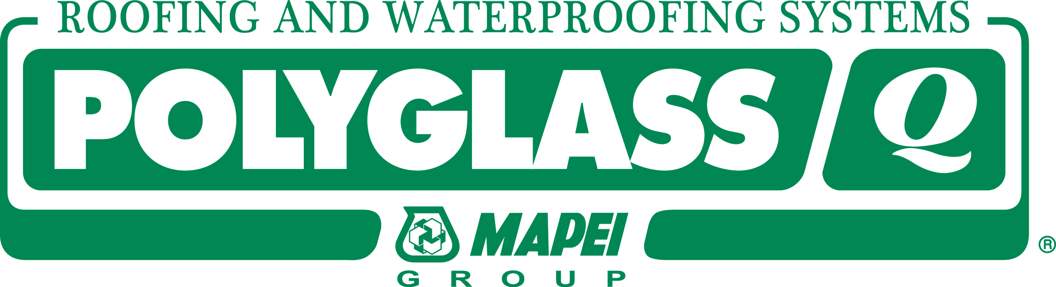 NEWS

RELEASE

FOR IMMEDIATE RELEASE

Polyglass Achieves ISO 9001:2015 Certification

Polyglass U.S.A., Inc. has transitioned to ISO 9001:2015, an international quality management standard that recognizes an organization’s commitment to a culture of continuous improvement.

DEERFIELD BEACH, Fla. Jan. 6, 2018—Polyglass U.S.A., Inc. announced today that it has achieved ISO 9001:2015 certification. This accomplishment validates Polyglass’ commitment to manufacturing quality roofing and waterproofing products, enhancing customer satisfaction, and improving business performance.

“We are proud to receive ISO 9001:2015 for all of our Polyglass locations,” said Polyglass CEO Natalino Zanchetta. “As a quality-focused company, implementing a Quality Management System is a natural step for Polyglass. It increases our reputation for quality products in the industry and builds trust and confidence in our brand.”

Certification to ISO 9001 requires an accredited registrar (third-party auditing organization) to thoroughly review the company’s policies, processes, and procedures to ensure that they are capable of consistently meeting customer, regulatory requirements and the intent of the ISO 9001:2015 standard.

The ISO 9001 standards are published by the International Organization for Standardization, an international agency composed of the national standards bodies of more than 160 countries. A new version of the ISO 9001 appears about every seven years to ensure organizations continue to adapt to the changing environment in which they operate. ISO 9001:2015 is the latest of the ISO 9001 international standards.

About Polyglass:
Polyglass U.S.A., Inc. is a leading manufacturer of roofing and waterproofing systems for low-and steep-slope applications. Known for its self-adhered modified bitumen roofing systems based on the company’s patented ADESO® Technology and CURE Technology®, Polyglass also produces a full line of premium roof coatings and roof maintenance systems. As an ISO 9001:2015 certified company, Polyglass provides quality products and adds value worldwide. For more information about the premium products and services offered by Polyglass, call 800.222.9782 or visit www.polyglass.us.

Media Contact:
Angeline Isen
(954) 233-1176
aisen@polyglass.com

