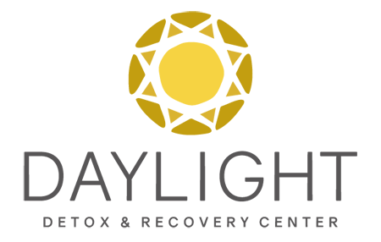

FOR IMMEDIATE RELEASE: Tierney Steiginga, Daylight Detox & Recovery Center
M. (330) 921.1291 O. (561) 241-4630
tierney@daylightrecoveryfl.com

Cutting Edge Facility Rebels Against Traditional Treatment Methods To Curb Opioid Epidemic
Going Against South Florida’s Rehab Industry Norms Are Cutting Opioid Based Drug Relapse Rates

PALM BEACH GARDENS, FL, February 6, 2018: Daylight Detox & Recovery Center is not persuaded by the overall belief of the South Florida Addiction Treatment Industry when it comes to the general view on Medication Assisted Therapy (MAT). According to the National Institute of Drug Abuse, MAT addiction treatment has been proven to be 50%-62% more successful than the failing traditional 12-step methods.

The South Florida Rehab Industry thinking is largely influenced by the AA and NA model of recovery, where abstinence is the only way to recover from a drug or alcohol addiction. This idea is widely accepted and implemented strictly in clinical programs because most of the industry professionals in this demographic area themselves are in recovery. At Daylight Detox & Recovery Center, the focus is saving lives, whether that be an abstinence 12-based method or MAT Programs. Each client that comes through the doors at Daylight is given a treatment plan that is customized to their specific needs.

The main goal of curbing this opioid epidemic is saving the lives of those who are suffering from the disease of addiction. Daylight Detox & Recovery Center implements medication assisted treatment to their clients and sees drastic results from those that have previously been labeled “chronic relapsers” or a lost cause.

In Daylight’s MAT Program, medications are administered to block drug cravings, while the client attends intensive therapy in both individual and intimate peer group settings. In therapy the core root of the addiction issues are addressed, clients receive education on the disease of addiction, groups focus on relapse prevention, and each client is receiving therapy plans and exercises unique to their needs.

MAT at Daylight has been extremely successful because of the family-like atmosphere, low client to staff ratio, and the focus on no client can be lost in translation. Daylight Detox & Recovery Center will take clients who have been blacklisted from a majority of other local facilities and give them the chance with a new method of treatment and have seen drastically encouraging results. By blocking the cravings of the drug, the client has a real chance to focus on healing through therapy.

“When a client who has been deemed unfixable, graduates our treatment program successfully, that is what myself and staff here (at Daylight Detox & Recovery) live for.” Debbie Stone, Clinical Director, LCSW explains.

Daylight Detox & Recovery Center stays on the cutting edge when it comes to effective client care in the addiction treatment industry. Established in 2013, the goal has been saving lives. At Daylight Detox and Recovery Center offers three levels of care in their treatment model. They also have specialized programs that are focused around the unique needs of the clientele. The belief is the addiction treatment recovery process starts with healing. Daylight focuses on healing the entire individual; mind, body, and soul. The setting for recovery is safe, comfortable and encouraging. It gives clients serenity as they learn how to experience life again- free of drugs and alcohol addiction. Please visit our website for more information: www.daylightdetox.com.

###

For more information or to schedule an exclusive interview with our clinical/medical team please feel free to email Tierney Steiginga, at tierney@daylightrecovery.com, or call (330) 921-1291.

