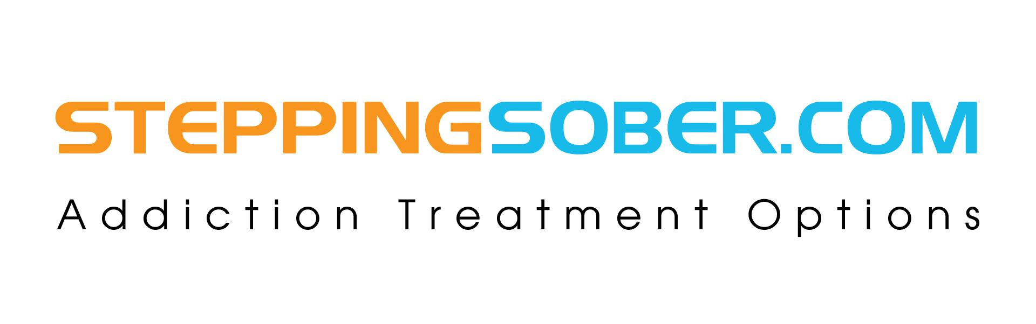
FOR IMMEDIATE RELEASE: Tierney Steiginga
Stepping Sober Addiction Treatment Options
M. (330) 921.1291 O. (561) 241-4630
tierney@daylightrecoveryfl.com

Addiction Resource Company Suggests New Methods For Opioid Addiction Treatment
Relapse Addiction Rates Cut In Half By New Medication Plans Implemented with Therapy

PALM BEACH GARDENS, FL, February 6, 2018: . Medication Assisted Therapy (MAT) for addiction has been proven to be 50-62% more effective than abstinence based addiction treatment programs, according to the NIDA,. One of the largest efforts to battle the drug crisis our country is currently facing is proper and effective drug detox and rehabilitation programs. Stepping Sober Addiction Treatment Options is “Stepping Up” as a resource to those who need to know more about this crisis, by offering educational content, and treatment resources for those suffering from this deadly disease.

In order to aid in the battle against opioid drugs-(like oxycodone, morphine and heroin) and save the lives of those who are struggling with from the disease of addiction, more information must be provided to the pubic. Stepping Sober wants to educate the public specifically on the newer forms of medication assisted treatment that has been proven more successful than previously implemented rehab programs.

Blocking drug cravings while easing withdrawal symptoms are the aspects of medication assisted treatment that seems to be the key ingredients that make medication assisted treatment so successful. While patients receive medication they also gain therapy to get to the issues surrounding the disease of addiction. Most rehabilitation centers offer therapy groups which focus on relapse prevention, addiction education, co-occurring disorder or trauma therapy.

Stepping Sober Addiction Treatment Options strives to battle the opioid and heroin crisis dead on. Established in 2013, the have been focused on providing educational content and treatment advising resources for those who are suffering from addiction. Their focus is specifically opioid- pain medications and heroin resources. They also believe that each rehabilitation option should offer specialized programs that are focused around the unique needs of the clientele. For more information visit: www.steppingsober.com

###

For more information or to schedule an exclusive interview with our clinical/medical team please feel free to email Tierney Steiginga, at tierney@daylightrecovery.com, or call (330) 921-1291.

