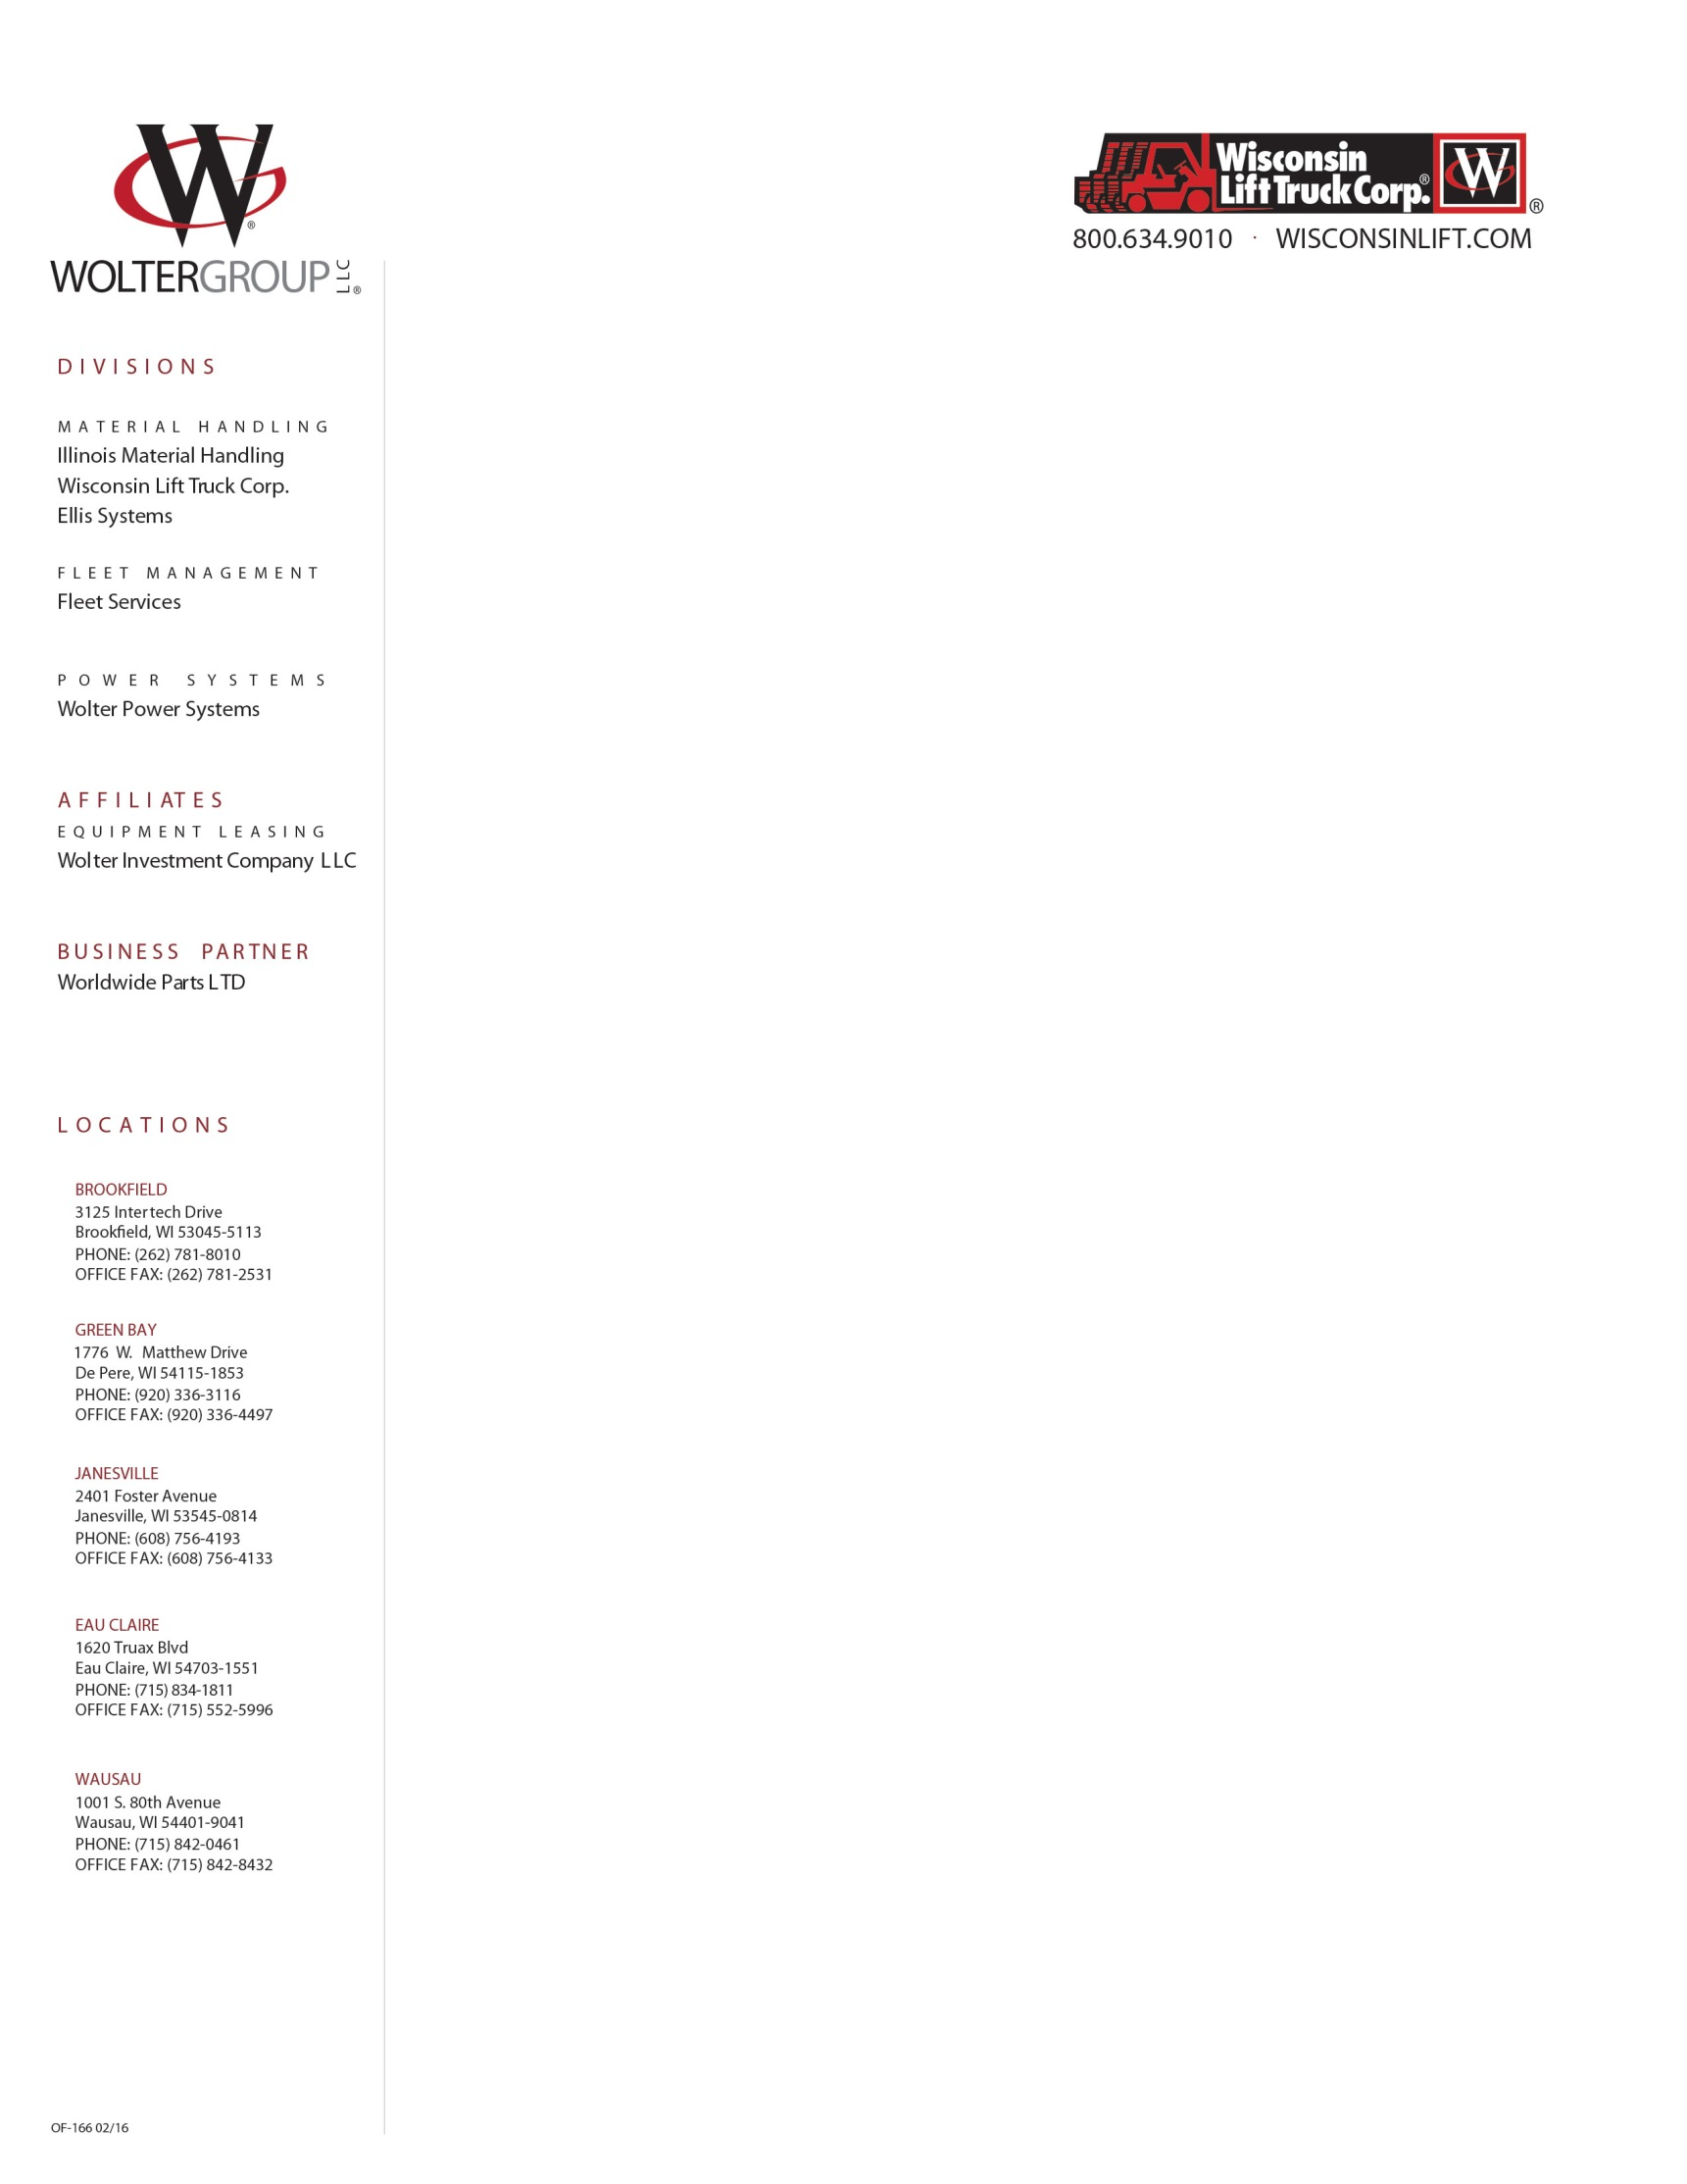

News Release February 15th, 2018

For Immediate Release WLT-0218

**WISCONSIN LIFT TRUCK CORP. AWARDED**

**EIGHTH CONSECUTIVE MHEDA MVP STATUS FOR 2018**

**BROOKFIELD, WI-** Wisconsin Lift Truck is honored to have received the reputable MVP (Most Valuable Partner) Award for 2018! This is the company’s eighth consecutive year being selected for MVP status by the Material Handling Equipment Association (MHEDA), one of the industry’s highest regarded trade associations.

Members of MHEDA must fulfill a substantial set of criteria in order to be a part of the 10% considered for the award. As a 2018 MVP, Wisconsin Lift Truck has successfully demonstrated a commitment to business excellence, professionalism and good stewardship.

In order to qualify for the annual MVP Award, companies are required to provide evidence of their dedication to their partners in business. These partners include their customers, employees and suppliers. In addition, they must meet the following criteria:

* Industry Advocacy
* Customer Service & Safety Practices
* Business Networking
* Continuing Education
* Business Best Practices

“We’re proud to have earned our eighth consecutive MVP status award from MHEDA. Attaining the MHEDA MVP award makes a statement to our employees, our suppliers and our customers. It confirms our commitment to high standards and continuous improvement to lead the industry.” – Jerry Weidmann, President, Wolter Group LLC.

*Wisconsin Lift Truck Corp., part of the material handling arm of Wolter Group LLC, delivers superior service to over 15,000 customers in its tristate service area shared with Illinois Material Handling. The foundation of Wolter Group’s success is its highly trained staff of over 390 employees with an average tenure of 17 years of service. Other members of Wolter Group LLC include Wolter Power Systems, specializing in industrial engines and generators, Ellis Systems featuring office and industrial storage solutions; as well as Fleet Services, offering ways to improve fleet performance to reduce the cost of material handling.*

*For more information, contact Kristin Lelewicz, at Wolter Group LLC; Phone 262-781-8011 x3145;   
E-mail:* [*kristin.lelewicz@woltergroupllc.com*](mailto:kristin.lelewicz@woltergroupllc.com)