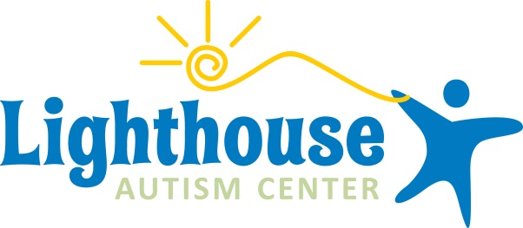

Press Release - FOR IMMEDIATE RELEASE
Contact: Michele Rohyans
Family Outreach Coordinator
269-359-0689 | micheler@lighthouseautismcenter.com

New Autism Center Hosts Open House in Portage, Michigan
Lighthouse Autism Center Welcomes The Community To Their New Location

PORTAGE, MI, Feb 1, 2018 – Lighthouse Autism Center, a facility for children with autism, has opened a new location in Portage, Michigan. Lighthouse Autism Center provides year-round intensive center-based therapy utilizing the principles of Applied Behavior Analysis (ABA).
Over 50 years of research documents the efficacy of ABA in reducing inappropriate behavior and in increasing communication, learning, and appropriate social behavior. After decades of research, the United States Surgeon General has endorsed intensive behavioral intervention for individuals with autism and other development delays.
This is the fifth location for Lighthouse Autism Center, who opened their first center in Mishawaka, Indiana in May 2012. Lighthouse was founded by parents Gregg and Sandy Maggioli, who have a son with Autism named Victor.

“When our son was diagnosed we were fortunate enough to have access to a wonderful center which offered ABA therapy in Carmel, Indiana.” Says Gregg Maggioli. “This intensive center based therapy has made a huge difference in our son Victor’s life. Sandy and I spent eight years volunteering at the center. I served as Chairman of the Board and Sandy held a variety of positions.”

When Gregg heard that his hometown of Mishawaka, Indiana didn’t have a quality ABA center like the one in Carmel, he knew his home area was in need.
“It quickly became apparent an intensive ABA center was needed in the Michiana community — we needed to offer the children in Michiana the same opportunities that our son had received.”

Now Gregg and Sandy have brought their expertise in autism therapy to Portage, Michigan.

The therapy that Lighthouse centers provide is intensive, center-based ABA. The centers are open throughout the whole year and each child’s therapy plan is custom-tailored to their specific needs.

This type of ABA therapy is unique to the Kalamazoo area, and Gregg is adamant about the clinical effectiveness of this format.

They plan to serve the needs of at least 15 children at the new location in Portage.

To celebrate the opening of the new center, Gregg and Sandy are hosting an open house on Tuesday, March 6th from 6 pm to 9 pm (EST). There will be appetizers and light beverages served. Guests will get to tour the new center and learn about Lighthouse’s year-round ABA therapy programs.

About Lighthouse Autism Center
At Lighthouse, we understand the struggles you face as a parent when you are told that your child has Autism. We understand the frustration of feeling helpless — that there is no one out there to help your child reach his/her potential. This is why we created Lighthouse Autism Center. We offer hope for every child, every family.

For more information please call 269-359-0689 or visit us on the web at www.lighthouseautismcenter.com/lighthouse-autism-center-portage-michigan/.

###

