20/02/2018

Experienced team led by Tim Walker launches Aura Technology – on a mission to redefine the relationship between business and IT

A team of technology professionals with decades of experience between them have launched Aura Technology, a new managed service provider with a mission to “redefine the relationship between businesses and IT”.

Aura, led by Managing Director Tim Walker, works closely with businesses at senior level to make sure their IT provision is aligned to their business plans and goals. Tim was previously the Managing Director of Taylor Made Computer Solutions, and prior to that founded a London-based managed service provider, Iconnyx.

The company, which currently has offices in Ocean Village, Southampton, and Adam Street, Central London, works across the South and in the capital. It is recruiting quality IT support engineers as the company grows and expects to add offices and create 40 jobs over the next three years.

Aura has an experienced top team, all of whom have experience of working together. Aura’s Technical Director, Pete Hughes, has more than 20 years’ experience in IT services, business management systems and product design, while Head of Customer Strategy, Richard Flanders, has spent 10 years working strategically with UK businesses in all areas of IT. Steve Stokes is Head of Business Development, also leading on customer service and account management.

Tim (pictured), along with Pete Hughes, launched Aura after identifying that in general many IT providers claim to take a strategic approach but very often fail to live up to their promises.

Aura has developed a Strategic Review that would normally form the first engagement with a new client. This benchmarks the performance of the existing infrastructure, identifies issues or opportunities for improvement and recommends a bespoke solution.

Tim says: “In preparing to launch the company, we conducted a huge amount of research into the market and found that although many managed service providers claim to offer a strategic relationship with clients, few achieve this in practice on any meaningful level.

“A strategic approach is key to maximising efficiency, profitability and return on investment in technology, which is why Aura places great emphasis on building relationships at board or senior level to really have a positive impact on the businesses we work with.

“Automation has the potential to dramatically improve both the productivity and efficiency of any business. Aura’s real strength is the ability to identify where these solutions can be deployed to optimise business performance.

“Our approach is designed to eliminate technical jargon and confusion, collaborate with our clients and make independent recommendations so that the services being implemented fit the need – never the other way around.”

Once Aura has implemented a client’s recommended IT infrastructure, the focus then shifts to providing a truly proactive service – another area where Aura believes many managed services providers let customers down.
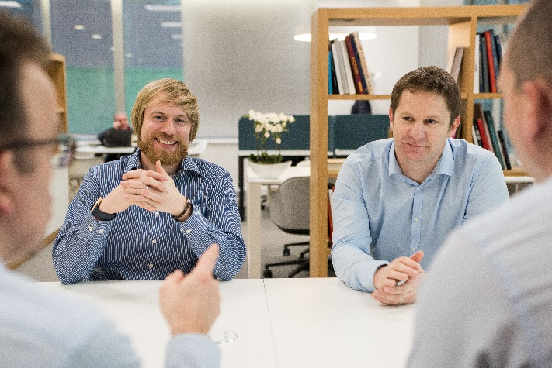
Tim says: “Lots of providers claim to proactively manage systems but this means very little in reality. At Aura we take this to a whole new level – it’s not just about maintaining the system, it’s about continuous improvement. Each client has a dedicated proactive engineer and account manager along with access to a director.

“We believe that genuinely proactive service is a serious responsibility, crucial to minimising disruption and downtime and delivering an ever-increasing return on investment.”

Aura’s core customer base is mid-market companies with between 50 and 500 IT users. It already has a growing roster of clients, with Isle of Wight-based sailing products specialist, Spinlock, the latest to be added.

To find out more, visit www.auratechnology.com or call 0333 320 8601.

Ends

About Aura
Aura Technology provides proactive strategic IT consultancy, managed services and support to mid-market companies across the South.
Operating from offices in Southampton and London, Aura redefines the relationship between businesses and IT, working closely with senior executives to align their technology infrastructure with their business strategies.
Aura is led by Tim Walker, who has run successful managed IT services companies for more than a decade, backed by a senior team of experienced IT and customer service professionals.
www.auratechnology.com

Contact: Issued on behalf of:
Graeme Patfield Aura Technology
E: auratechnology@polymediapr.co.uk www.auratechnology.com
W: polymediapr.co.uk
T: 01329 822866

