**TxDMV Board approves two new plates for Texas**

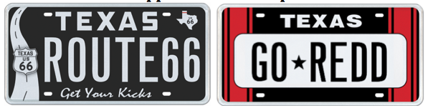

Austin (February 23, 2018) – MyPlates.com, the state’s vendor for specialty license plates in Texas has two new plate designs to market, following the TxDMV Board’s approval earlier this month of the Route 66 and the Racing Stripe Red designs.

My Plates is now accepting pre-orders for each of these new designs as they need to reach 200 to move the plates to production and final release.

The Route 66 plate design was proposed by My Plates after they conducted a survey in 2017 where hundreds of people registered support for the new design. The plate design features the iconic Texas road sign US.66 and carries the popular slogan “Get Your Kicks” along the legend area of the plate.

In Texas, US Route 66 extended across the Texas Panhandle running east-west from Texola, Oklahoma to the stateline-straddling Glenrio, sharing New Mexico and Texas roots. Amarillo is the only major city on the Texas portion of US 66. Small Texas towns Glenrio, Adrian, Vega, Conway, Groom, Jericho, Alanreed, McLean and Shamrock all once hosted the flow of travelers on the Mother Road as it made its way across the Panhandle. Each still retains certain characteristics of that past. Adrian is the midpoint of Route 66, an equal 1,139 miles towards either the LA or Chicago ends. Shamrock showcases the iconic Conoco Tower Station. Conway has a long seven-mile preserved stretch of still drivable original road. Vega has a surviving court motel still in pristine condition. And Glenrio an entire historic district full of original structures. All are worthy reminders of the glorious past of Route 66.

Several states including Illinois, Oklahoma, New Mexico and Arizona have already launched dedicated Route 66 plate designs in their respective markets. If 200 pre-orders are received, then Texas will be the next in line.

My Plates will dedicate a portion of the proceeds, 10%, to the Old Route 66 Association of Texas Fund dedicated to promoting this important part of Texas History.

“This is such an iconic route in the U.S, so it’s time that Texas also provide a Route 66 plate for all those travelers, adventurers, desperados and dreamers who have had the chance to experience this historic route to proudly show their support on their bumpers” said Steve Farrar, President of My Plates.

The second plate approved is a new design that sports car enthusiasts should be excited to order. The Racing Stripe – Red plate is designed to complement the many sports cars driving the roads of the Lone Star State with a black & red racing stripe paint job.

My Plates surveyed sports car owners to get feedback on which color scheme should launch first. The red stripe combination won and the vendor will also consider launching other stripe colors once the Red plate has won the race to 200 and made it to the market.

“With the red and black combination lapping the field, it launches first, but we’ll consider other stripe colors such as white, blue, green and pink” said Steve Farrar.

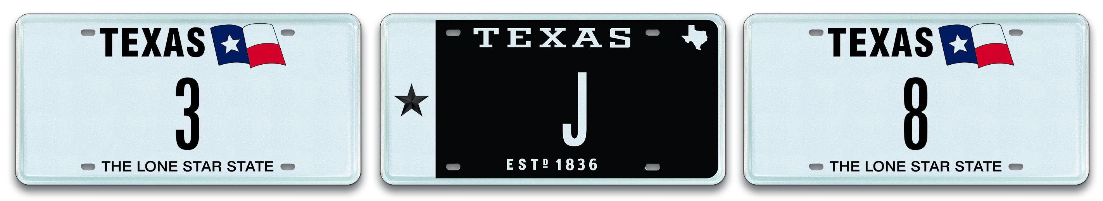

In other news, My Plates is conducting their first-ever single digit license plate auction where the messages “3”, “8” and “J” are being offered for sale. The current bids on these plates are all in the thousands and as of February 22nd at 5pm, they are:

* $10,250 bid on the low number 3
* $7,250 bid on the low number 8
* $5,500 bid on the single letter J.

The auction will run until February 28, 2018 with the first of the lots closing at 7pm.

To find out more information about the new plates are about the single digit auction, Texans can visit [www.MyPlates.com](http://www.MyPlates.com).

______________________________________________________________________________________________

**My Plates** designs and markets new specialty license plates as a vendor for the Texas Department of Motor Vehicles. Texans have bought more than 345,000 My Plates since November 2009, putting more than $62 Million in the state general revenue fund. My Plates’ goal is to create a long-term, mutually beneficial relationship designed to maximize revenues for the state through the sale of My Plates specialty plates. [www.myplates.com](http://www.myplates.com).

**The Texas Department of Motor Vehicles (TxDMV)** serves protects and advances the citizens and industries in the state with quality motor vehicle related services. For every $1 it spends, the TxDMV returns $11 to the state. The agency currently registers 24 million vehicles; issues more than 7 million vehicle titles; licenses more than 38,000 motor vehicle dealers and distributors; credentials nearly 60,000 motor carriers; issues more than 800,000 oversize/overweight permits; investigates more than 15,000 complaints against dealers and motor carriers; and awards grants to law enforcement agencies to reduce vehicle burglaries and thefts. Learn more at [www.TxDMV.gov](http://www.TxDMV.gov).

Contact Steve Farrar at (512) 633-7978 or [steve@myplates.com](mailto:kristy@myplates.com)