Press Release Contacts: For Immediate Release Vinitaly International
International Media Dept.

+39 045 8101447
media@vinitalytour.com
www.vinitalyinternational.com
Twitter: @VinitalyTour
Join Italian Wine Community on LinkedIn

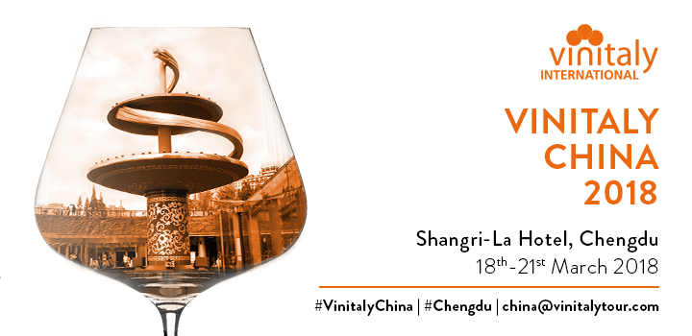
Vinitaly International and the city of Chengdu: it’s a match!

With China being in the process of becoming the world’s biggest importer of wine, it is only natural Vinitaly International decided to charm the Sichuan’s capital with the fifth edition of Vinitaly China-Chengdu. Moreover, an increasing number of Chinese consumers pursuing high-quality lifestyles and the consumption of imported wines becoming more and more widespread in the country encouraged Veronafiere to take a new priority: make the Chinese market fall head over heels for Italian products.

Asking any international tourist to come up with the one thing they remember best about the city, most people would probably mention pandas. Lovely, cute giant pandas. On the other hand, when asking a Chinese the response will probably include hot pots. The once silk brocade capital is now famous among the Chinese as the “leisure city” and was actually named UNESCO City of Gastronomy in 2010. It is no wonder then why the China Food and Drinks Fair for Wine and Spirits, its off-showcase —the International Wine and Spirits Show—, and Vinitaly China-Chengdu take place here.

Held at the luxurious Shangri-La hotel, Vinitaly China-Chengdu has definitely a lot to offer to this year’s participants for many reasons: 14 Italian wineries and 12 Chinese importers offering B2B Walk Around Tastings; executive seminars from the Vinitaly International Academy held by one of its Italian Wine Ambassadors (IWA); and a range of different Masterclasses organised in collaboration with ITA, the Italian Trade Agency. The event has all the premises to definitely be the perfect springboard for Italian wine makers (but not only!).

Among the various masterclasses, Vinitaly International’s one will focus on 5StarWines. The masterclass will be the perfect opportunity to learn more about
“5StarWines - the Book”. The guide is a compendium on the world’s finest wines born out of 5StarWines starring Wine Without Walls, a three-day grand tasting organised every year by Veronafiere and Vinitaly. During the event, 60 famous international wine virtuosos, together with a group of Italian experts blindly taste and evaluate samples. The book, which includes only the wines that score 90 points out of 100 (the 5 Star Wines from the grand tasting), was not created as a mere all-round catalogue of wines produced each year. Instead, “5StarWines- the Book” aims for a greater visibility to a range of different and worthy winemakers while also letting the public discover new under-the-radar products.

While the 5StarWines travelling to Chengdu this year are the 2017’s edition participants and have already been selected, chances to go to China in 2019 are still open! Sure enough, wineries who are interested in courting the Chinese market and having their wines evaluated by top judges from around the world have until March 20th to send their samples. (http://www.5starwines.it)

About
The grand Vinitaly 2018 will be held from April 15th to the 18th next year. Every year, Vinitaly counts more than 4,000 exhibitors on a 100,000+ square meter area and 130,000 visitors from over 140 different countries with more than 30,000 top international buyers. The premier event to Vinitaly, OperaWine (www.operawine.it) “Finest Italian Wines: 100 Great Producers,” which will be held on the 14th of April, one day prior to Vinitaly will unite international wine professionals in the heart of Verona, offering them the unique opportunity to discover and taste the wines of the 100 Best Italian Producers, as selected by Wine Spectator. Since 1998 Vinitaly International travels to several countries such as Russia, China, USA and Hong Kong thanks to its strategic arm abroad, Vinitaly International. In February 2014 Vinitaly International launched an educational project, the Vinitaly International Academy (VIA) with the aim of divulging and broadcasting the excellence and diversity of Italian wine around the globe. VIA this year launched the third edition of its Certification Course and today counts 122 Italian Wine Ambassadors and 9 Italian Wine Experts.

