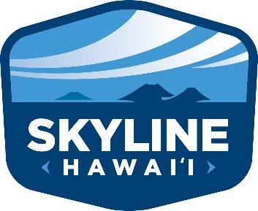
Media Contact:
Thomas Kratsch
Director Marketing
Skyline Eco-Adventures
808-878-8037
tkratsch@zipline.com

Skyline Hawai’i Removes 2184 LBS of Trash & Ocean Debris from Maui Beaches

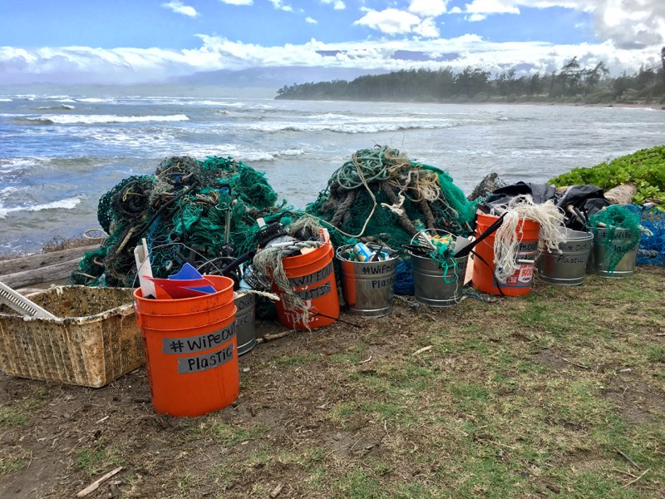

Maui, Hawaii (February 26th, 2018) - Skyline Hawai’i, Maui’s newest Haleakala National Park Tour Operator, has removed more than 1 TON of rubbish from Maui Beaches since December 2017 through a series of company beach clean-ups. The clean-ups have removed 2184 lbs of coastal and ocean debris – including discarded fishing nets and traps, plastic bottles and containers, polystyrene food containers, and nylon ropes along with many other smaller items. The clean-up efforts are part of an on-going company campaign in to address marine debris called Wipe Out Plastic.

“Our ocean and shoreline areas are quickly becoming inundated with plastic based rubbish which does not breakdown in the environment” said Danny Boren, President of Skyline Hawai’i. “We feel it is our kuleana as a Maui business, and as lifelong local residents, to do our part to help protect the coastlines and waters of Maui and Hawai’i through reducing our use of disposable plastic items and helping to clean-up the rubbish which is already out there causing harm to marine species and ultimately all of us on Maui.”

As part of the Wipe Out Plastic campaign, Skyline Hawai’i plans to continue regular company beach clean-ups throughout this year and in the years to come and has set a 2018 goal of removing 3 Tons of rubbish from Maui beaches. Through the Wipe Out Plastic Campaign, Skyline Hawai’i is also sponsoring Water Bottle Refill Stations at local Maui Elementary Schools through $10,000 grants given by the company in order to encourage Maui’s Keiki to have access to fresh clean water and utilize refillable water bottles on a daily basis. So far Water Bottle Fill Station Grants have been provided to Haiku Elementary School and Lihikai Elementary School, with 2 – 3 more school grants planned for 2018.

Skyline Hawaii provides guided tours of Haleakalā National Park including Haleakalā sunrise tours and daytime tours into the park. Skyline Hawaii operates Maui’s only Haleakalā Sunrise Bike & Zipline tour along with exclusive daytime tours that include a visit to MauiWine and Ali’i Kula Lavender farm. For reservations or more information visit www.skylinehawaii.com or call (808) 878-8400

Skyline Eco-Adventures provides awe inspiring zipline tours on Maui, Kauai and Big Island. Skyline Eco-Adventures is the United States' 1st zipline tour company, founded in 2002 on Maui, Hawaii. Skyline's first location, the Haleakalā Skyline Tour, is located on Historic Haleakalā Ranch in beautiful Upcountry Maui. For reservations or more information visit www.skylinehawaii.com or call (808) 878-8400

