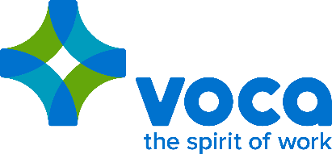

**National Release – Ray Culver Promoted to Chief Revenue Officer at Voca**

**VOCA, A NATIONAL STAFFING COMPANY BASED IN ROCHESTER, MN ANNOUNCES THE PROMOTION OF RAY CULVER TO NEWLY CREATED “C” SUITE ROLE – CHIEF REVENUE OFFICER**

Voca – a national staffing firm based in Rochester, MN – announced today the creation of a new “C” Suite role, Chief Revenue Officer and the promotion of Ray Culver to this new role.

Stephen Knaup, Voca’s CEO explains, “The addition of this role, and Ray accepting the role, will help Voca to design the right sales strategies for each segment of business that we staff for today and are looking to branch into for the future, while not letting our foot off of the gas in our sales efforts”.

In his new role, Culver will continue to lead sales for Voca throughout the US and will work to build and implement strategies to grow revenue effectively across all sales channels that Voca currently supports today. Culver brings over 23 years of industry experience to the position serving global staffing organizations including ManpowerGroup, Randstad/SFN Group, and most recently serving as Vice President, North American Sales for Voca.

“To say I am excited and honored to be asked to launch the CRO role for Voca would be an understatement,” comments Culver. “In my new role, I will be focused on driving strategy across all parts of the Voca organization to ensure that we are not only growing within existing business segments but opening up new segments at the same time.”

“I couldn’t be prouder of the job Ray has done over the last year and look forward to seeing how having someone to drive strategy across the enterprise helps to catapult Voca to the next level… 2018 is looking bright” said Knaup.

**About Voca:** Headquartered in Rochester, MN, Voca is a relationship organization focused on uniting talented individuals with exceptional companies to rediscover the spirit of work. Voca partners with leading public, private, non-profit, and government clients throughout the United States, providing support across diverse verticals including the Healthcare, Professional, Legal, Financial, Creative and Technology fields. For more information on Voca, please visit myvoca.com