Press Release
Taipei, Taiwan – March 6th, 2018
Cincoze Announces Sunlight Readable Panel PC and Touch Monitor for Outdoor Applications
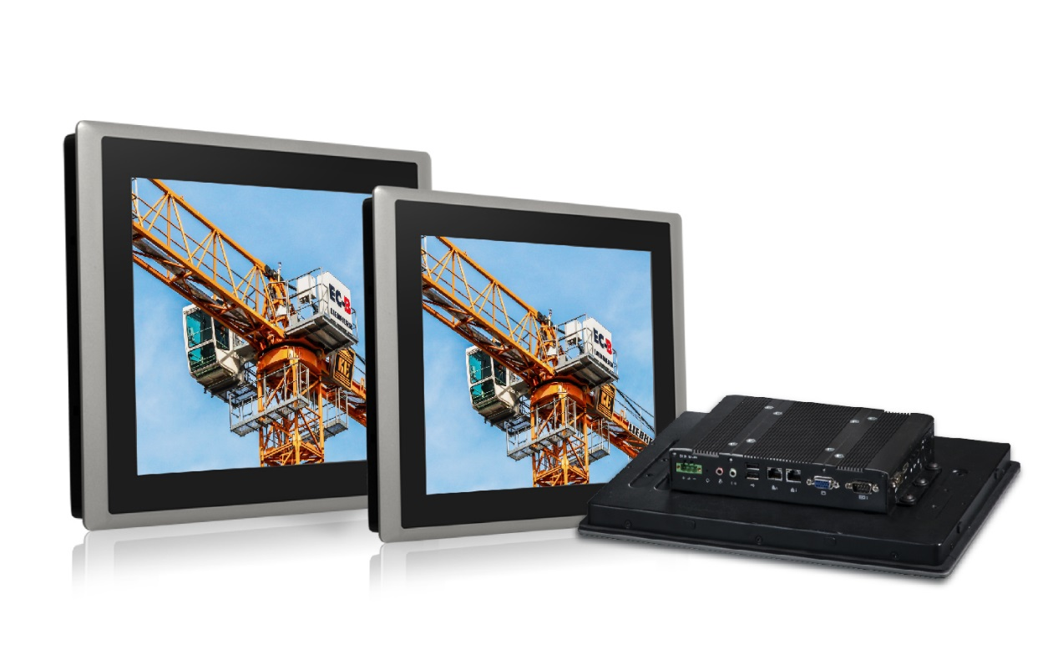
Cincoze is proud to announce sunlight readable panel PC and touch monitor “CS-100 Series”. The product series incorporates an ultra high brightness backlight module up to 1,600 nits which provides superior readability under a high-ambient light condition and even direct sunlight. CS-100 Series also supports wide range operating temperature (max. range: -20°C ~ 70°C) to ensure stability and reliability of the system in outdoor environments.
Built with solid aluminum die-casting front bezel, true flat IP65 front panel protection and 7H anti-scratch projected capacitive touchscreen make it ideal for installation in harsh environments. Without compromising rugged functionality, CS-100 Series still keep slim-type design and provide the same look and feel within Cincoze display computing solution.
CS-100 Serie also supports optical bonding for an alternative. By eliminating the air gap, optical bonding can reduce reflection and increase sunlight readability. In addition, it has higher resistance to shock & vibration, prevents fog formation during rapid temperature change, and also benefits better touch performance and heat dissipation.
Furthermore, CS-100 Series is fully supporting Convertible Display System (CDS) technology which is based on modular design concept. It can offer users the possibilities of upgrading computing module and changing display module. Comparing with regular standalone panel PCs, it is more cost-effective and reduces on-site maintenance time.
“Taking advantages of Cincoze patent CDS technology, CS-100 Series is compatible with existing CDS models, including M1000 monitor module, P2000 and P1000 system modules. The users can easily configure their applications, such as heavy-duty lifting & moving equipment, e-toll collection system, car-sharing system and outdoor kiosk.” said Brandon Chien, CEO of Cincoze. “With the launch of CS-100 Series, Cincoze is not only providing the products for indoor use, but also expanding its product range to outdoor use.”
CS-100 Series offers five panel sizes that range from 10.4 to 19 inches and the industrial panel PCs are available with two different CPU versions, including Intel® Core™ i and Atom™ to fulfill different performance requirements.
Key features of CS-100 Series:
- 10.4” to 19” TFT-LCD with Ultra High Brightness up to 1,600 nits
- Wide Range Operating Temperature (max. range: -20°C ~ 70°C)
- True Flat IP65 Front Panel Protection
- Rugged Aluminum Die-casting Front Bezel
- Convertible Display System (CDS) Technology Supported
- Supports Optical Bonding

CS-100 Series Line Up
Panel Size (Brightness) | Industrial Panel PCs |  | Industrial Monitors
 | Core™ i5-6300U | Atom™ E3845
10.4", XGA (1500 nits) | -- | CS-110/P1001  CS-110/P1001E** | CS-110/M1001
12.1", XGA (1500 nits) | CS-112/P2002  CS-112/P2002E* | CS-112/P1001  CS-112/P1001E** | CS-112/M1001
15", XGA (1600 nits) | CS-115/P2002  CS-115/P2002E* | CS-115/P1001  CS-115/P1001E** | CS-115/M1001
17", SXGA (1500 nits) | CS-117/P2002  CS-117/P2002E* | CS-117/P1001  CS-117/P1001E** | CS-117/M1001
19", SXGA (1600 nits) | CS-119/P2002  CS-119/P2002E* | CS-119/P1001  CS-119/P1001E** | CS-119/M1001
* with 1x PCI or 1x PCIex4 Expansion slot
** with 2x Universal I/O Brackets

About Cincoze
Cincoze, a professional manufacturer of embedded computing platforms. We design, manufacture, and market Rugged Fanless Computer, Industrial Panel PC and Monitor for harsh and demanding environments. With its leading-edge products and application-driven functionalities, Cincoze enables new technologies and solutions for multiple applications, including factory automation, machine automation, machine vision, in-vehicle computing, intelligent transportation, and surveillance.

Cincoze Co., Ltd.
7F., No.4, Aly.1, Ln.235, Baociao Rd, Sindian Dist., New Taipei City 23145, Taiwan
Tel: +886-2-2918-8055
Fax: +886-2-2918-8066
http://www.cincoze.com/

All product names, logos, and brands are the property of their respective owners. All company, product and service names used in this document are for identification purposes only. Use of these names, logos, and brands does not imply endorsement.
Copyright 2018 Cincoze Co., Ltd. All rights reserved.

