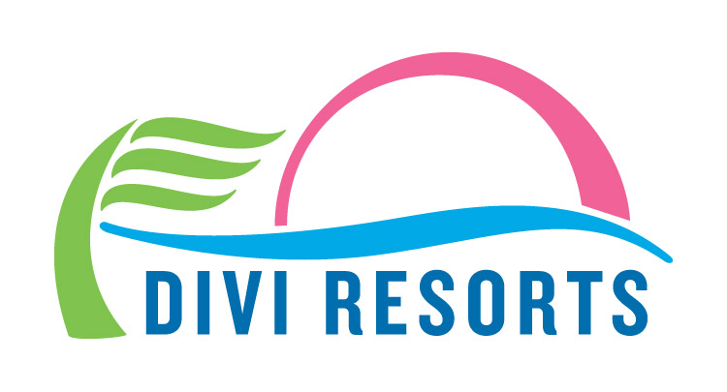

Contact: Alyssa Smith
Phone: (919) 419-2039
Alyssa.smith@diviresorts.com

Splash Into Savings with 30% Off Divi Resorts’ Top Caribbean Destinations
Book between March 5 & April 30 to score rates as low as $149 per night!

CHAPEL HILL, NC— Divi Resorts is making waves with its latest splash sale, featuring 30% off top Caribbean destinations in Aruba, Bonaire, Barbados and St. Maarten. Travelers searching for warm weather and cool drinks can take advantage of this offer from March 5-April 30 for all 2018 travel dates.

“After a long, cold winter in the states and Europe, we are happy to offer relief for those hoping to escape to paradise,” said Marco Galaverna, Divi Resorts President & COO. “Warm sand, smiling faces and swaying palm trees await you at Divi Resorts!”

Boasting tropical Caribbean locations on the enchanting islands of Aruba, Bonaire, Barbados, and St. Maarten, Divi Resorts provides a wide variety of on-site amenities, including elegant restaurants with mouthwatering menus, lively bars with thirst-quenching libations, fabulous freshwater pools, sports courts, spas and more!

Divi’s all-suite accommodations are perfect for couples on the hunt for a romantic getaway and families needing extra space to stretch out. Plus, with Divi’s Kids Stay and Eat Free Program* and Treasures of the Caribbean Kids Club, even the youngest of guests will have plenty to do, for a fraction of the cost. And since room only stays are priced per room and not per person, solo travelers can also enjoy Divi’s safe, friendly islands, without the extra cost.

Divi Resorts proudly offers a 20% discount, in addition to the 30% off deal, for a total of 50% off for those who have served their country and communities. This offer is available to all military personnel, firefighters and police, including those who are on active service, reserve and retired, as well as their spouses and children.

Deals on room only and all-inclusive stays are as follows:

- Divi Village Golf & Beach Resort on Aruba – rates start at $175 per night (room only) or $227 per person, per night (all-inclusive)

- Divi Dutch Village Beach Resort on Aruba – rates start at $169 per night (room only) or $200 per person, per night (all-inclusive)

- Divi Aruba Phoenix Beach Resort on Aruba – rates start at $249 per night (room only)

- Divi Flamingo Beach Resort & Casino on Bonaire – rates start at $149 per night (room only) or $178 per person, per night (all-inclusive)

- Divi Southwinds Beach Resort on Barbados – rates start at $159 per night (room only)

- Divi Little Bay Beach Resort on St. Maarten – rates start at $189 per night (room only) or $195 per person, per night (all-inclusive)

This limited time offer runs from March 5th, 2018 at 12:00 a.m. through April 30th, 2018 at 11:59 p.m. EST, for all 2018 travel dates. For reservations, book online at https://www.diviresorts.com/caribbean-promotion.htm or call 1-800-367-3484 (Toll-free US) or 1-919-419-3484 (International). For group reservations, please call 1-800-801-5550 or email groupsales@diviresorts.com.

Travelers can also enter for a chance to win a free 7-Night Summer Vacation at Divi Resorts as part of Divi’s 90-Day Caribbean Giveaway. A lucky winner will be selected Thursday, March 22 at 4:00 p.m. EST.

*For more information on Divi’s Stay and Eat Free Program or Treasures of the Caribbean kids club please visit http://www.diviresorts.com/kids.htm.

About Divi Resorts
Divi Resorts is the vacation expert of the Caribbean, with a collection of eight premium resorts spanning the five stunning Caribbean islands of Aruba, Barbados, Bonaire, St. Croix, and St. Maarten. For more information on Divi Resorts, call 1-800-367-3484 or visit www.diviresorts.com.

Sale Terms & Conditions
This offer applies to reservations made from March 5-April 30 for all 2018 travel dates. Discount based on rack pricing. All-inclusive rates based on double occupancy. Taxes & services charges NOT included, except for All-Inclusive packages. 3-night minimum stay required for All-Inclusive packages. No maximum night stay is required. Restrictions & blackout dates apply. Full payment is required at time of reservation. Cancellations must be received at least 7 days prior to arrival for refund. Flight cancellations are subject to airline cancellation policies. Divi Resorts is not responsible for changes in airfare pricing. Offer is subject to availability and may be discontinued at any time. Offer valid on new reservations booked at a nightly rate only. Offer not valid on timeshare reservations. Cannot be combined with any other Divi special offer.

