FOR IMMEDIATE RELEASE: Media Inquiries:
5W Public Relations
Tel: (212) 999-5585
info@preval.com



PREVAL ENTERS 2,400 WALMART STORES
Industry leader for spray and touch-up solutions expands its retail roster

Bridgeview, Illinois (February XX, 2018) – Preval, the industry leader in spray and touch-up solutions, announces its official launch into 2,400 Walmart locations across the country as well as part of the retailer’s online offerings. Preval is entering into noteworthy markets including Nashville, Orlando, Salt Lake City, Austin, Las Vegas and Dallas, to name a few. The brand is continuously developing its distribution channels nationally and around the globe, already sold in a number of countries, such as the United Kingdom, Spain, Brazil and France.

“As a growing company, we are excited to expand Preval’s availability into Walmart” says Preval President, Sam Averbuch. “As we remain the leader in spray and touch-up solutions, this certainly validates Preval as an influential brand in the industry.”

With 45 years of innovation, the Preval Sprayer is truly a multipurpose gadget that allows consumers to take any paint, coating or lacquer and turn it into a spray, offering convenient and effective results. Priced at Walmart for just under $10, this affordable aerosol can allows users to pick any paint for use in a variety of projects from revamping old furniture or decorating home accessories to touching up car paint. By entering into Walmart stores, Preval is providing consumers with additional resources for all professional and DIY projects as a first of its kind and unlike any spray paint that comes in standard colors.

In addition to the Preval Sprayer, Walmart will also be carrying an assortment of Preval accessories to make spray painting easier. These include the vGrip Universal Handle, vFan Airbrush, Dip Tubes, Domestic Auto Power Unit and extra plastic bottles.

For additional information please visit: www.preval.com, as well as the company’s Facebook, Instagram, Twitter and YouTube pages.

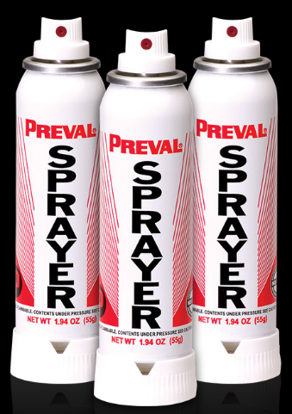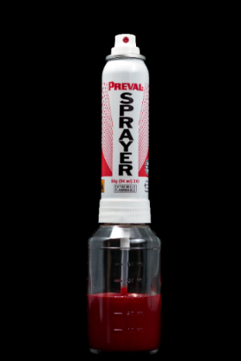

About Preval:
Preval is the industry leader for spray and touch-up solutions. The company’s suite of precision-based technology products and accessories allow consumers to take any paint, coating or lacquer and turn it into a spray, offering convenient and effective results for the professional and DIY user. Preval’s products provide versatility by delivering both ultra-thin and thick coatings, allowing users to achieve professional level results time after time, while maintaining a low environmental impact.

Preval to share if Walmart boilerplate is needed as well

###

