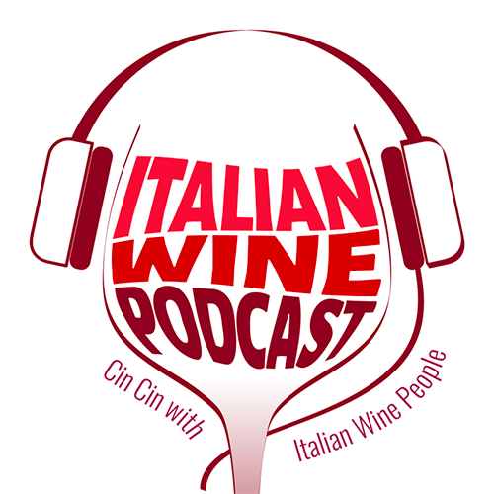

Press Release
For Immediate Release Italian Wine Podcast
Giulia Bruna (Project Coordinator)
Ph. +39 045 8101447
info@italianwinepodcast.com
www.italianwinepodcast.com
Available on SoundCloud, iTunes, and Ximalaya
Follow us on Facebook, Twitter, Instagram, LinkedIn

March 9th, 2018

One year on air: Italian Wine Podcast celebrates its first birthday

On March 10th, 2017, Italian Wine Podcast broadcast its first episode on SoundCloud and iTunes. The episode featured an interview with Elisabetta Gnudi Angelini, owner of Altesino winery and other estates, telling podcast host Monty Waldin about sustainable viticulture and her love for tortellini. On March 10th, 2018, after 87 episodes broadcast every Tuesday and Wednesday, Italian Wine Podcast celebrates its first-year anniversary.
Italian Wine Podcast is an English-language podcast project dedicated to the storytelling of Italian wine through the voice of its main proponents: producers in the first place along with a number of personalities (educators, experts, trade professionals) orbiting planet vino in Italy and abroad. Listeners can enjoy the show free of charge by subscribing to one of the show’s multiple platforms: SoundCloud, iTunes, the official website, and the recently-launched XimalayaFM channel which makes the podcast available in China.
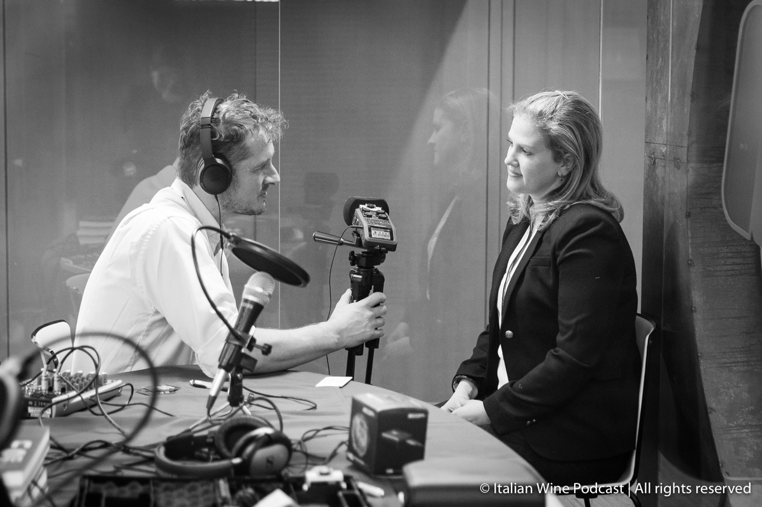
Photograph: Podcast host Monty Waldin recording episode 86 with Alison Napjust (Senior Editor at Wine Spectator) as part of the new “Let’s talk wine biz – wine2wine series”

The Italian Wine Podcast host is the English wine writer Monty Waldin, who has published widely particularly on biodynamic wine. Waldin explains the importance of the project: “The Italian Wine Podcast is a guide into the endlessly fascinating world of Italian wine from A to Z in easily digestible, bite-sized audio chunks! My interviewees range from 100-points-scoring winemakers that grace the covers of the world’s leading wine magazines, via little known artisans with a story to tell to up-and-coming winemakers. The Podcast also focuses on the commercial side of wine-growing where I interview those who follow–and set–trends in sales and marketing or create innovations in packaging. Leading sommeliers, importers, and distributors who work intimately with Italian wines from New York to Hong Kong get plenty of air-time too. Leading wine writers also get to sit in the podcast hotseat, explaining the ins and outs of how they get the best stories about Italian wines and winemakers into print or out online.” Waldin’s winemaking background coupled with his long-standing interest in alternative wine-growing also means Italian winemakers who work either organically, naturally, or biodynamically get to share their story too.
Italy counts the largest number of native grape varieties in the world grown on its national territory—this grape biodiversity being an impressive primacy in this era of climate change. Moreover, as is well known, Italy’s wine and food culture along with its romantic landscapes are among the factors which make the country famous worldwide. Yet, both the diversity of Italian wines coming from lesser-known grape varieties and the regional fragmentation of the country’s wine and food traditions may at times hinder a deeper understanding of the high quality of Italian wines. Italian Wine Podcast was born to explain this complexity and the century-long history of Italian wine. The mastermind behind the project is Stevie Kim, Managing Director at Vinitaly International. Kim’s constant quest for innovative and digital ways to communicate Italian wine to international audiences pushed her to invest in an English-language podcast project: “Podcast is not yet very popular among winemakers, but I really believe the audio format is the way forward. Nowadays it is all about competing for attention and the audio format has an enormous potential: for example podcasts can be enjoyed while doing other activities (driving, working out, travelling) and podcast listeners are incredibly loyal to shows. So I am confident the podcast medium will soon come around in our sector too becoming a crucial tool for us to broadcast our ideas and passion about Italian wine.”
The Italian Wine Podcast’s mission—to inform, educate, and entertain about Italian wine—is reinforced also in a number of thematic series which orderly guide listeners to learn more about Italian wine. At present, every Tuesday the “Let’s talk wine biz – wine2wine series” introduces some key players in the global wine business and discusses Italian wine in relation to hot topics such as social media, international markets and more. Every Wednesday, Waldin once more unearths the great family histories of Italian wine producers. In addition, listeners can also browse through the podcasts regionally in the “Discover Italian Regions” series. A series on “Italian Wine Coops” introduces Italian wine cooperatives, unveiling the inner workings and cruciality of the cooperative system in the Italian wine industry. The series “Italian Native Grape Varieties” provides a specific focus on three Italian native grapes, Glera, Aglianico, and Sangiovese. Additional series include podcasts on “Natural Wine” where wine writers and professionals advocate for less invasive wine-making methods and the “Learning about Italian Wine” series, which groups together the experiences of international experts and students coming to grips with Italian wine’s complexity. In the second year of air-life for the Italian Wine Podcast new thematic series coming up in the Spring will feature Sagrantino producers and Italian wine influencers.

About:
Italian Wine Podcast: Cin Cin with Italian Wine People! is a new podcast project dedicated exclusively to the Italian wine world. Wine writer Monty Waldin uncovers the unique Italian wine-making tradition in conversation with some of its key protagonists. Italian Wine Podcast aims to inform, educate, and entertain about Italian wine.

