Press Release Contacts: For Immediate Release Vinitaly International
International Media Dept.

+39 045 8101447
media@vinitalytour.com
www.vinitalyinternational.com
Twitter: @VinitalyTour
Join Italian Wine Community on LinkedIn

A star-spangled OperaWine opens Vinitaly 2018

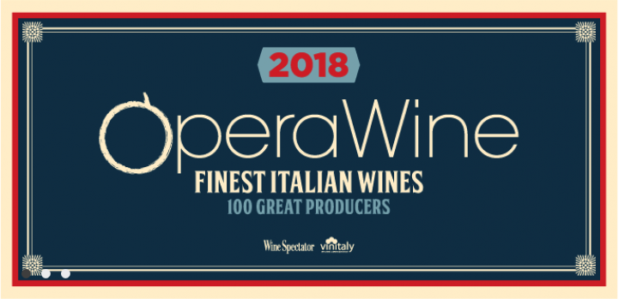
Although Italy’s attention has recently shifted on the Asian wine market, the United States does remain the strongest ally of Italian wine. Paying homage to this connection and the works of American street artist Shepard Fairey, on April 14th Vinitaly and Wine Spectator will present an urban OperaWine 2018 at Palazzo della Gran Guardia in the heart of Verona.

There was a time when street art was viewed as an act of vandalism. The success of graffiti king Banksy, London gallery Tate Modern inviting artists to create outdoor pieces, and councils worldwide commissioning urban works were some of the trends which elevated this democratic form of expression to the realm of art. This shift was a major and well deserved achievement, since the intrinsic characteristics of street art—accessibility, boldness and openness—are what made it so cutting-edge.

This year Stevie Kim, Korean-American who leads Vinitaly International and OperaWine, attempts to connect the dots and to challenge people to think about Italian wine in the same way they feel about street art: refreshed, rejuvenated. Combining the urban movement’s spry energy and one of its presumed places of origin—the U.S.— Vinitaly has put together a star-spangled OperaWine 2018. Inspiration came also from street artist Shepard Fairey, whose little-known name is balanced out by the fame of the colourful posters he created for the Obama 2008’s presidential campaign. In entering the premises of the historic Palazzo della Gran Guardia the simplified lines and geometry, the red, the white, and the blue will all be there to highlight the precious and enduring Italian-American bond.

As usual, OperaWine’s spotlight will be on the 107 wine producers nominated by leading publication Wine Spectator. On her comeback to Palazzo della Gran Guardia, Marchesi Antinori, winemakers since 26th generation of Prunotto commented, “We are honoured to be part of Wine Spectator’s “100 Great Producers” with our historical winery. Founded in 1904, Prunotto has been selecting the best cru in the Alba area of Langhe since its very beginning. The wine we will present, Barolo Bussia 2011, celebrates our 50th anniversary of production from the single vineyard of Bussia.”

Out of the over 100 wineries attending, 13 made it through the selection for the first time: Quintodecimo, Gravner, Mamete Prevostini, Bortolotti, Nino Franco, Leone de Castris, Pietradolce, Serraglia, Tenuta San Leonardo, Boscarelli, Tenuta di Trinoro, Maculan. Serena Guida for Leone de Castris expresses her satisfaction in being one of the new entries: “For us, it surely is a source of pride, as well as a stimulus to keep up with the quality standards and enhancement of our grape varieties and territory. In addition, it occurs on the occasion of the 75th Five Roses harvest, the very first Italian rosé wine, which we have been producing since 1943.” Similarly, Mateja Gravner (Gravner) states: “It's a real honour to be part of the wineries selected for the seventh edition of OperaWine and it represents a good opportunity to meet both the producers and the foreign press involved.”

Opening act of the 53rd edition of Vinitaly, OperaWine is a portrait of the best Italian wine producers and the perfect networking opportunity for wineries. Vinitaly’s customary preview since 2012, OperaWine is a window on Italian biodiversity. With a selection of products ranging from the Northern region of Valle d’Aosta to the Southern island of Pantelleria, from hundred-year-old wineries to the ones that only recently appeared on the market, OperaWine 2018 will, once again, tell the multifaceted story of Italian wine.

Special thanks to Volkswagen (Main Partner); UniCredit (Official Partner for the Press Conference); Asiago DOP, Electrolux, Levoni, Peltrolux, and Surgiva (Technical Partners).

Full list of OperaWine Producers 2018
Binomio
Masciarelli
Elena Fucci
San Martino
Odoardi
Vincenzo Ippolito
Fattoria Galardi
Feudi di San Gregorio
Mastroberardino
Quintodecimo
Salvatore Molettieri
Drei Donà
La Stoppa
Tenuta Pederzana
Gravner
Jermann
La Tunella
Livio Felluga
Falesco
Cantine Lunae Bosoni
Bellavista
Ca’del Bosco
Mamete Prevostini
Nino Negri
Garofoli
Umani Ronchi
Di Majo Norante
Bortolotti
Nino Franco
Aldo Conterno
Antoniolo
Braida di Giacomo Bologna
Cavallotto
Elvio Cogno
Falletto di Bruno Giacosa
Gaja
Giuseppe Mascarello & Figlio
Luciano Sandrone
Marchesi di Barolo
Massolino
Paolo Scavino
Produttori del Barbaresco
Prunotto
Renato Ratti
Vietti
Gianfranco Fino
Leone de Castris
Schola Sarmenti
Tormaresca
Agricola Punica
Argiolas
Cantina Sociale di Santadi
Dettori
Cusumano
Donnafugata
Feudi del Pisciotto
Morgante
Pietradolce
Planeta
Serraglia
Tasca d’Almerita
Tenuta delle Terre Nere
Elena Walch
Ferrari
Tenuta San Leonardo
Altesino
Antinori
Avignonesi
Biondi-Santi
Boscarelli
Carpineto
Casanova di Neri
Castello Banfi
Castello d'Albola
Castello di Ama
Castello di Volpaia
Fattoria di Fèlsina
Fontodi
Il Poggione
Le Macchiole
Marchesi de' Frescobaldi
Mastrojanni
Mazzei
Petrolo
San Felice
Siro Pacenti
Tenuta dell’Ornellaia
Tenuta di Trinoro
Tenuta San Guido
Valdicava
Arnaldo Caprai
Lungarotti
Tabarrini
Grosjean Freres
Allegrini
Bertani
Cesari
Gini
Leonildo Pieropan
Maculan
Masi
Prà
Suavia
Tedeschi
Tommasi
Zenato
Zymè

About OperaWine:
Veronafiere together with Vinitaly and with the valuable contribution of the prestigious magazine Wine Spectator, present “OperaWine, Finest Italian Wines: 100 Great Producers” (www.operawine.it) an exclusive event aimed at appraising the distinctive characteristics of Italian wine. “OperaWine” offers international wine professional the opportunity to try and get to know the best wines presented by 100 greatest Italian producers selected by Wine Spectator. The new premier event to Vinitaly 2018 “OperaWine”, will be held on April 14th 2018 in Verona. OperaWine, at its seventh edition, has become the successful premier event to Vinitaly and welcomes all those who wish to experience the best that Italy has to offer in one afternoon.

