
FOR IMMEDIATE RELEASE: (03/20/2018)
Ray Almgren
Swift Sensors, Inc.
ralmgren@swiftsensors.com
+1-512-415-3261

Swift Sensors Custom Dashboard Simplifies Data Viewing and Analytics for Cloud-based Wireless Sensor System
End-to-end IoT sensor system adds user-defined customization and expanded language support

Austin, TX: Swift Sensors, Inc. a supplier of plug-and-play cloud wireless sensors systems for Industrial IoT, announces the addition of user-defined dashboards to simplify and enhance viewing and analytics of critical sensor data. These new features will help Swift Sensors customers gain deeper insight into “big data” from wireless sensor networks and simplify IoT systems to deliver true value.

“Providing a simple, intuitive cloud dashboard is essential to driving value from a wireless sensor (IoT) system,” says Sam Cece, founder and CEO of Swift Sensors. “Our end-to-end system delivers simplicity and value at all levels -- from installation to configuration to data analytics.”

The Swift Sensors cloud-based dashboard allows real-time asset monitoring and sophisticated analytics from anywhere. The enhanced dashboard will allow customers to show sensor data in the manner that’s most relevant to their business, including the option to create multiple views of data streams to identify patterns and correlations.

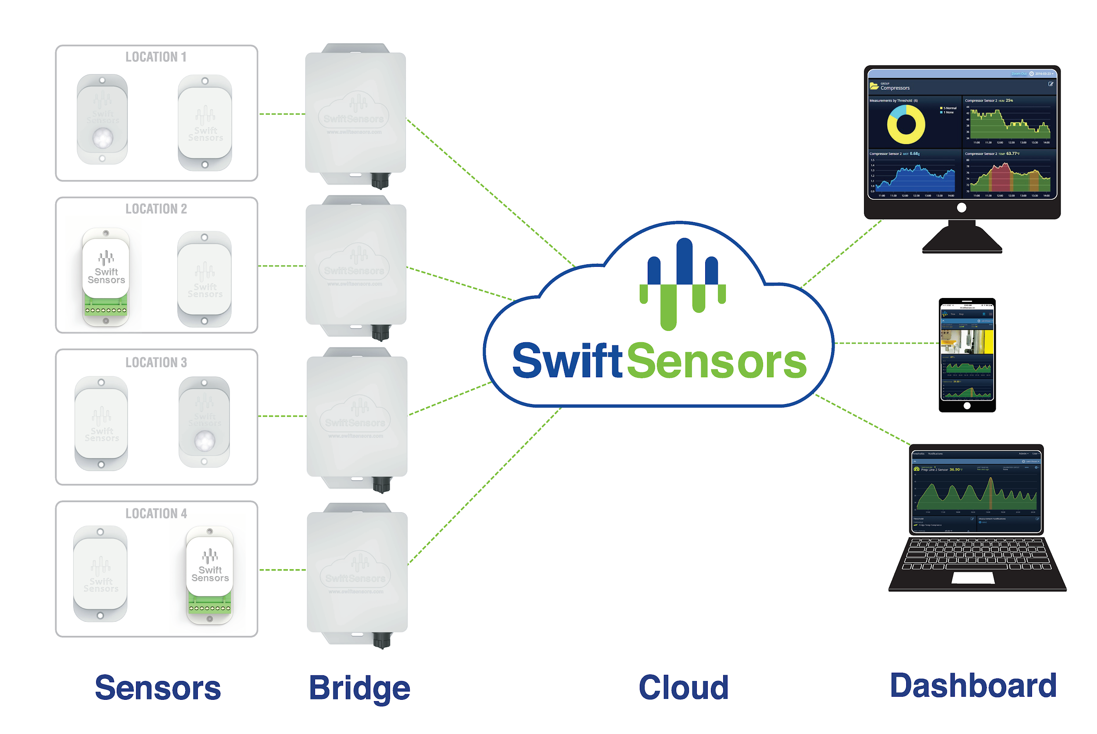
More details on the new dashboard features:
- Custom Dashboards: Users can now create custom dashboards shared with all account users. Custom Dashboards are user-defined pages with a collection of panels with only the data users want to see, in the order they want to see it.
Customer Use: Aerospace manufacturing company uses custom dashboard to track sensors measuring machine output and utilization.
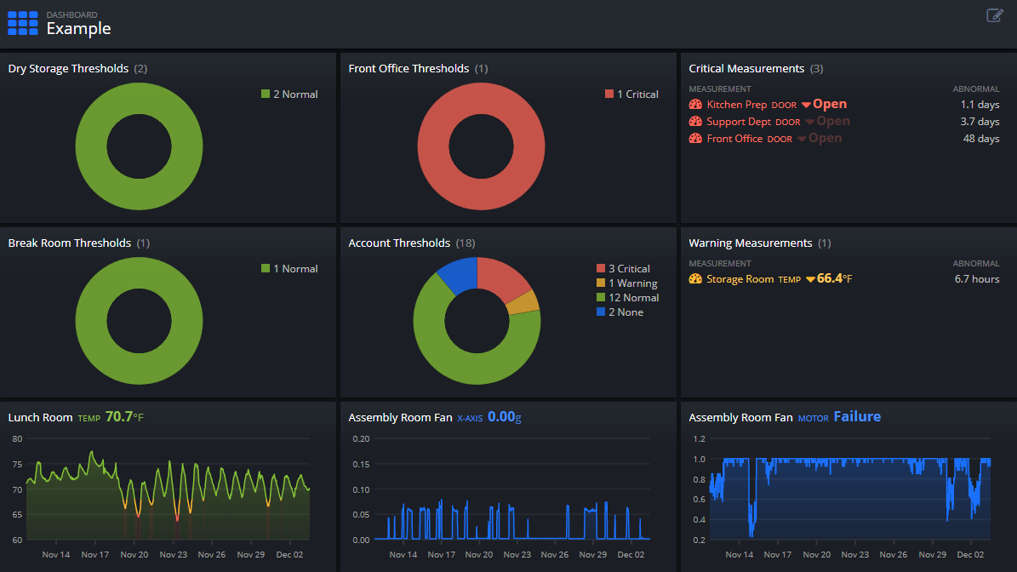

- Set Default Dashboard: Users can select their favorite dashboard to be their default view. When a Dashboard is marked as the default view, the user will be taken directly to this Dashboard upon signing into Swift Sensors.
Customer Use: A 1000 seat restaurant and banquet facility manager creates default view for walk-in coolers and freezers.
- Combo Chart: The dashboard now supports a new Combo Chart panel. This panel allows up to four measurements to be rendered on the same chart, even if those measurements use different units.
Customer Use: A large food manufacturer tracks vibration and temperature data to enhance preventive maintenance program.
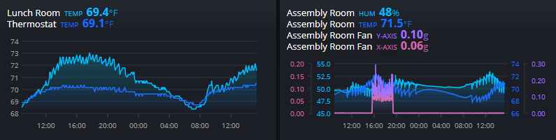
- Expanded Language Support: Support for six new languages has been added. In addition to English and Japanese, users can now also choose Danish, German, Spanish, French, Italian, and Portuguese.
- Full Screen App behavior on mobile devices: The Swift Sensors Dashboard behaves like a full-screen app on mobile devices, thanks to full-screen support when launched from a Home Screen icon on iOS and Android.
- Incomplete Threshold and Notification Warning: Threshold and notification lists now show a yellow warning icon next to incomplete thresholds and notifications with missing assignments of users, measurements, bridges, and/or sensors

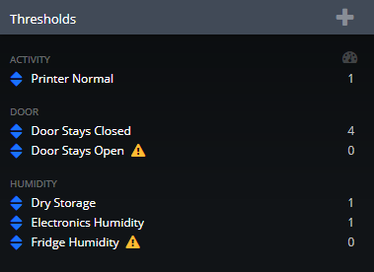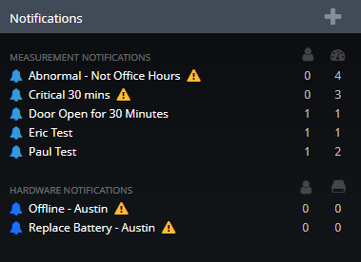

Swift Sensors products are available through a worldwide network of resellers and integrators. All features of the Dashboard are available to Swift Sensors customers through a low annual subscription to the Cloud Dashboard and Analytics, with configurations optimized for the size of the facility.

Swift Sensors, Inc. is a cloud wireless sensor IoT company, providing a low-cost sensor system for industrial and commercial applications. Its flagship product is the Swift Sensors Cloud Wireless Sensor System, comprised of low-power wireless sensors and cloud-based monitoring, notifications, analytics, and reporting. The sensor system proactively protects and monitors a wide range of equipment and processes. Swift Sensors applications include manufacturing, food service, facility management, cold chain, transportation, research & development, and power. The headquarters is located at 4611 Bee Caves Road, Suite 100, Austin, Texas, 78746. For more information, please visit www.swiftsensors.com or call +1-866-308-1340.

###

