**The My Plates great plate auction is now live!**

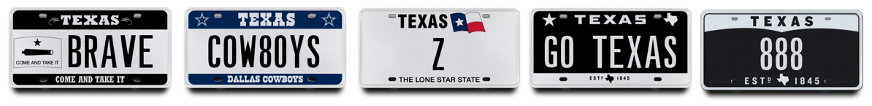

*The Great Plate Auction showcases 50 unique plate messages*

*Including historic license plate numbers!*

Austin, TX, March 30, 2018. My Plates will be conducting their biggest auction of the year, **the Great Plate Auction**. The auction will showcase 50 select, highly sought-after license plate messages with many never before available, including seven letter messages like “**40 ACRES**, **GO TEXAS** and **TEACHER**”. Some of the featured lots include rare two-digit numbers **17** and **99** as well as the single letter plate **Z**.

The My Plates Great Plate Auction for 2018 will conclude at 8PM on April 25, so Texans have plenty of time to get in their bids.

With 50 plate messages on offer, there’s a wide variety of choice, from team names like **COW8OYS, TEXENS, ASTRO5** and **LAKERS**, to everyday messages like **FRIEND** & **WELCOME**.

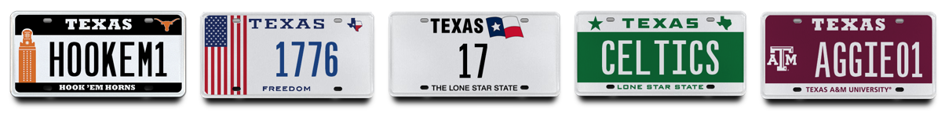

“The auction features a little something for everyone” said Steve Farrar, President of My Plates. From Texas themed plates, to motor vehicle brands, College teams, two letter messages and even City names. Imagine owning a city’s name like **DALL4S** or **ATLANTA** as your official Texas plate?

My Plates is also offering a variety of other historic license plate numbers including, the year **1776,** celebrating the United States official beginning of its nationhood and the message **888**, a very lucky number in many cultures.

Unlike other everyday Texas license plates, plate messages sold at auction by My Plates are offered for a 5-year term and are legally transferable. The plate owner then has the right to sell the plate message to another person with the same ongoing rights or gift it to a family member or friend. Transferability also means these plates could make great investments.

The Great Plate auction will be conducted online and will run through April 25, 2018. If you don’t live in Texas that’s okay, people from outside the state can purchase a Texas license plate for display on their wall, however, in order to display the auction plate on a vehicle, the vehicle must be registered by a Texas resident.

People interested in the auction can visit [www.myplates.com/auction](http://www.myplates.com/auction) for more information and to view the complete list of plates for sale.

____________________________________________________________

Previous Auction Results:

* **12THMAN** sold for $115,000 making it the most expensive plate message in Texas.
* **HOUSTON** sold for $25,000 in January 2013.
* **ROCKETS** sold for $16,500 in January 2013.
* **COWBOYS** sold for $11,500 in January 2011.
* **J** sold for $10,500 in February 2018.
* **ALAMO** sold for $10,250 in March 2016.
* **DALLA**S sold for $7,250 in March 2014.
* **12** sold for $6,250 in November 2016.
* **1969** sold for $5,250 in August 2017.

_____________________________________________________________

Why buy at Auction?

* *Opportunity to purchase a truly exclusive plate message from My Plates' reserve collection.*
* *First right of renewal at the state's everyday pricing, which means you can keep the plate for as long as you choose to renew it.*
* *Auction plates are fully transferable. Not only can they be transferred from one vehicle to another, but also person-to-person, such as parent to their children or friend-to-friend. The plate owner also has the right to sell the plate message to another person with the same ongoing rights. As a result, Auction plates could be an excellent investment.*
* *Peace of mind, knowing that you're purchasing your official Texas license plates from My Plates, the authorized specialty plate vendor for the Texas Department of Motor Vehicles.*
* *Supports the General Revenue Fund of Texas, which provides services for all Texans.*

_____________________________________________________________

**My Plates** designs and markets new specialty license plates as a vendor for the Texas Department of Motor Vehicles. Texans have bought more than 350,000 My Plates since November 2009, putting more than $62M in the state general revenue fund. My Plates’ goal is to create a long-term, mutually beneficial relationship designed to maximize revenues for the state through the sale of My Plates specialty plates. [www.myplates.com](http://www.myplates.com).

**The Texas Department of Motor Vehicles (TxDMV)** serves protects and advances the citizens and industries in the state with quality motor vehicle related services. For every $1 it spends, the TxDMV returns $11 to the state. The agency currently registers 24 million vehicles; issues more than 7 million vehicle titles; licenses more than 38,000 motor vehicle dealers and distributors; credentials nearly 60,000 motor carriers; issues more than 800,000 oversize/overweight permits; investigates more than 15,000 complaints against dealers and motor carriers; and awards grants to law enforcement agencies to reduce vehicle burglaries and thefts. Learn more at [www.TxDMV.gov](http://www.TxDMV.gov).

PR Hero image #1 link:

<https://ce9a9387e1bc258c3cfa-af7906f4e771b24864bbfa3048e4a635.ssl.cf2.rackcdn.com/Gr8Pl8_PR_1.jpg>

PR Hero Image #2 link:

<https://ce9a9387e1bc258c3cfa-af7906f4e771b24864bbfa3048e4a635.ssl.cf2.rackcdn.com/Gr8Pl8_PR_2.jpg>