Press Release
For immediate release
Contacts:
Italian Wine Unplugged Grape by Grape
Giulia Bruna
Project Coordinator
+39 045 8101447
Email: info@italianwineunplugged.com
Website: www.italianwineunplugged.com
Facebook: @ItalianWineUnplugged
Instagram: italianwineunplugged
Twitter: @IWUnplugged
LinkedIn: Italian Wine Unplugged Company Page

April 3rd, 2018

Paperback version of Italian Wine Unplugged now available in the United States

The paperback version of Italian Wine Unplugged Grape by Grape is now available in the United States through Amazon USA (24 dollars). The ultimate study guide to the grapes of Italy can now be purchased through multiple channels through Amazon USA, Amazon Europe, and in ebook version through Amazon Kindle.
The book unpacks the complexity of Italian wines through its native grape varieties. It aims to assist students and professionals in the wine industry to learn and appreciate the biodiversity of Italian wine. Overall, the book features 430 color-coded entries detailing Italian grapes and subdivided in three macro-sections (Must-know, Lesser-known, Rare varieties) that will facilitate the exploration. Introductory essays also ease the reader into the complicated world of Italian wine appellations and areas of wine production. The book’s visual sections include photographs of grape bunches, maps of Italian wine appellations, and mind maps. Italian Wine Unplugged is also the core text for the intermediate-level course Italian Wine Maestro, a new certification dedicated to wine professionals looking to deepen their knowledge of Italian wines. The Italian Wine Maestro pilot course was held in Vancouver in Autumn 2017 and the program will be officially launched internationally in the incoming months.
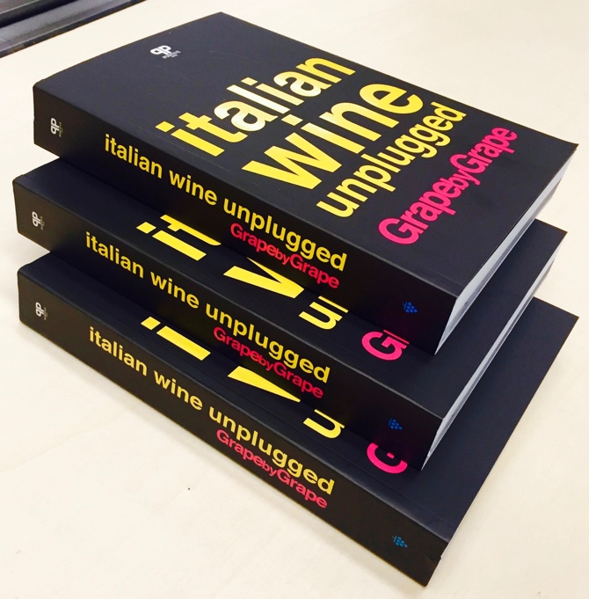
Italian Wine Unplugged has been first released in ebook version through Amazon Kindle and on the European market in the Fall 2017. The distribution of the book in the United States through Amazon USA is key to inform and educate Italian wine lovers in that specific market, that is also the main international market for Italian wine sales.
Since its first release in 2017, reviews of the book appeared in a number of newspapers and wine blogs internationally. Isaac Baker, in the award-winning wine blog Terroirist, defines it a “master key,” its “grape-by-grape breakdown… an incomparable reference tool for Italian wine grapes.” Paul Howard, in his Wine Alchemy blog, is enthusiastic about the digital format: “Read at home, refer to it in a shop or restaurant or take it to a vineyard or winery… The style is visual and infographic, the text well written and engaging.” Steve Raye, in his Bevology blog, remarks on the book’s visual apparatus and commends in particular the mind maps, “a very useful graphic that helps the reader understand the relationship of the varietal heritage, characteristics and the wines that each produces.” Book mentions and interviews to author Stevie Kim also appeared in an article by Patrick Schmitt in The Drinks Business and in the Korean wine magazine The Scent.
On Italian media, the book was positively received by a number of outlets and unanimously described as a tool that will bring international wine lovers closer to Italian wine. In his review for the Intravino blog, Ulrich Kolhman appreciates the grape focus: “In this age of globalization, a communicative approach that focuses on the grape variety and not on the bizantine superstructure of Italian denominations can be a winning strategy (transl. from Italian).” In a review for the Italian Association of Sommeliers (AIS), Gherardo Fabretti points out that the book represents “an example for whoever finds it difficult to transmit their passion for wine to those who do not speak Italian.” Angelo Peretti at The Internet Gourmet stresses that the book will be a useful “support for export managers and wine makers who are globetrotters,” while reviewers at Cronache di Gusto also see it useful to “producers and wineries.” Elisabetta Tosi, in her blog Vino Pigro, defines the book as “a sort of ‘everything you always wanted to know about this topic but were too shy (or lazy) to ask’.” The informativeness and accessibility of the publication was highlighted also in Giambattista Marchetto’s review for Il Sole 24Ore. The book appeared in an article for the national newspaper Corriere della Sera, where renowned food and wine critic Luciano Ferraro paired 5 wines with 5 books, matching Italian Wine Unplugged with Valle d’Aosta wine Nathan by Ermes Pavese, from the Prié grape.

REVIEWS of Italian Wine Unplugged:

Baker, Isaac. “Book Review: Italian Wine Unplugged Grape by Grape.” Terroirist. A Daily Wine Blog. 10 September 2017. https://goo.gl/rhy1NE
Fabretti, Gherardo. Italian Wine Unplugged I Vini Italiani Spiegati Facili. 29 January 2018. https://goo.gl/LMbBz5.
Ferraro, Luciano. “5 libri da bere. 5 vini da leggere.” Corriere della Sera. 22 December 2018. https://goo.gl/J9PWN4.
Howard, Paul. “Book Review: Italian Wine Unplugged Grape by Grape.” Wine Alchemy. 7 September 2017, https://goo.gl/kjt9aG
Kohlmann, Ulrich. “Italian Wine Unplugged, 430 vitigni italiani nel libro di Stevie Kim e Ian d’Agata” Review. Intravino. 16 January 2018. https://goo.gl/WUw8RC.
Marchetto, Gianbattista. “Italian Wine Unplugged: vademecum digitale sui vitigni italiani (per esperti/appassionati/curiosi). Il Sole 24Ore. 12 September 2017. https://goo.gl/KfdtfH.
Park, Chan Jun. “A small giant in the Italian wine industry.” The Scent. 20 November 2017, https://goo.gl/opVdHx.
Peretti, Angelo. “Anche il vino può essere unplugged (per fortuna).” The Internet Gourmet. 20 February 2018. https://goo.gl/YD2HeD.
Raye, Steve. “Review of Italian Wine Unplugged Grape by Grape.” Bevology Blog. 25 September 2017, https://goo.gl/ugRYPq .
Schmitt, Patrick. “New Book aims to be ‘gold standard for Italian wine’.” The Drinks Business. 15 November 2017, https://goo.gl/kh8xvp.
“To tell the Italian vineyard to the world. Ian D'Agata and Stevie Kim try it with a book.” Book Review. Cronache di Gusto. 20 January 2018. https://goo.gl/zdkhUk
Tosi, Elisabetta. “A book to read: Italian Wine Unplugged (Grape by Grape).” Vino Pigro Blog. 8 January 2018. https://goo.gl/qvaFdZ.

Review copies can be requested by emailing info@italianwineunplugged.com.

About:
Dedicated to both wine lovers and wine professionals, Italian Wine Unplugged Grape by Grape is a concise yet comprehensive cultural and scientific introduction to Italian wine and its hundreds of native grape varieties. The book analyzes over 430 Italian native grape varieties in accessible and easy-to-read entries. It also features an extensive visual apparatus with infographics, photographs of grape bunches, maps of Italian wine appellations. Available on: Amazon USA http://amzn.to/2HZbpKY; Amazon EU https://amzn.to/2uwwJ8I; Amazon Kindle https://amzn.to/2GdkdfE. Book website: www.italianwineunplugged.com.

