Press Release Contacts: For Immediate Release Vinitaly International
International Media Dept.
+39 045 8101447
media@vinitalytour.com
www.vinitalyinternational.com
Twitter: @VinitalyTour
Join Italian Wine Community on LinkedIn

Vinitaly International Academy Executive Wine Seminars showcase
Italy in a Glass of Wine

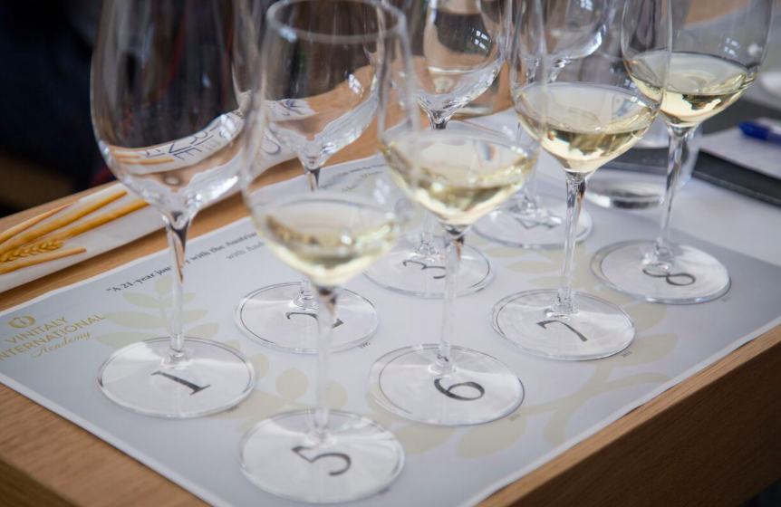
With the intent to shed a light on the hidden gems of Italian wine, Vinitaly International Academy (VIA) will host two Executive Wine Seminars during the 52nd edition of Vinitaly. Henry Davar, wine educator from USA and Vinitaly International Academy certified Italian Wine Expert, will introduce two unique tastings aimed at drawing attention to white and passito wines yet to be fully discovered and appreciated.
On Sunday April 15th, the first seminar, “L’Età del Bianco - A White Wine’s Age,” will demythologize the belief that you cannot age white wine. The tasting will introduce a unique selection of labels that stand out for their surprising evolution in the bottle. When discussing the ageing potential of Italian wines, there is a tendency to think only about red wines. The common thought is that white wines should be consumed while you can still enjoy their youthful and fresh character. However, this habit at times deprives these white wines from the notion of “nobility”. As Davar responds, “The landscape is different today. As ampelology, viticultural practices, and winemaking techniques have evolved, we are better able to realize the potential of Italian varieties especially as they flourish in their preferred habitats. Often times we have been led to these realizations by visionary winemakers who recognized the potential of their local grape and their prized plot of land.” Hence, “L’Età del Bianco” tasting represents a special opportunity not only to discover the Italian viticultural traditions, but also to celebrate a country which is still full of hidden treasures.

On Monday April 16th, the second seminar, “Vini Santi: An Italian heritage” will examine the rich history of the most famous Italian passito wines—a true expression of the winemaking traditions of the “Belpaese.” Among the extremely diverse category of Passito wines in Italy, “Vino Santo” is very popular and historical, with the first mentions dating back to the origin of Christianity. The legend has it that after the Romans abandoned wine production in Tuscany, the monks set about managing the vines and producing wine on the hills around Florence and Siena, as they needed it for liturgy. That is where “Santo,” meaning holy, comes from.

In a world where mass-production is taking over the artisanal know-how, Davar states: “Vin Santo is the ultimate craft beverage; one that can connect you to an almost forgotten heritage of craft (…). In the seminar, we will explore various expressions of these vini passiti from Northern and Central Italy and discuss perhaps how we might preserve this heritage.” As Davar continues, the seminar aims at showing attendees that in our fast-paced lives “vini santi” allow you “to slow down to enjoy this journey, to make a connection to a culture and a place rich in history.” With wines ranging from Trentino to Umbria, Davar will survey the various expressions of these wines.

Once again, the VIA Executive Seminars will bring Italian wine lovers on a rare and unique journey across the Italian peninsula, on a quest for its cultural diversity expressed in its artisanal and undiscovered wines. See full details of the seminars below:

1. Executive Wine Seminars “L’Età del Bianco - A White Wine’s Age”
Convenor: Henry Davar, VIA certified Italian Wine Expert
Time: Sunday, 15th April 2018, 11.00 - 13.00
Location: wine2digital
Link: http://bit.do/ecRSZ
• Vino Santo Trentino ( Pisoni) 1983
• Vino Santo Trentino, Alessandro Poli - 2002
• Vino Santo Trentino, (Francesco Poli ) 2003
• Colli Piacentini Vin Santo di Vigoleno, Lusignani Alberto, 2006
• Vinsanto di Carmignano doc Riserva Capezzana, 2010
• Vin Santo del Chianti Classico - Fattoria di San Giusto 2002
• Vin Santo Doc Occhio di Pernice 2002 - Avignonesi
• Vin de Granaro 2007, Agricola Menti Giovanni. RITIRARE VINO DOMENICA
• Vino Santo della Valle del Tevere - "Cesare di Galparino” 2007, Filippi Chiara di Città di Castello.
Vinsanto Carpineto FARNITO VINSANTO DEL CHIANTI 1999

2. Executive Wine Seminars “Vini Santi: An Italian heritage”
Convenor: Henry Davar, VIA certified Italian Wine Expert
Time: Monday, 16th April 2018, 15.00 - 17.30
Location: wine2digital
Link: http://bit.do/ecRS6
- Soave Classico la Rocca 2006, Pieropan
- Verdicchio Campo alle Oche 2008, Fattoria San Lorenzo
- Nosiola 2003, Cesconi
- Pinot Bianco Sirmian 2012, Nals Margreid
- Timorasso 2007, Walter Massa,
- Trebbiano d’ Abruzzo 2007, Emidio Pepe
- Friulano 2010, Ferlat
- Fiorduva 2010, Marisa Cuomo
About:
Veronafiere is the leading organizer of trade shows in Italy including Vinitaly (www.vinitaly.com), the largest wine and spirits fair in the world. During its 51st edition Vinitaly counted more than 4,270 exhibitors on a 100,000+ square meter area and 128,000 visitors from 142 different countries with more than 30,000 top international buyers (up by 8%). The next edition of the fair will take place on 15 - 18 April 2018. The premier event to Vinitaly, OperaWine (www.operawine.it) “Finest Italian Wines: 100 Great Producers,” will unite international wine professionals on April 14th in the heart of Verona, offering them the unique opportunity to discover and taste the wines of the 100 Best Italian Producers, as selected by Wine Spectator. Since 1998 Vinitaly International travels to several countries such as Russia, China, USA and Hong Kong thanks to its strategic arm abroad, Vinitaly International. In February 2014 Vinitaly International launched an educational project, the Vinitaly International Academy (VIA) with the aim of divulging and broadcasting the excellence and diversity of Italian wine around the globe. VIA this year launched the fourth edition of its Certification Course and today counts 130 Italian Wine Ambassadors and 9 Italian Wine Experts.

