Press Release Contacts: For Immediate Release Vinitaly International
International Media Dept.

+39 045 8101447
media@vinitalytour.com
www.vinitalyinternational.com
Twitter: @VinitalyTour
Join Italian Wine Community on LinkedIn

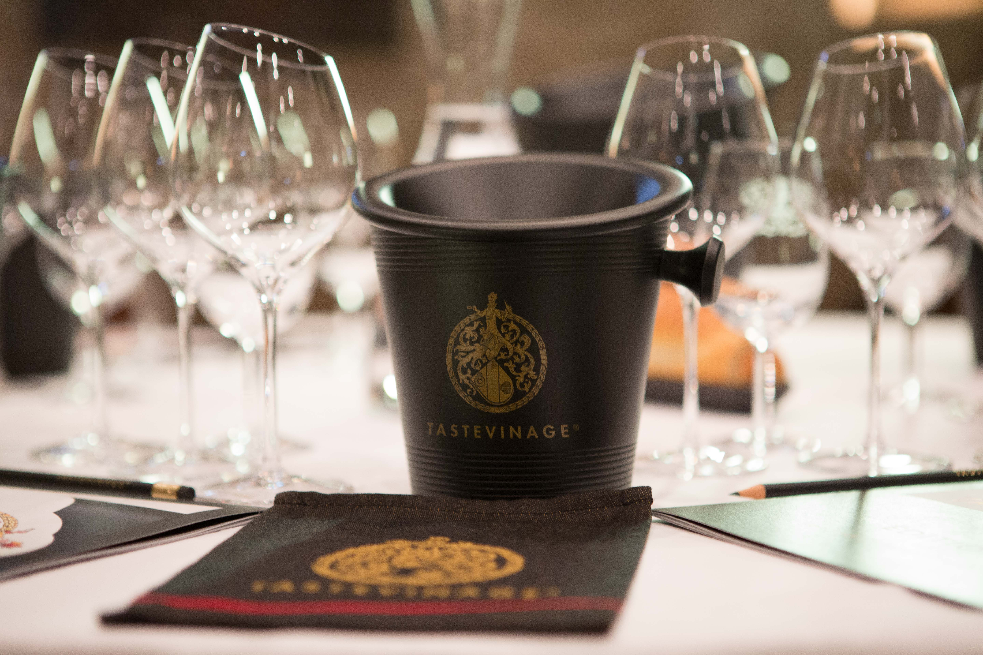
Open space, open doors: Vinitaly International’s events at Vinitaly 2018

During Vinitaly, Veronafiere’s wine2digital space will present a unique line-up of events: from a breakfast with wine influencers, to a talk about Millennials and wine, to tastings with wines coming from all over the world. Once more, Vinitaly International in collaboration with the Vinitaly International Academy and other partners will showcase international wine cultures with a wide range of tastings and business opportunities.

Recently refurbished and located on the fair grounds of Veronafiere, wine2digital is an open space venue featuring both areas for wine tastings and office space. Opened in December 2016, wine2digital is Veronafiere’s creative hub entirely dedicated to the wine product and the digital world. With the intent to bridge the gap between producers and consumers, throughout the year wine2digital holds innovative and international wine events with a digital twist and is the home of Vinitaly International, Vinitaly’s strategic arm abroad. During Vinitaly, the Vinitaly International’s calendar of events happening at wine2digital is varied.

The wine tastings will focus on both Italian and international wines. With wines coming from France, Austria, California and China, once again, Vinitaly International won’t fail to embrace cultural diversity in wine. Conseiller d’Honneur of the Confrerie des Chevaliers du Tastevin Arnaud Orsel will present the winners of the famous Tastevinage competition, the gathering of Burgundy wine enthusiasts. CEO of the Austrian Wine Marketing Board Willi Klinger will delve into the world of Austrian sweet wines. Enolytics CEO Cathy Huyghe will shed light on the “women of wine”, while La Marca sparkling wines will accompany a breakfast with some of the most famous wine influencers in Italy. Italian producers Angiolino Maule and Emma Bentley will conduct a tasting on artisanal wines. Lastly, Emma Gao will present the first winery boutique of China, Silver Heights, with wines from the famous Chinese wine region Ningxia.

As part of its intent to serve as a hub for the wine business, wine2digital will also host a number of useful meetings where wine professionals will be able to acquire new knowledge on foreign markets and consumer trends. Restaurateur and TV personality Joe Bastianich along with the Mirai Bay team will speak on Millennials and their attitude towards the wine sector.

During Vinitaly, the Vinitaly International Academy will also run its Executive Wine Seminars. After hosting the VIA certification course from April 6th to 10th, on Sunday 15th and Monday 16th, VIA will continue its educational mission by organising two seminars, the first focusing on aged Italian white wines and the second on “Vini Santi”, both led by VIA-certified Italian Wine Expert Henry Davar.

The open space office concept was created in 1958 by a German consulting group to increase productivity and team communication. The aim was to put the flowing of ideas at the centre of everyday office life. 60 years later, 70% of work spaces have an open floor plan and Vinitaly International has one too. A thriving venue all year long, during Vinitaly wine2digital is the open space that will facilitate business exchange and the sampling of wines from Italy and famous wine regions abroad.

Download the full program of Vinitaly International’s events at wine2digital during Vinitaly:

https://www.vinitaly.com/en/events2018/calendar/?d=2018-04-15

About
The grand Vinitaly 2018 will be held from April 15th to the 18th. Every year, Vinitaly counts more than 4,000 exhibitors on a 100,000+ square meter area and 130,000 visitors from over 140 different countries with more than 30,000 top international buyers. The premier event to Vinitaly, OperaWine (https://www.vinitalyinternational.com/?page_id=646) “Finest Italian Wines: 100 Great Producers,” which will be held on the 14th of April, one day prior to Vinitaly will unite international wine professionals in the heart of Verona, offering them the unique opportunity to discover and taste the wines of the 100 Best Italian Producers, as selected by Wine Spectator. Since 1998 Vinitaly International travels to several countries such as Russia, China, USA and Hong Kong thanks to its strategic arm abroad, Vinitaly International. In February 2014 Vinitaly International launched an educational project, the Vinitaly International Academy (VIA) with the aim of divulging and broadcasting the excellence and diversity of Italian wine around the globe. VIA this year launched the third edition of its Certification Course and today counts 122 Italian Wine Ambassadors and 9 Italian Wine Experts.

